CSc 8980 Spring 2020 - Dr. Daniel Takabi

Secure and Private AI Project

AbdulHaseeb Ahmed, Harnoor Singh, Naman Kanwar, Khushagra Patel

Georgia State University

Table of Contents

Attacks on Victim Model 2

Carlini LInf Method 2

Carlini L2 Method 3

Basic Iterative Method 4

Jacobian Saliency Method 5

Universal Perturbation Method 6

DeepFool Method 7

Virtual Adversarial Method 8

Fast Gradient Sign Method 9

Attack Appendix 10

Carlini LInf Method 10

Carlini L2 Method 32

Basic Iterative Method 55

Universal Perturbation Method 78

Jacobian Saliency Method 101

DeepFool Method 124

Fast Gradient Sign Method 147

# Attacks on Victim Model

## Carlini LInf Method

|  |  |
| --- | --- |
| Average Accuracy Over 10 Runs with learning_rate = 0.1 | |
| Benign Samples | 94.52% |
| Epsilon = 0.10 Samples | 4.5% |
| Epsilon = 0.25 Samples | 4.5% |
| Epsilon = 0.50 Samples | 4.5% |
| Epsilon = 0.95 Samples | 4.5% |

|  |  |  |  |  |  |  |  |  |  |  |
| --- | --- | --- | --- | --- | --- | --- | --- | --- | --- | --- |
| Average Accuracy per Class Over 10 Runs with learning_rate = 0.1 | | | | | | | | | | |
|  | Airplane | Car | Bird | Cat | Deer | Dog | Frog | Horse | Ship | Truck |
| Benign Samples | 96% | 99% | 93% | 83% | 97% | 89% | 100% | 95% | 93% | 92% |
| Confidence = 0.05 Samples | 2% | 0% | 7% | 13% | 2% | 8% | 0% | 2% | 5% | 6% |
| Confidence = 0.10 Samples | 2% | 0% | 7% | 13% | 2% | 8% | 0% | 2% | 5% | 6% |
| Confidence = 0.50 Samples | 2% | 0% | 7% | 13% | 2% | 8% | 0% | 2% | 5% | 6% |
| Confidence = 0.95 Samples | 2% | 0% | 7% | 13% | 2% | 8% | 0% | 2% | 5% | 6% |

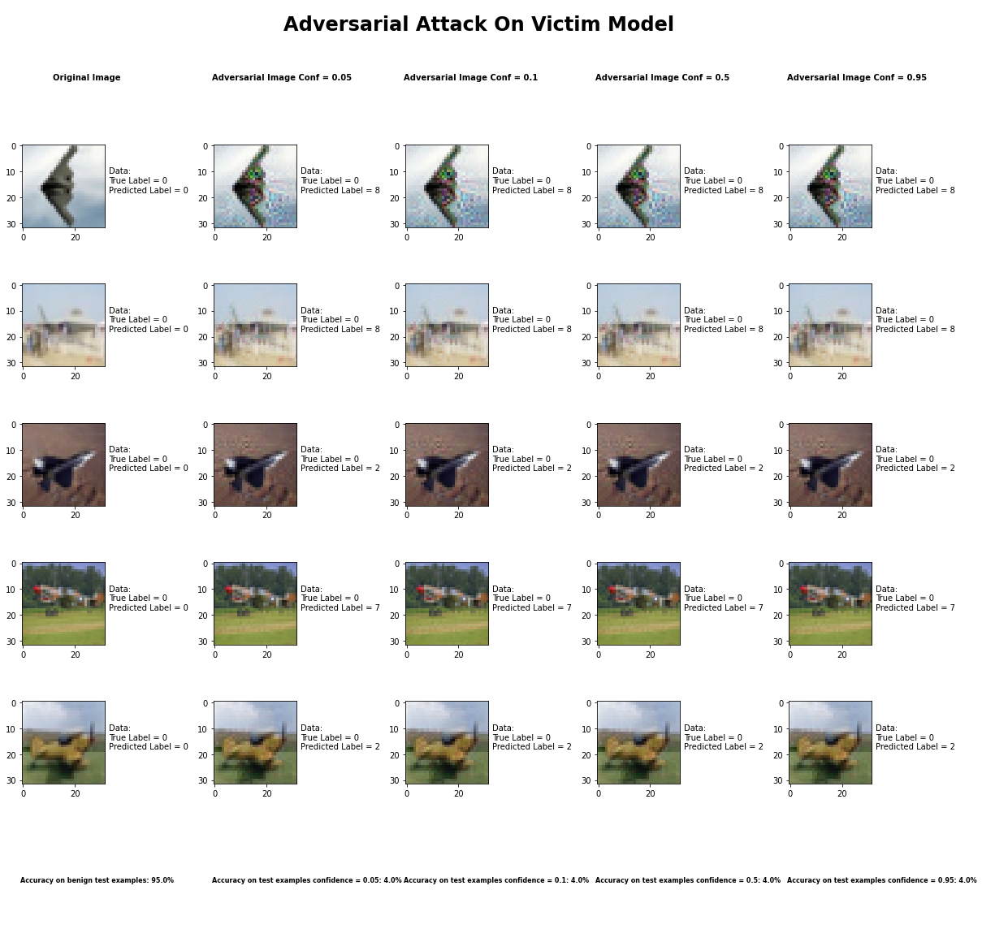

## Carlini L2 Method

|  |  |
| --- | --- |
| Average Accuracy Over 10 Runs with learning_rate = 0.1 | |
| Benign Samples | 94.52% |
| Epsilon = 0.10 Samples | 4.8% |
| Epsilon = 0.25 Samples | 4.8% |
| Epsilon = 0.50 Samples | 4.8% |
| Epsilon = 0.95 Samples | 4.8% |

|  |  |  |  |  |  |  |  |  |  |  |
| --- | --- | --- | --- | --- | --- | --- | --- | --- | --- | --- |
| Average Accuracy per Class Over 10 Runs with learning_rate = 0.1 | | | | | | | | | | |
|  | Airplane | Car | Bird | Cat | Deer | Dog | Frog | Horse | Ship | Truck |
| Benign Samples | 97% | 97% | 91% | 83% | 89% | 84% | 97% | 94% | 96% | 98% |
| Confidence = 0.05 Samples | 1% | 2% | 6% | 8% | 9% | 12% | 3% | 1% | 4% | 2% |
| Confidence = 0.10 Samples | 1% | 2% | 6% | 8% | 9% | 12% | 3% | 1% | 4% | 2% |
| Confidence = 0.50 Samples | 1% | 2% | 6% | 8% | 9% | 12% | 3% | 1% | 4% | 2% |
| Confidence = 0.95 Samples | 1% | 2% | 6% | 8% | 9% | 12% | 3% | 1% | 4% | 2% |

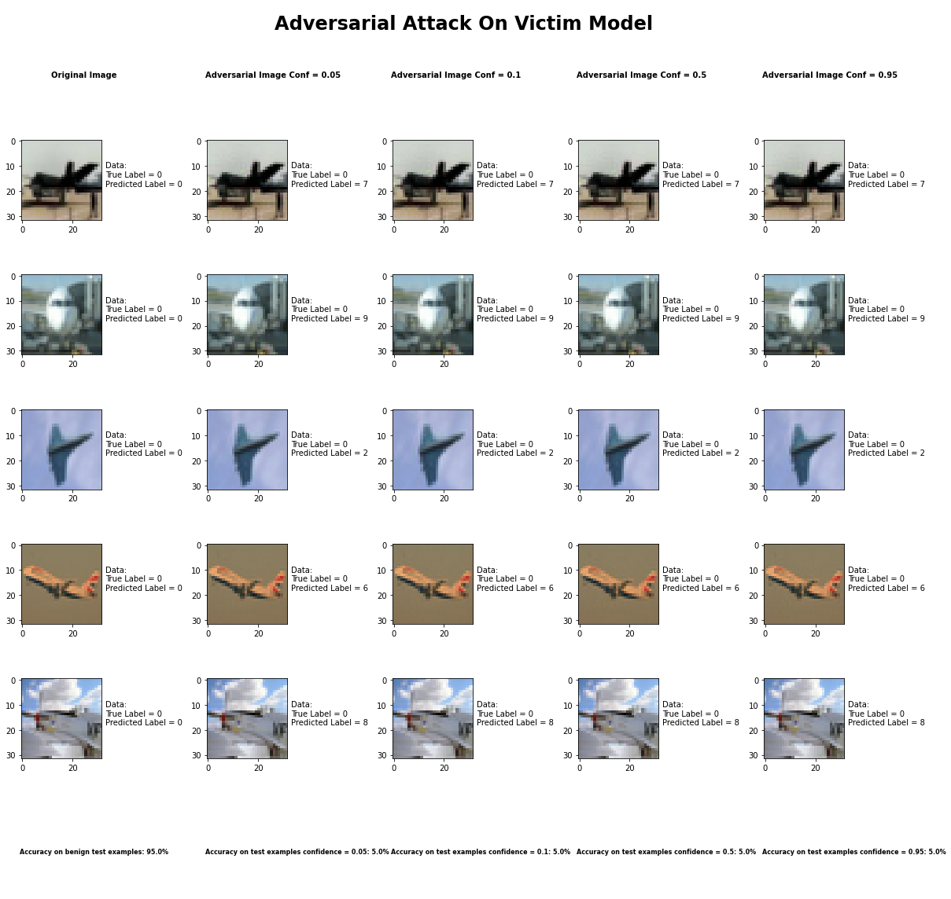

## Basic Iterative Method

|  |  |
| --- | --- |
| Average Accuracy Over 10 Runs with max_iter = 100 | |
| Benign Samples | 94.52% |
| Epsilon = 0.10 Samples | 34.0% |
| Epsilon = 0.25 Samples | 32.3% |
| Epsilon = 0.50 Samples | 32.0% |
| Epsilon = 0.95 Samples | 32.1% |

|  |  |  |  |  |  |  |  |  |  |  |
| --- | --- | --- | --- | --- | --- | --- | --- | --- | --- | --- |
| Average Accuracy per Class Over 10 Runs with max_iter = 100 | | | | | | | | | | |
|  | Airplane | Car | Bird | Cat | Deer | Dog | Frog | Horse | Ship | Truck |
| Benign Samples | 99% | 96% | 94% | 87% | 97% | 88% | 95% | 97% | 93% | 93% |
| Epsilon = 0.10 Samples | 35% | 30% | 44% | 27% | 29% | 22% | 54% | 30% | 33% | 36% |
| Epsilon = 0.25 Samples | 35% | 28% | 41% | 27% | 28% | 22% | 47% | 30% | 31% | 34% |
| Epsilon = 0.50 Samples | 35% | 28% | 40% | 25% | 28% | 22% | 47% | 30% | 31% | 34% |
| Epsilon = 0.95 Samples | 36% | 28% | 40% | 25% | 28% | 22% | 47% | 30% | 31% | 34% |

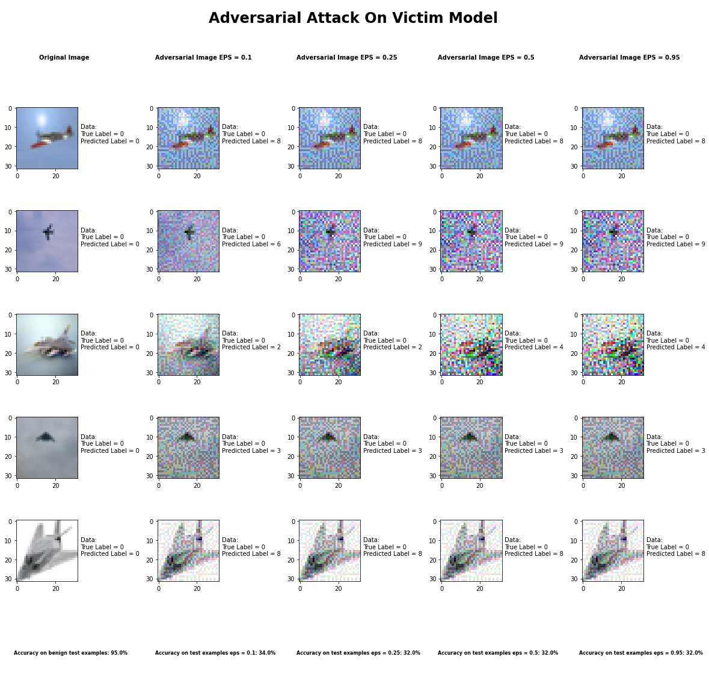

## Jacobian Saliency Method

|  |  |
| --- | --- |
| Average Accuracy Over 10 Runs with Theta = 0.05 | |
| Benign Samples | 94.52% |
| Gamma = 0.05 Samples | 12.5% |
| Gamma = 0.10 Samples | 2.1% |
| Gamma = 0.5 Samples | 0.2% |
| Gamma = 0.95 Samples | 0.1% |

|  |  |  |  |  |  |  |  |  |  |  |
| --- | --- | --- | --- | --- | --- | --- | --- | --- | --- | --- |
| Average Accuracy per Class Over 10 Runs with Theta = 0.05 | | | | | | | | | | |
|  | Airplane | Car | Bird | Cat | Deer | Dog | Frog | Horse | Ship | Truck |
| Benign Samples | 97% | 99% | 92% | 87% | 94% | 84% | 98% | 97% | 99% | 96% |
| Gamma = 0.05 Samples | 19% | 34% | 7% | 4% | 2% | 5% | 7% | 10% | 20% | 17% |
| Gamma = 0.10 Samples | 2% | 6% | 1% | 4% | 0% | 3% | 0% | 1% | 1% | 3% |
| Gamma = 0.5 Samples | 0% | 0% | 0% | 1% | 1% | 0% | 0% | 0% | 0% | 0% |
| Gamma = 0.95 Samples | 0% | 0% | 0% | 1% | 0% | 0% | 0% | 0% | 0% | 0% |

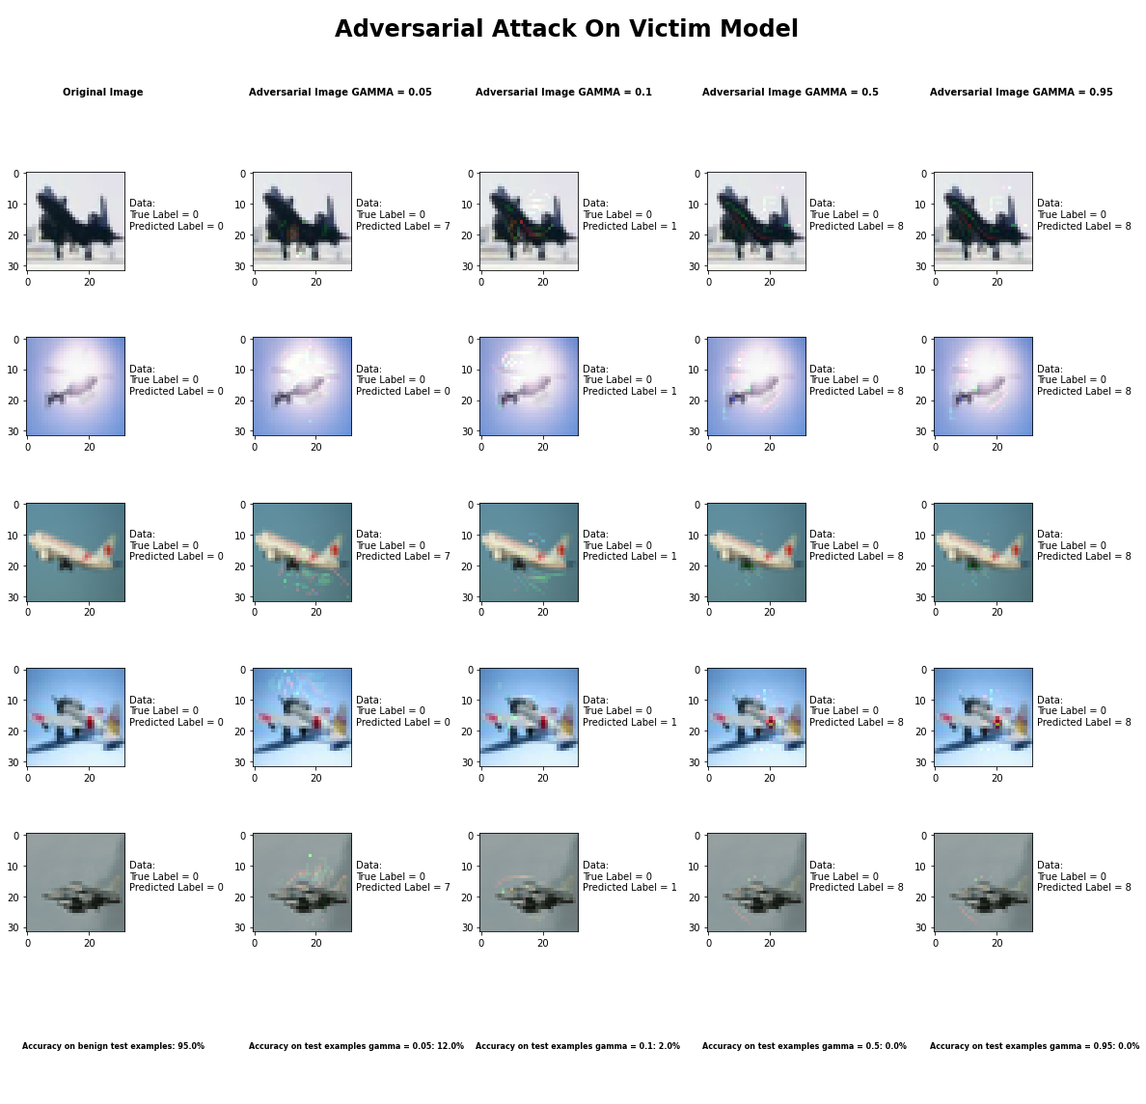

* Variable Gamma, and Theta close to 0 gave results with least perceptible changes
* Variable Gamma with Theta close to abs(1) gave results with most noticeable changes
* Variable Theta makes changes to image fade out as you get close to 0
* Variable Gamma increase area of changes in image, small gamma smaller area

## Universal Perturbation Method

|  |  |
| --- | --- |
| Average Accuracy Over 10 Runs with FGSM | |
| Benign Samples | 94.52% |
| Delta = 0.05 Samples | 10.6% |
| Delta = 0.10 Samples | 9.1% |
| Delta = 0.5 Samples | 10.5% |
| Delta = 0.95 Samples | 10.4% |

|  |  |  |  |  |  |  |  |  |  |  |
| --- | --- | --- | --- | --- | --- | --- | --- | --- | --- | --- |
| Average Accuracy per Class Over 10 Runs with FGSM | | | | | | | | | | |
|  | Airplane | Car | Bird | Cat | Deer | Dog | Frog | Horse | Ship | Truck |
| Benign Samples | 94% | 97% | 93% | 95% | 97% | 90% | 96% | 98% | 94% | 96% |
| Delta = 0.05 Samples | 54% | 1% | 0% | 0% | 0% | 0% | 2% | 0% | 0% | 49% |
| Delta = 0.10 Samples | 36% | 2% | 0% | 11% | 0% | 1% | 0% | 0% | 0% | 41% |
| Delta = 0.5 Samples | 37% | 21% | 0% | 1% | 0% | 1% | 10% | 0% | 0% | 35% |
| Delta = 0.95 Samples | 56% | 5% | 0% | 2% | 0% | 1% | 3% | 9% | 0% | 28% |

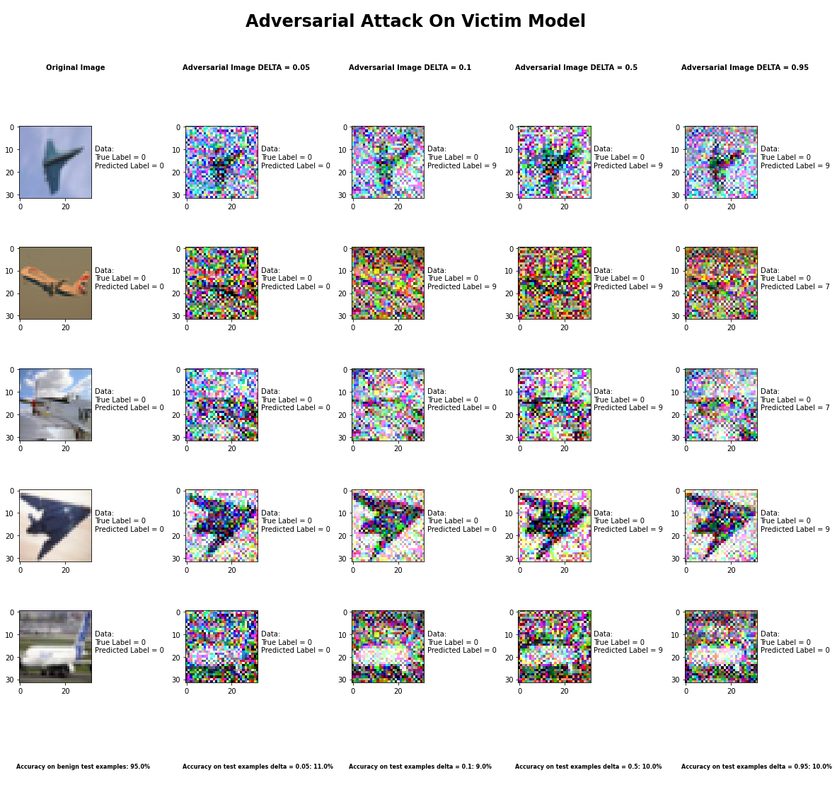

## DeepFool Method

|  |  |
| --- | --- |
| Average Accuracy Over 10 Runs | |
| Benign Samples | 94.52% |
| Epsilon = 1e-6 Samples | 30.2% |
| Epsilon = 1e-3 Samples | 31.3% |
| Epsilon = 1e-1 Samples | 30.1% |
| Epsilon = 1 Samples | 31.0% |

|  |  |  |  |  |  |  |  |  |  |  |
| --- | --- | --- | --- | --- | --- | --- | --- | --- | --- | --- |
| Average Accuracy per Class Over 10 Runs | | | | | | | | | | |
|  | Airplane | Car | Bird | Cat | Deer | Dog | Frog | Horse | Ship | Truck |
| Benign Samples | 95% | 92% | 96% | 86% | 95% | 88% | 99% | 93% | 94% | 98% |
| Epsilon = 1e-6 Samples | 42% | 45% | 27% | 29% | 37% | 20% | 26% | 21% | 32% | 26% |
| Epsilon = 1e-3 Samples | 46% | 51% | 31% | 26% | 33% | 22% | 24% | 25% | 30% | 24% |
| Epsilon = 1e-1 Samples | 46% | 48% | 24% | 22% | 38% | 23% | 29% | 24% | 28% | 21% |
| Epsilon = 1  Samples | 46% | 41% | 28% | 24% | 35% | 22% | 25% | 26% | 32% | 18% |

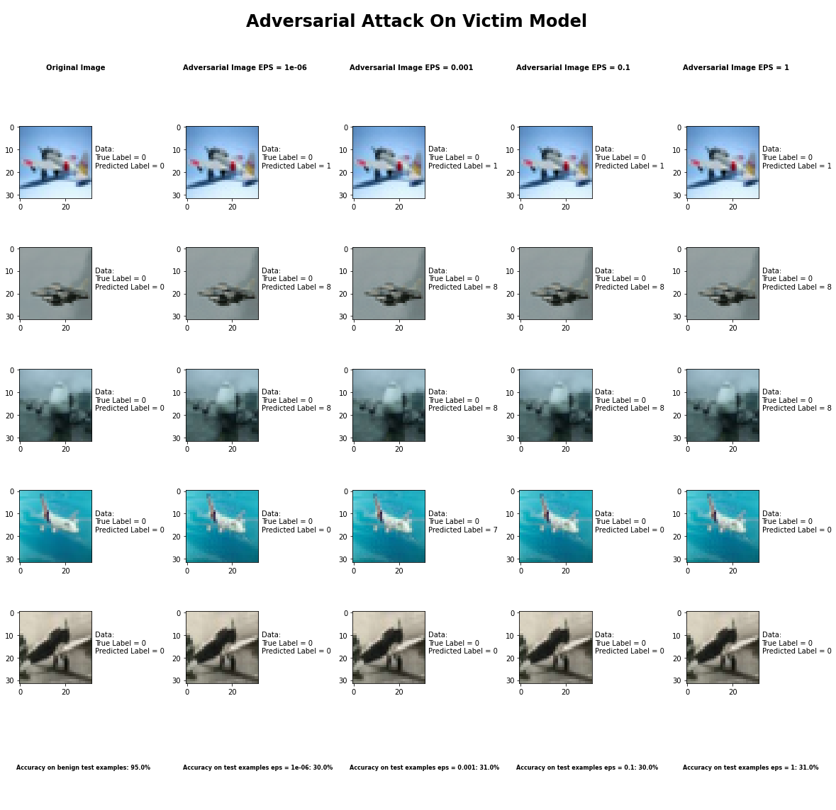

## Virtual Adversarial Method

|  |  |
| --- | --- |
| Average Accuracy Over 10 Runs | |
| Benign Samples | 94.52% |
| Epsilon = 0.05 Samples | 48.4% |
| Epsilon = 0.10 Samples | 39.9% |
| Epsilon = 0.5 Samples | 35.3% |
| Epsilon = 0.95 Samples | 35.3% |

|  |  |  |  |  |  |  |  |  |  |  |
| --- | --- | --- | --- | --- | --- | --- | --- | --- | --- | --- |
| Average Accuracy per Class Over 10 Runs | | | | | | | | | | |
|  | Airplane | Car | Bird | Cat | Deer | Dog | Frog | Horse | Ship | Truck |
| Benign Samples | 98% | 96% | 95% | 86% | 96% | 84% | 96% | 93% | 99% | 97% |
| Epsilon = 0.05 Samples | 32% | 60% | 68% | 42% | 43% | 31% | 60% | 33% | 58% | 57% |
| Epsilon = 0.10 Samples | 30% | 40% | 70% | 34% | 28% | 23% | 68% | 24% | 45% | 37% |
| Epsilon = 0.5 Samples | 33% | 40% | 34% | 37% | 20% | 23% | 26% | 24% | 45% | 71% |
| Epsilon = 0.95 Samples | 30% | 35% | 34% | 32% | 20% | 23% | 26% | 23% | 45% | 87% |

## Fast Gradient Sign Method

|  |  |
| --- | --- |
| Average Accuracy Over 10 Runs | |
| Benign Samples | 94.52% |
| Epsilon = 0.05 Samples | 48.4% |
| Epsilon = 0.10 Samples | 39.9% |
| Epsilon = 0.5 Samples | 35.3% |
| Epsilon = 0.95 Samples | 35.3% |

|  |  |  |  |  |  |  |  |  |  |  |
| --- | --- | --- | --- | --- | --- | --- | --- | --- | --- | --- |
| Average Accuracy per Class Over 10 Runs | | | | | | | | | | |
|  | Airplane | Car | Bird | Cat | Deer | Dog | Frog | Horse | Ship | Truck |
| Benign Samples | 98% | 96% | 95% | 86% | 96% | 84% | 96% | 93% | 99% | 97% |
| Epsilon = 0.05 Samples | 32% | 60% | 68% | 42% | 43% | 31% | 60% | 33% | 58% | 57% |
| Epsilon = 0.10 Samples | 30% | 40% | 70% | 34% | 28% | 23% | 68% | 24% | 45% | 37% |
| Epsilon = 0.5 Samples | 33% | 40% | 34% | 37% | 20% | 23% | 26% | 24% | 45% | 71% |
| Epsilon = 0.95 Samples | 30% | 35% | 34% | 32% | 20% | 23% | 26% | 23% | 45% | 87% |

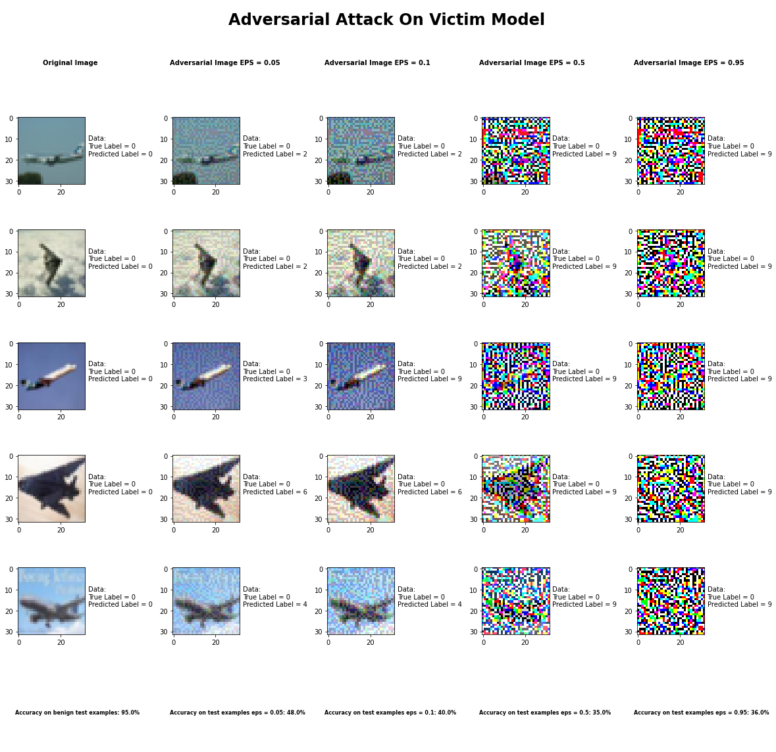

# Attack Appendix

## Carlini LInf Method



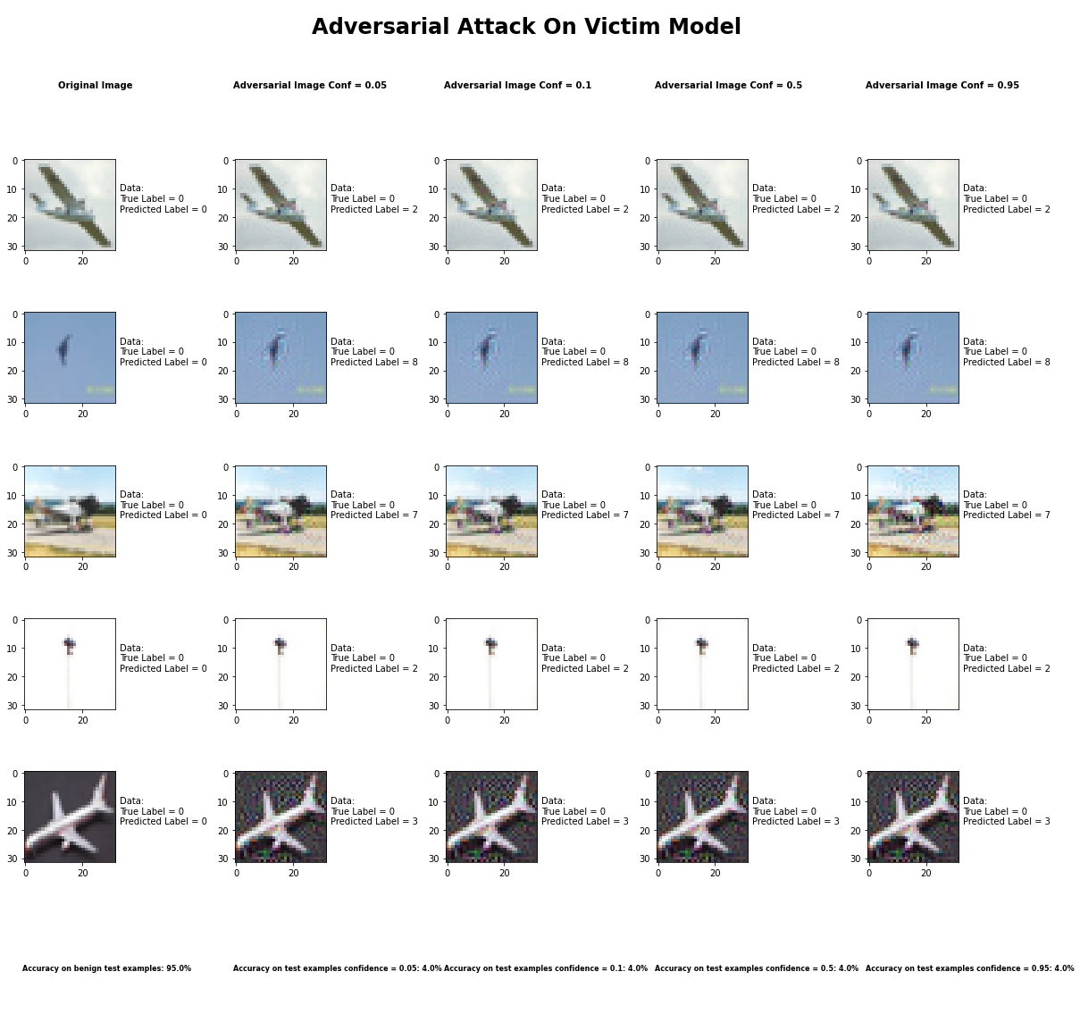

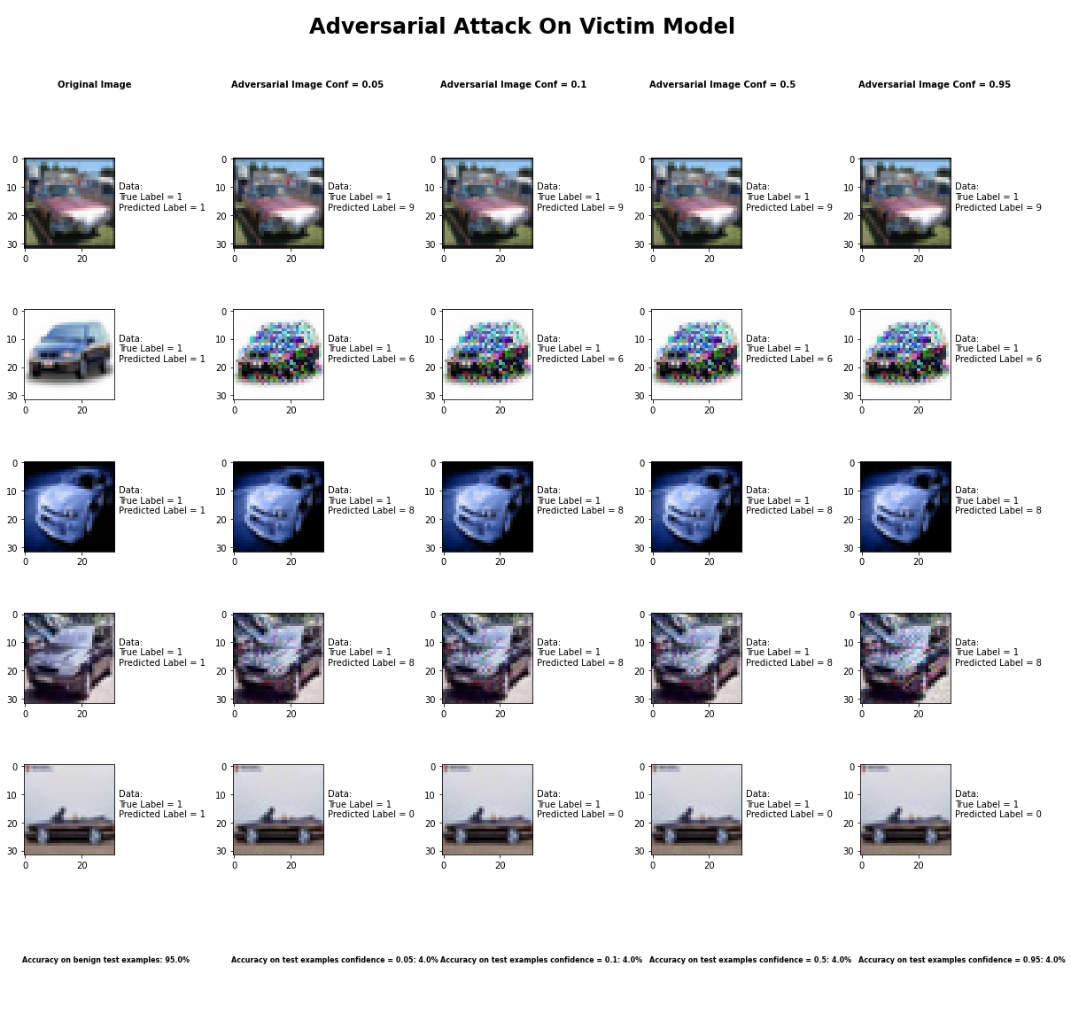

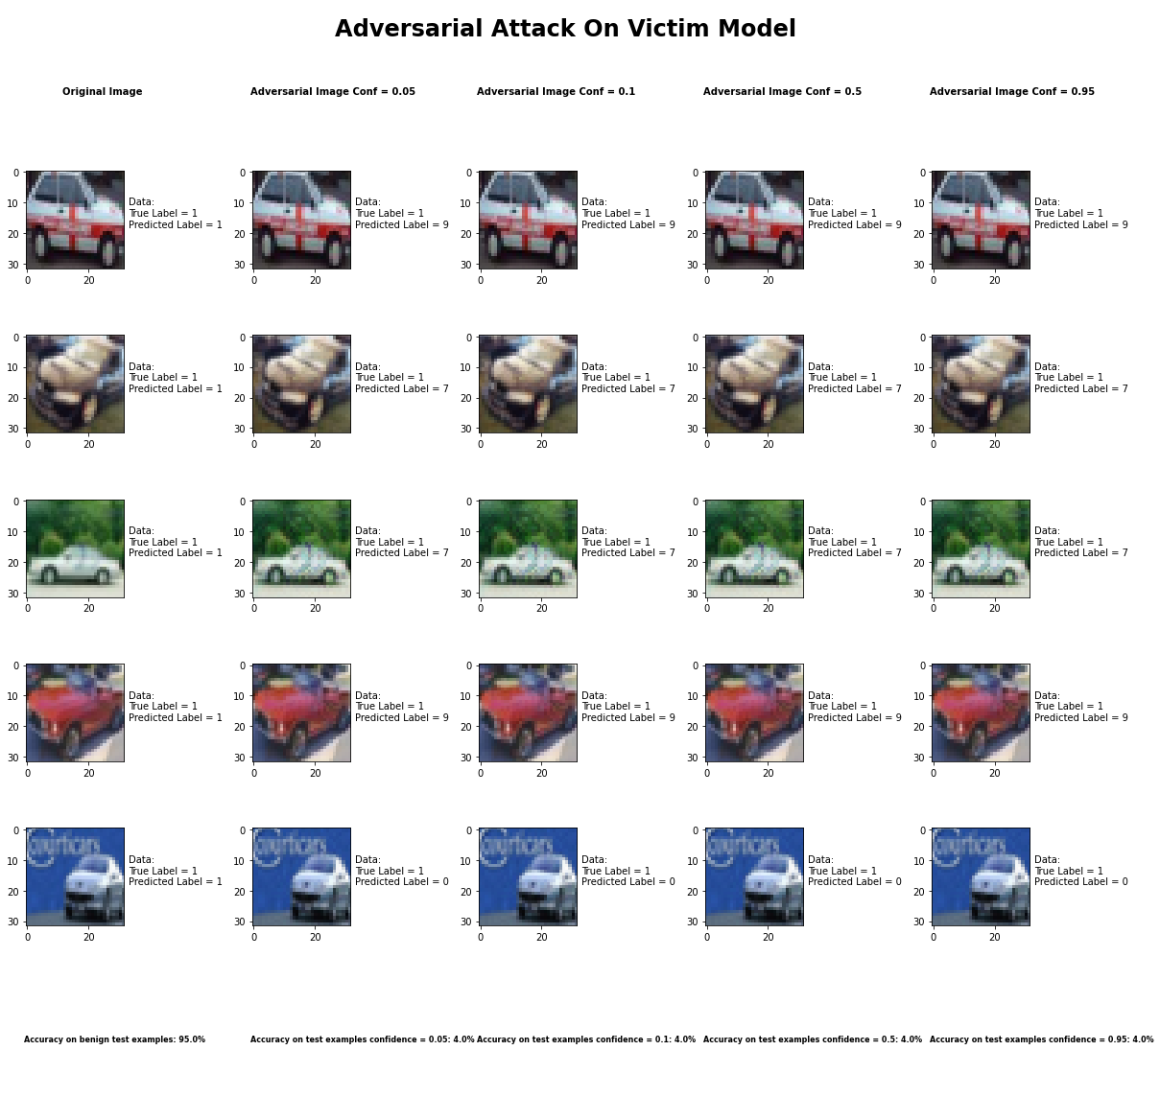

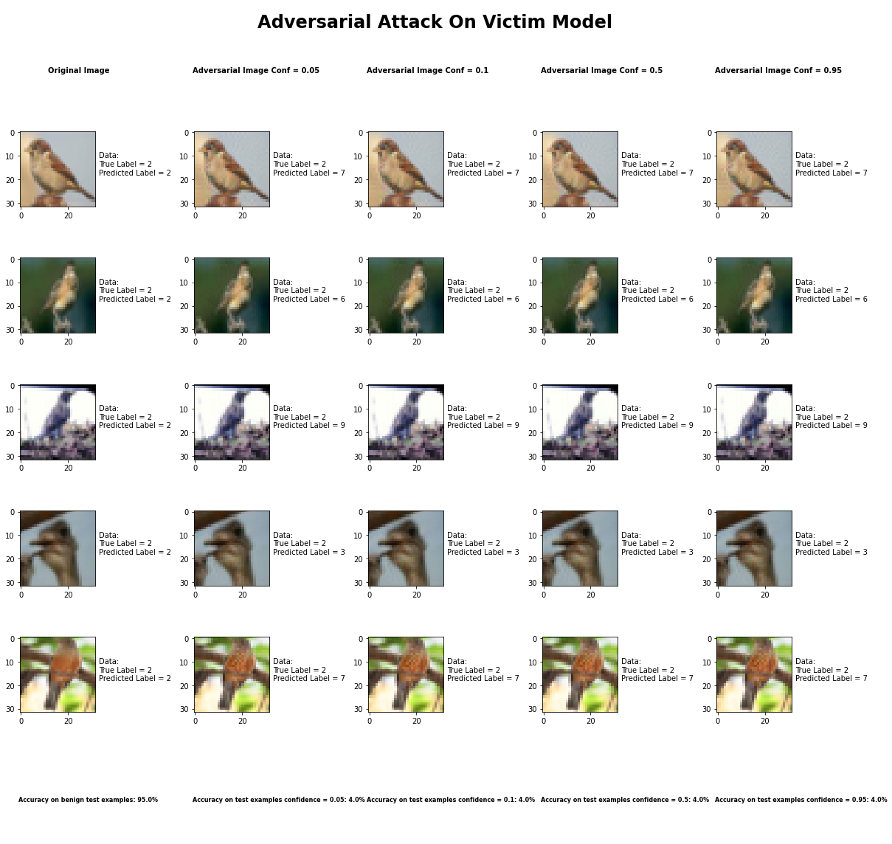

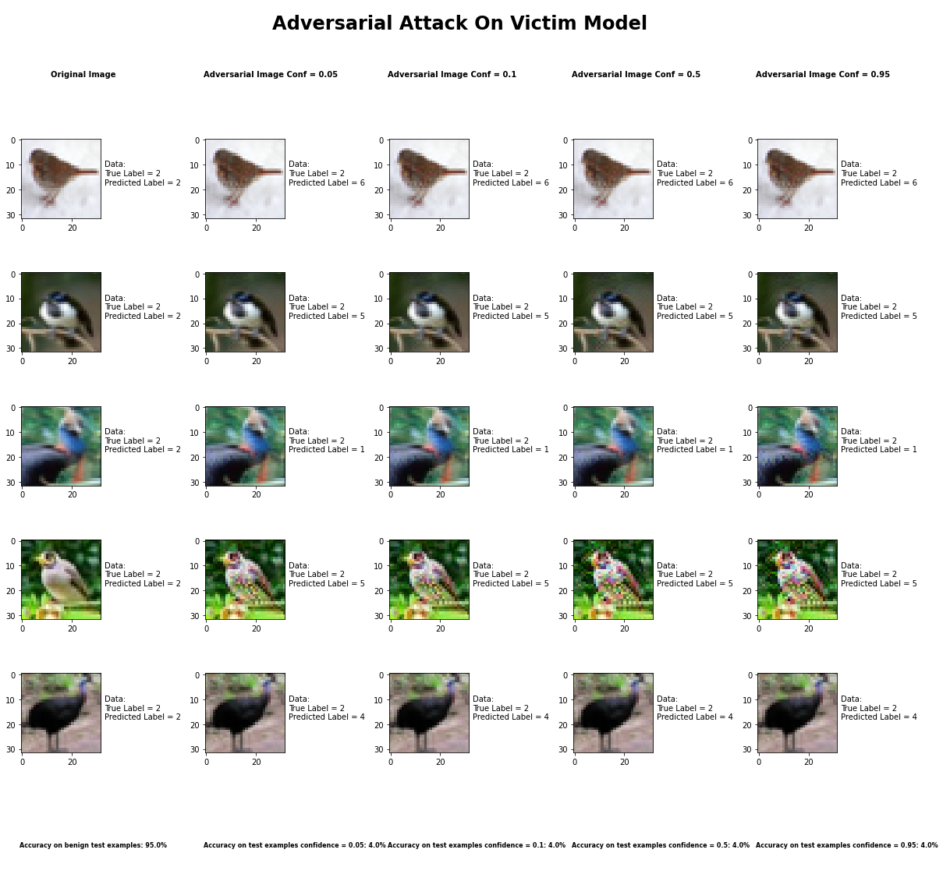

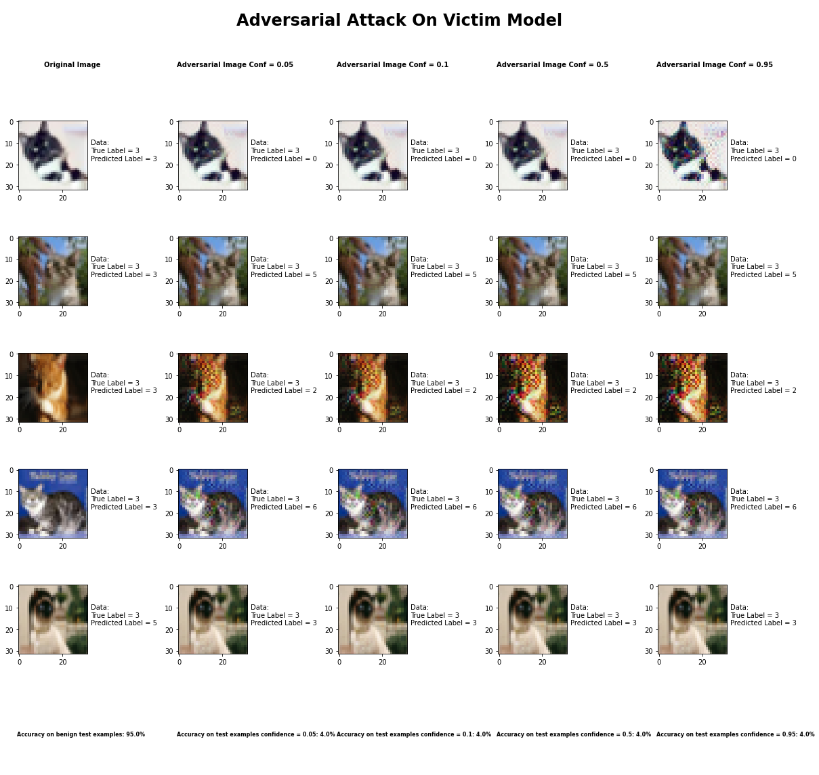

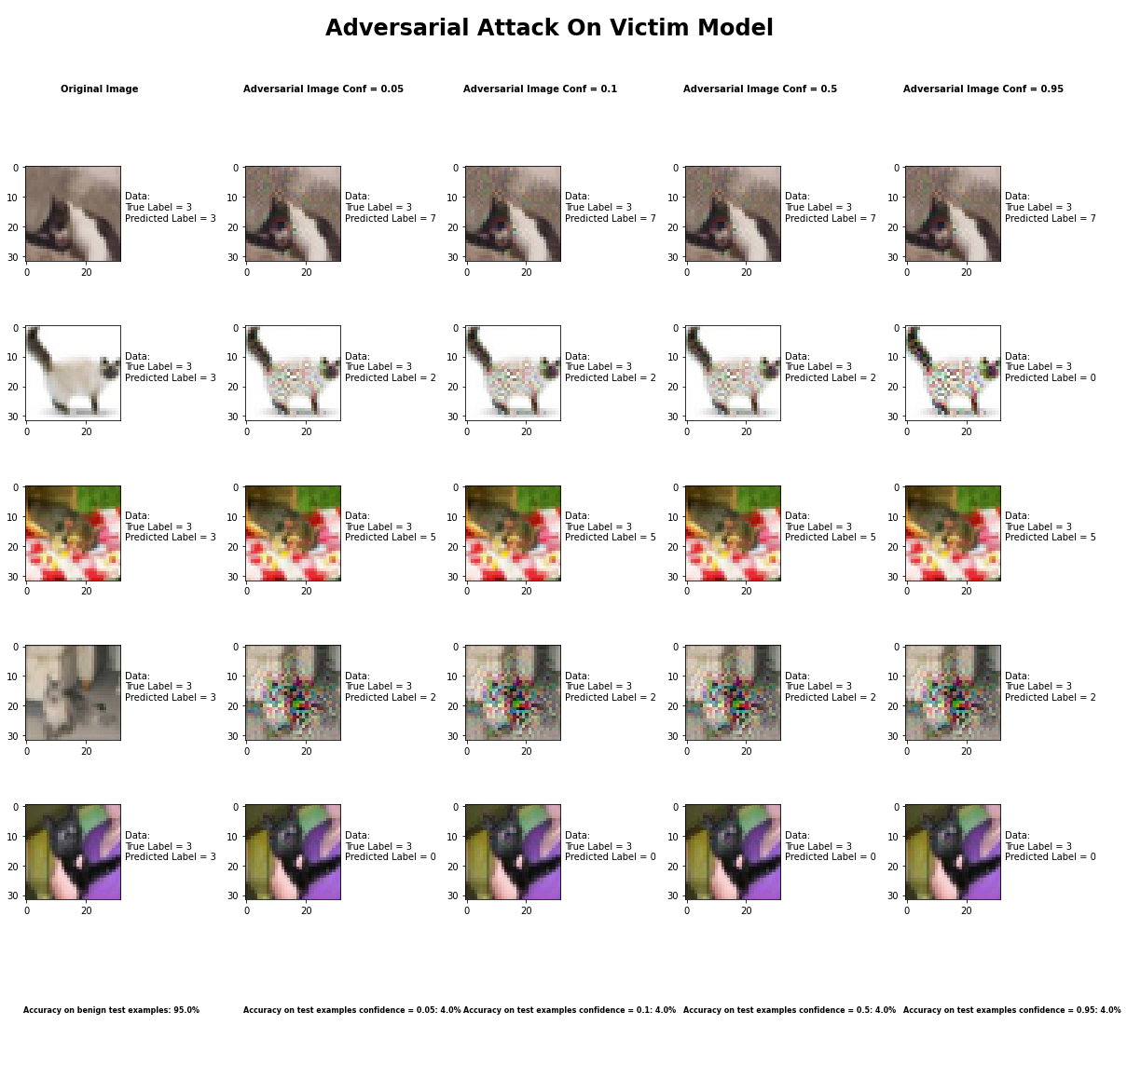

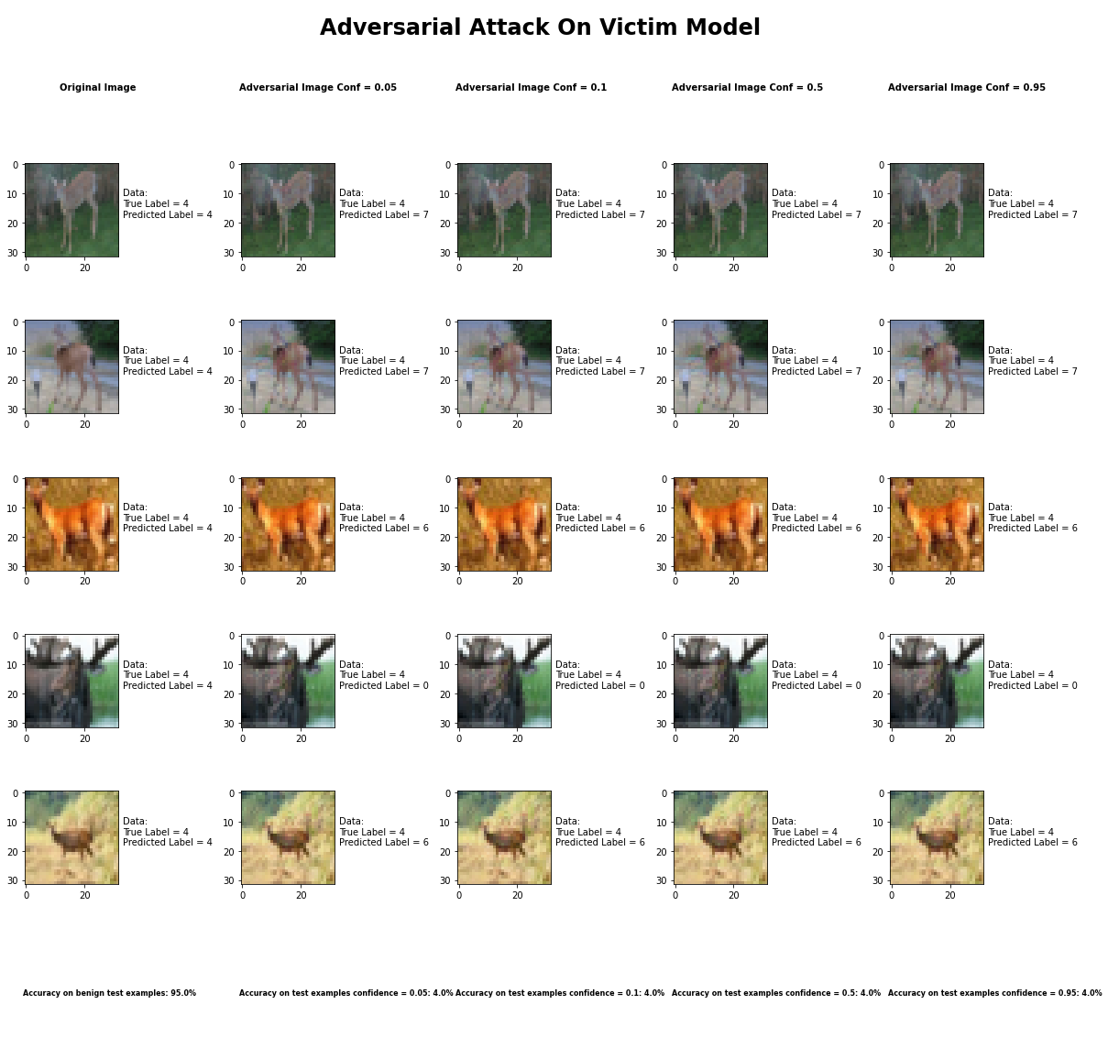

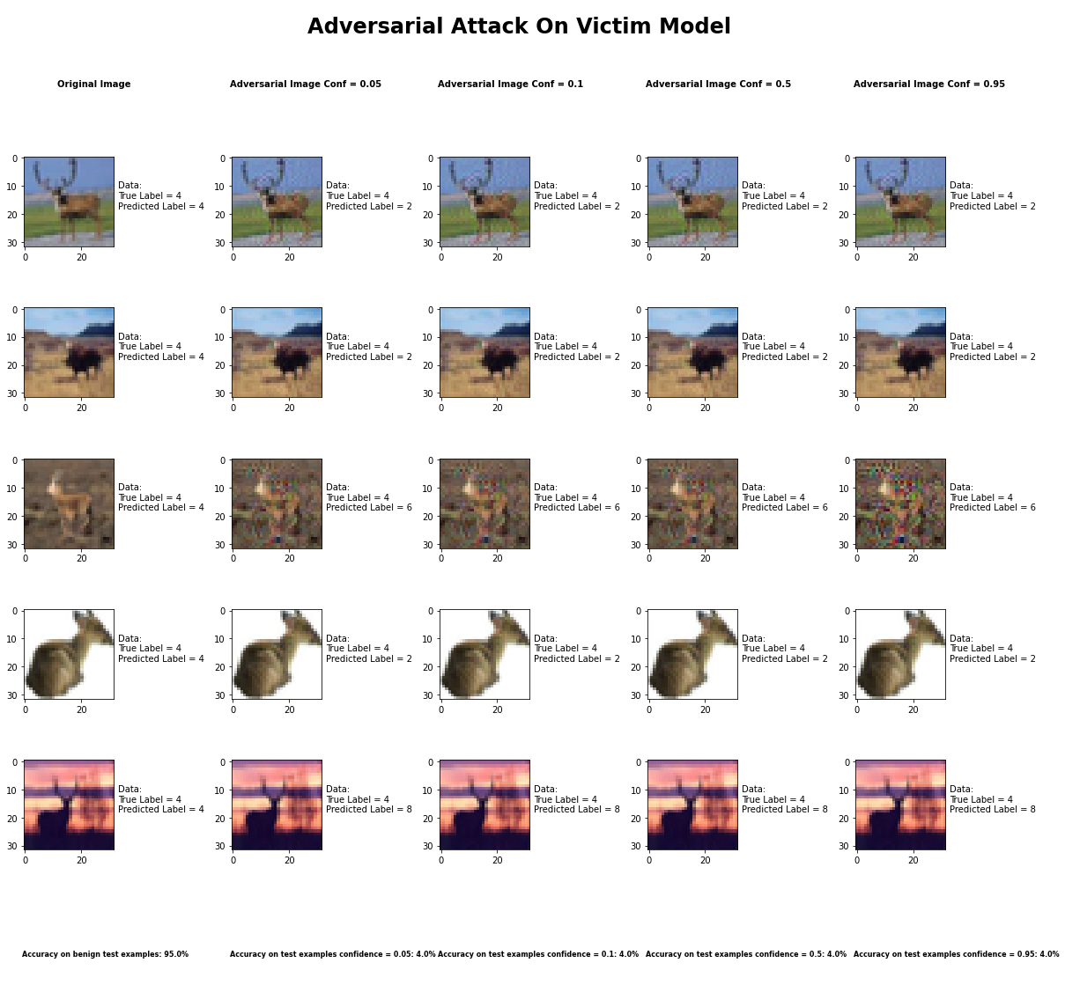

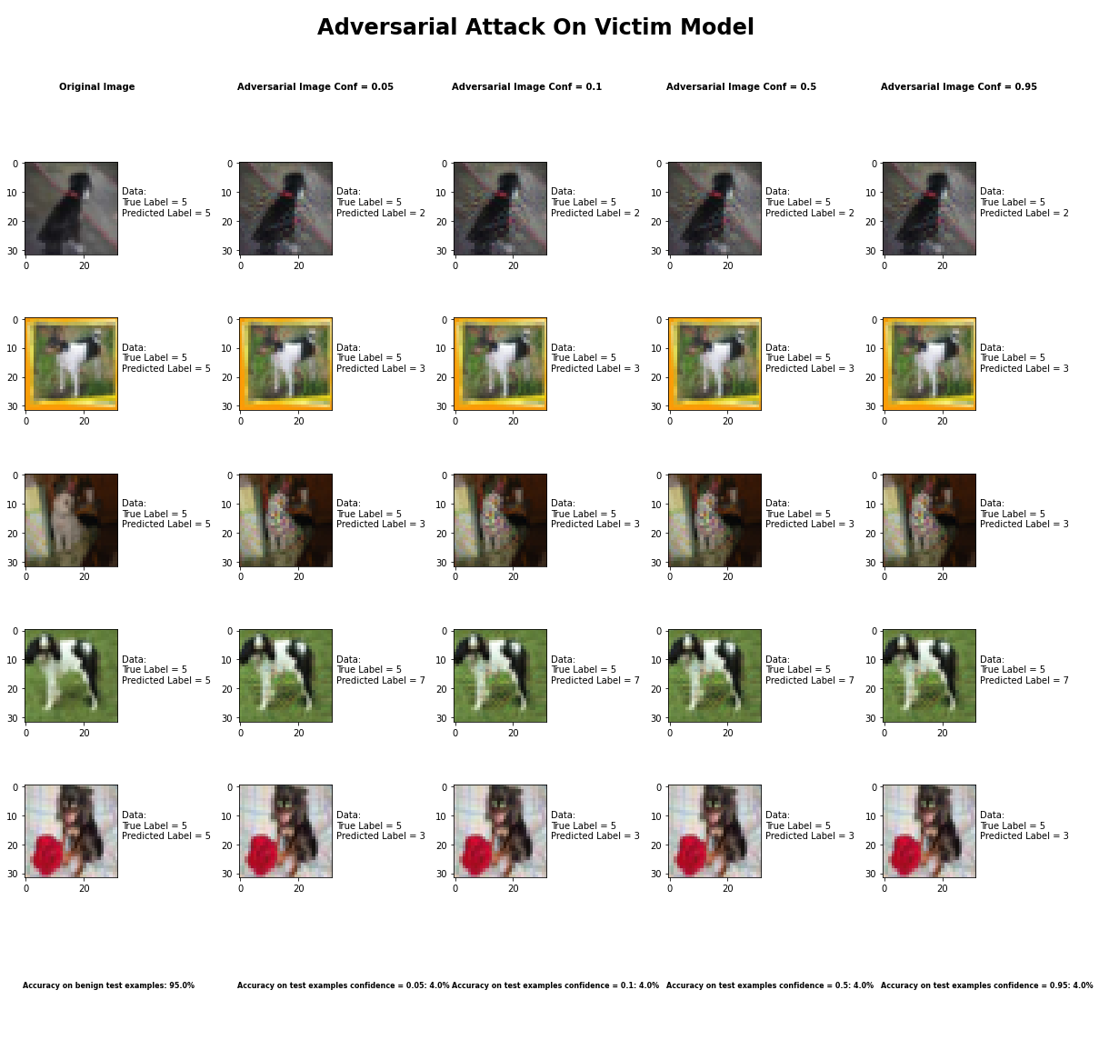

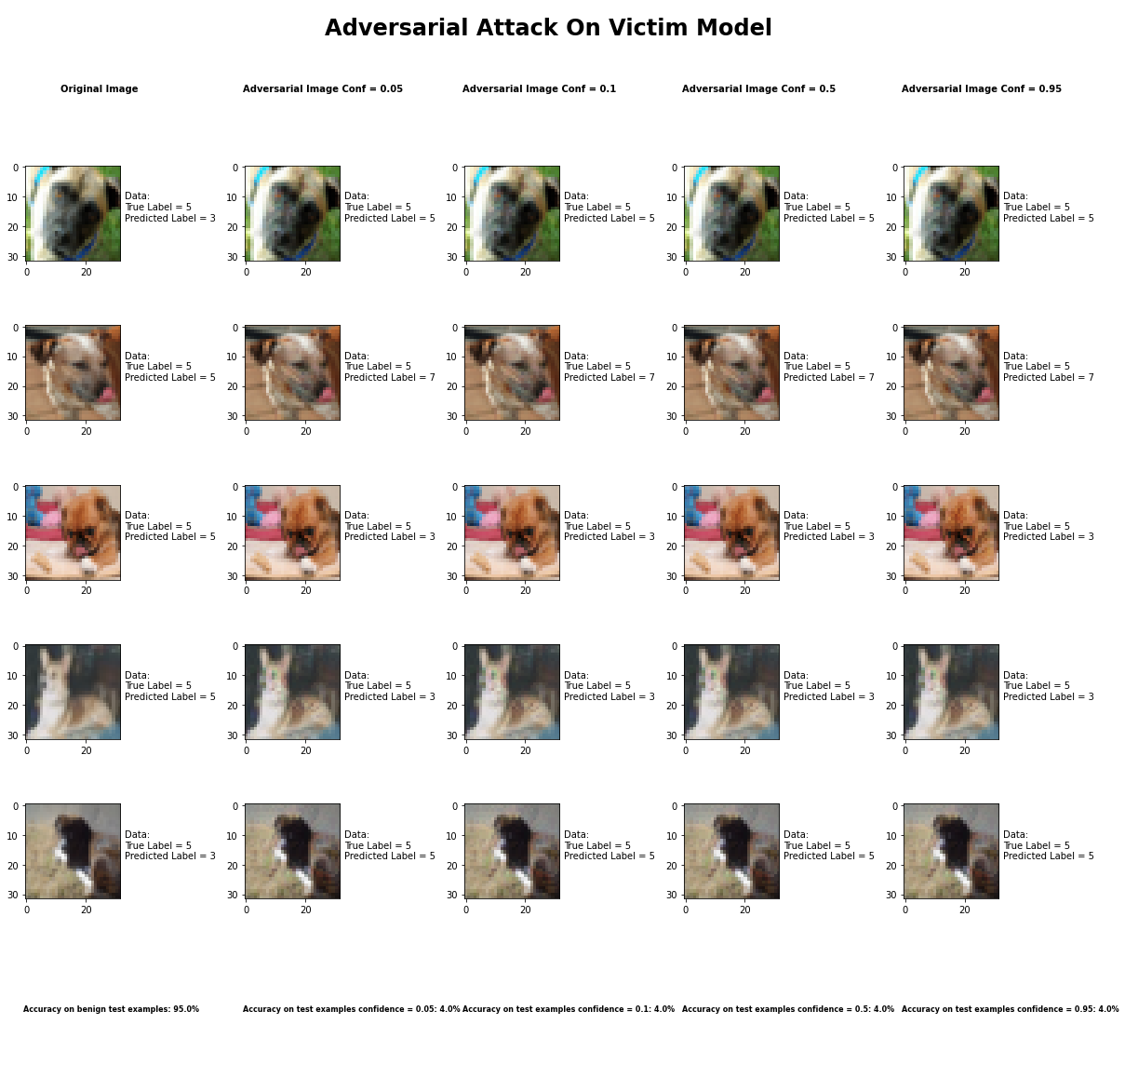

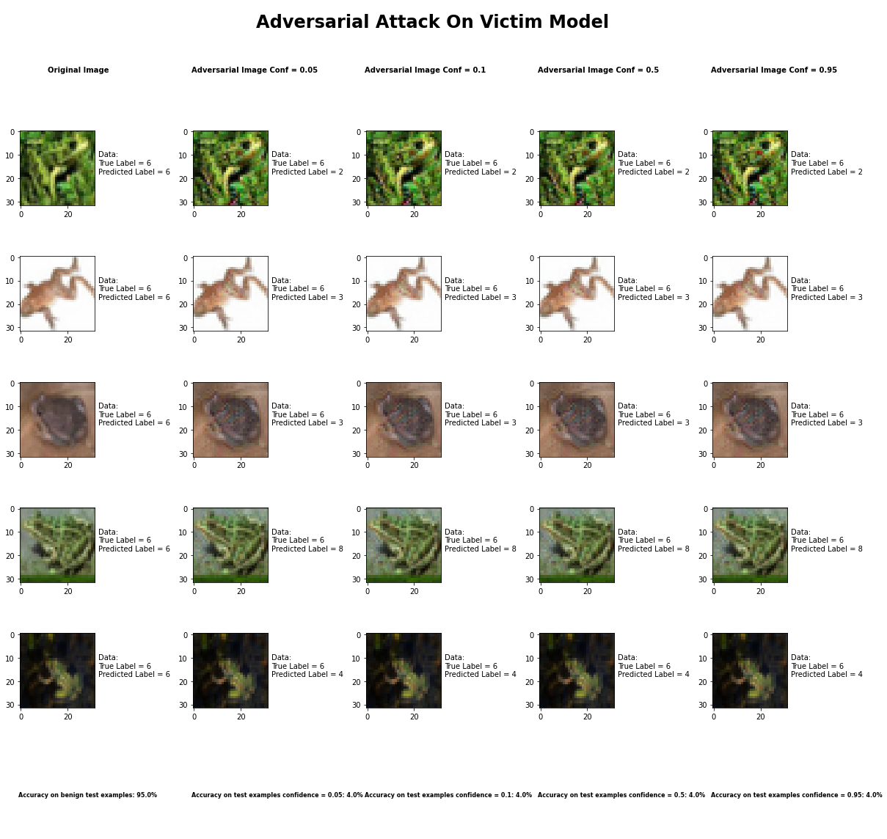

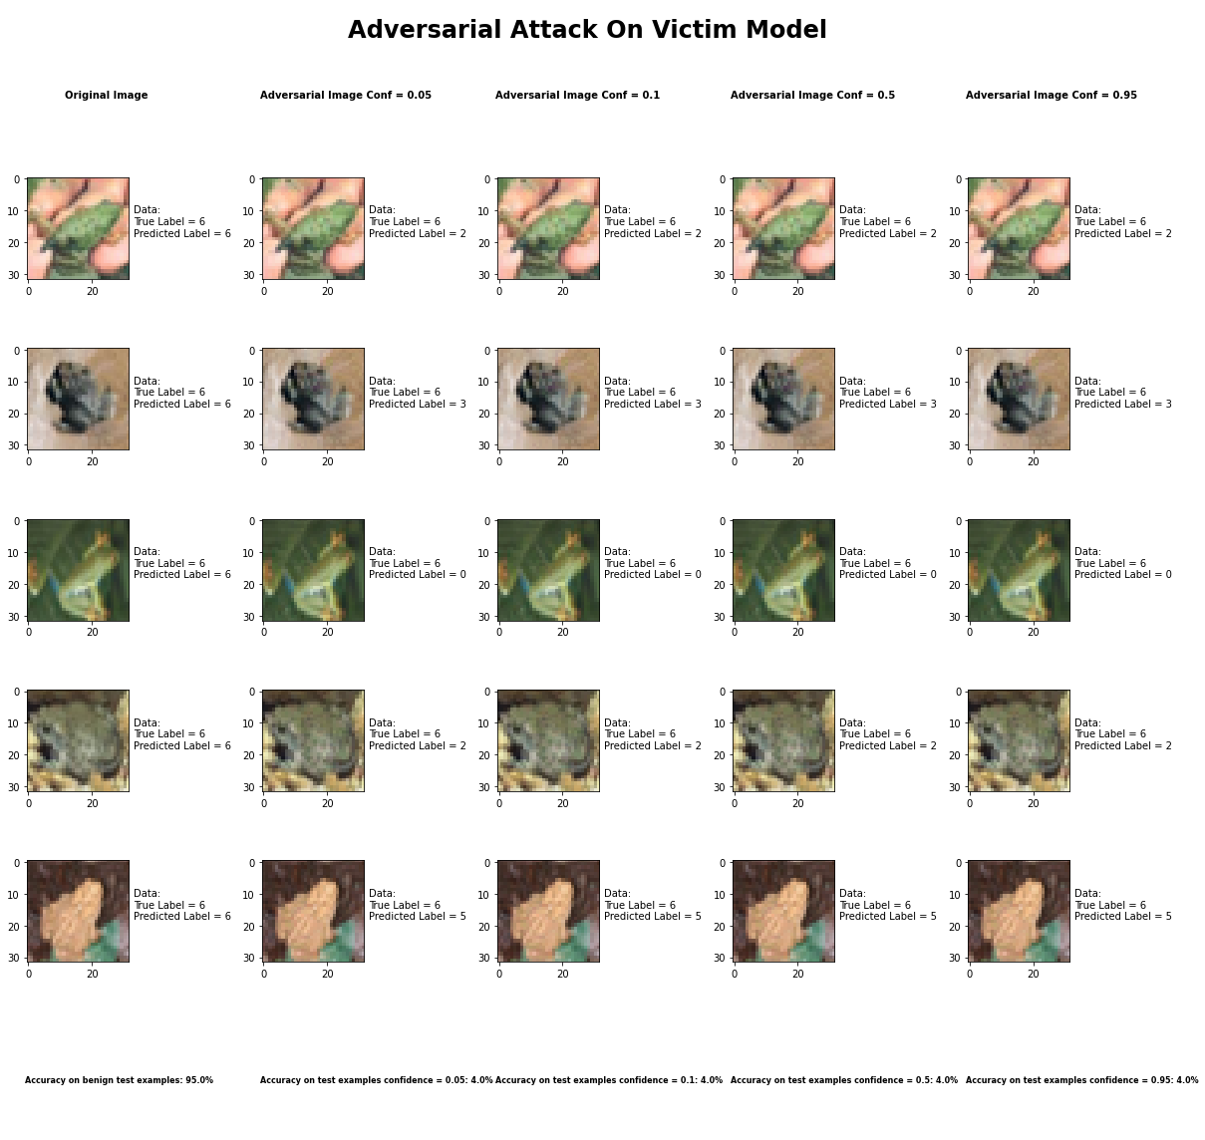

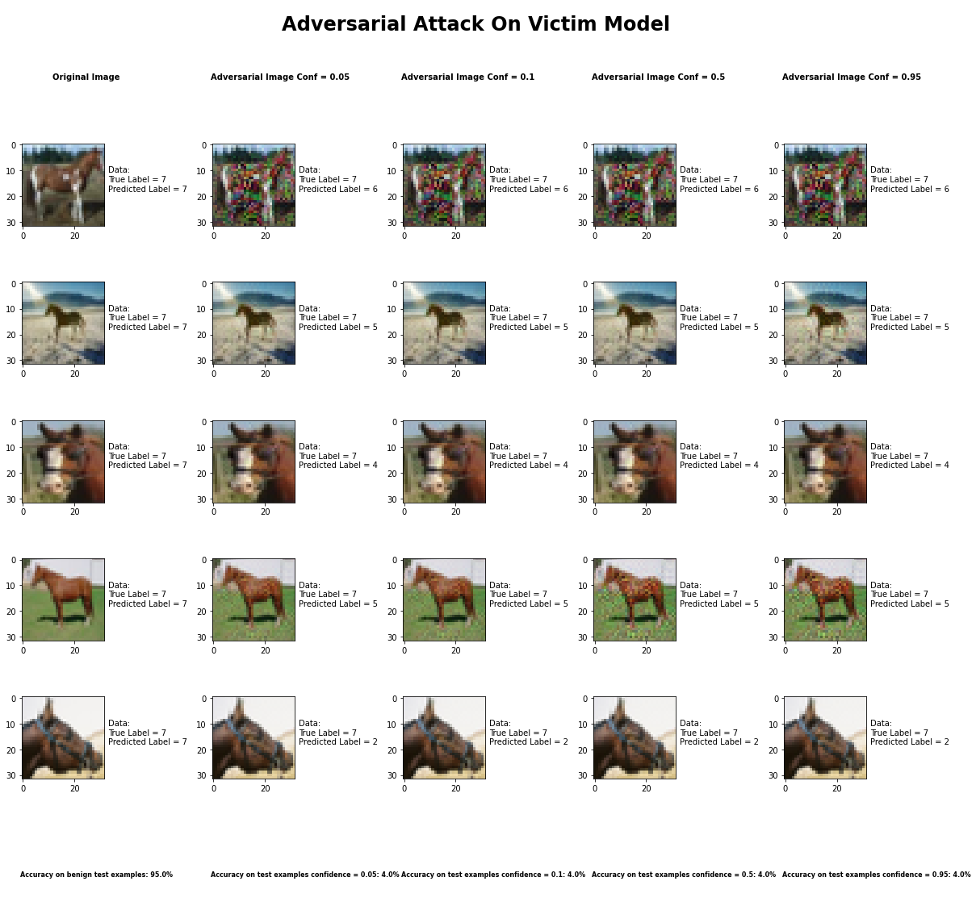

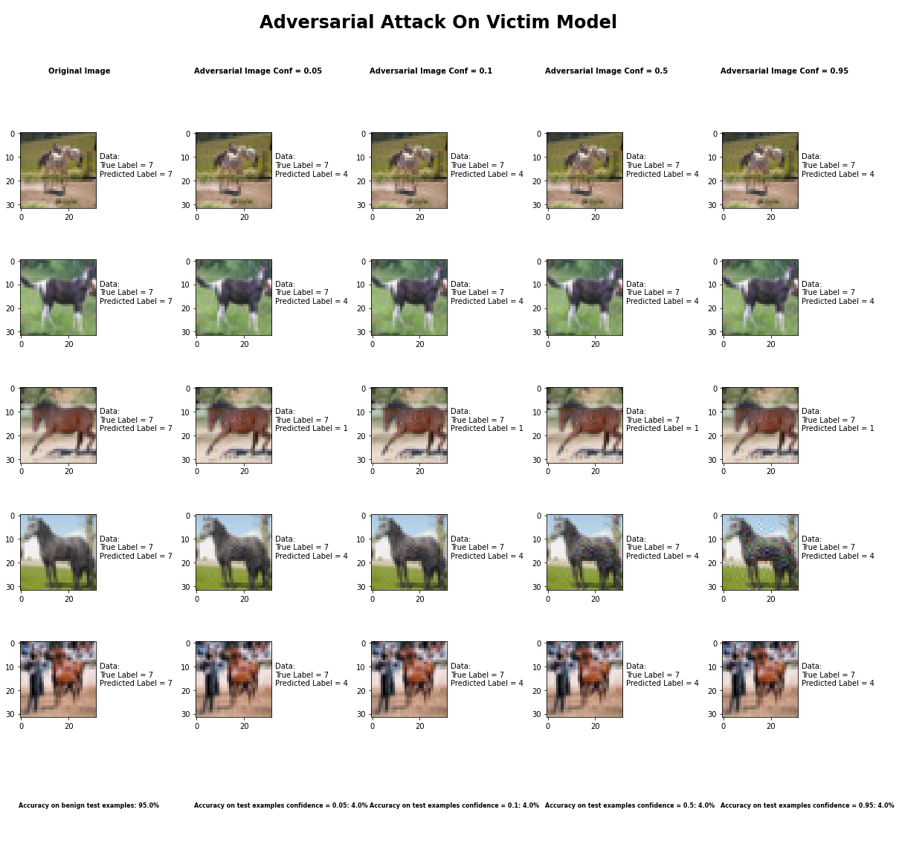

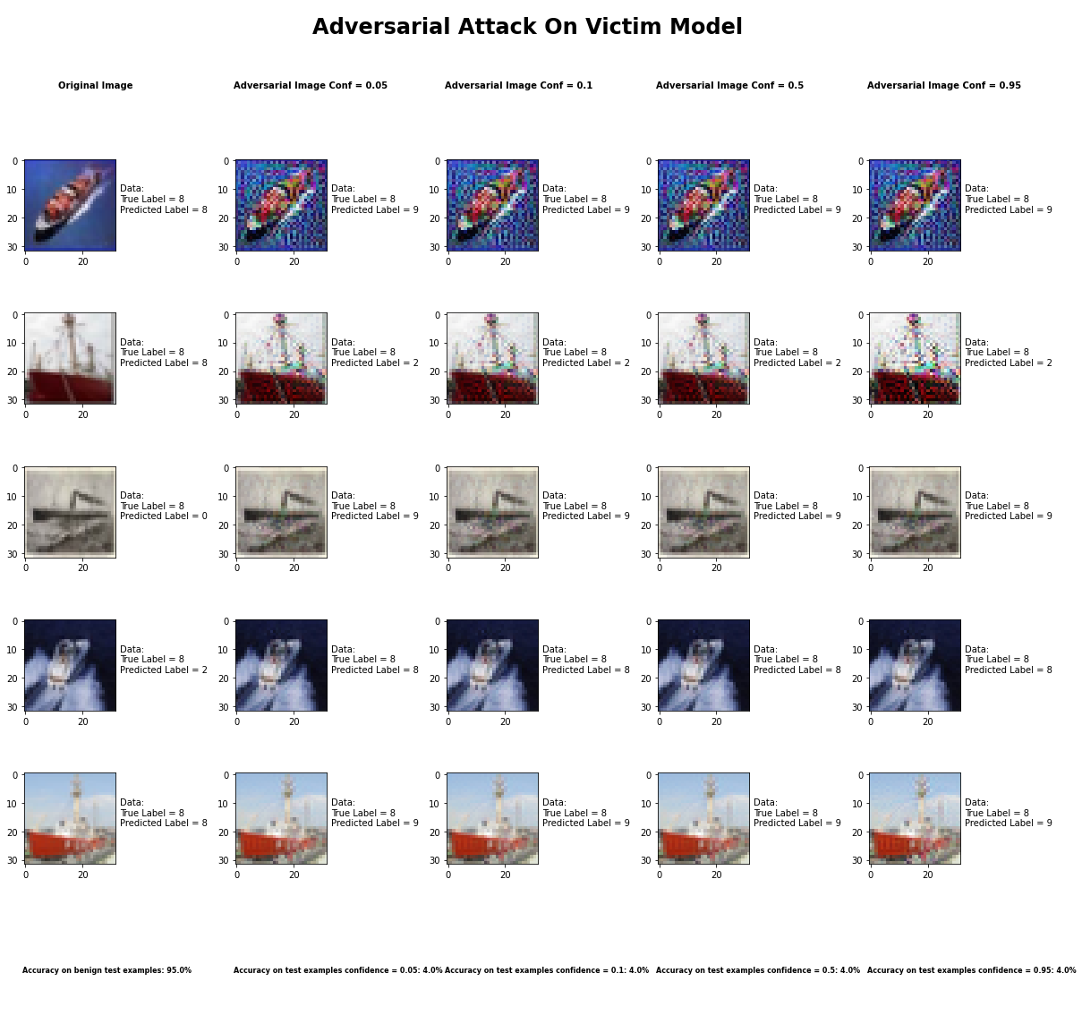

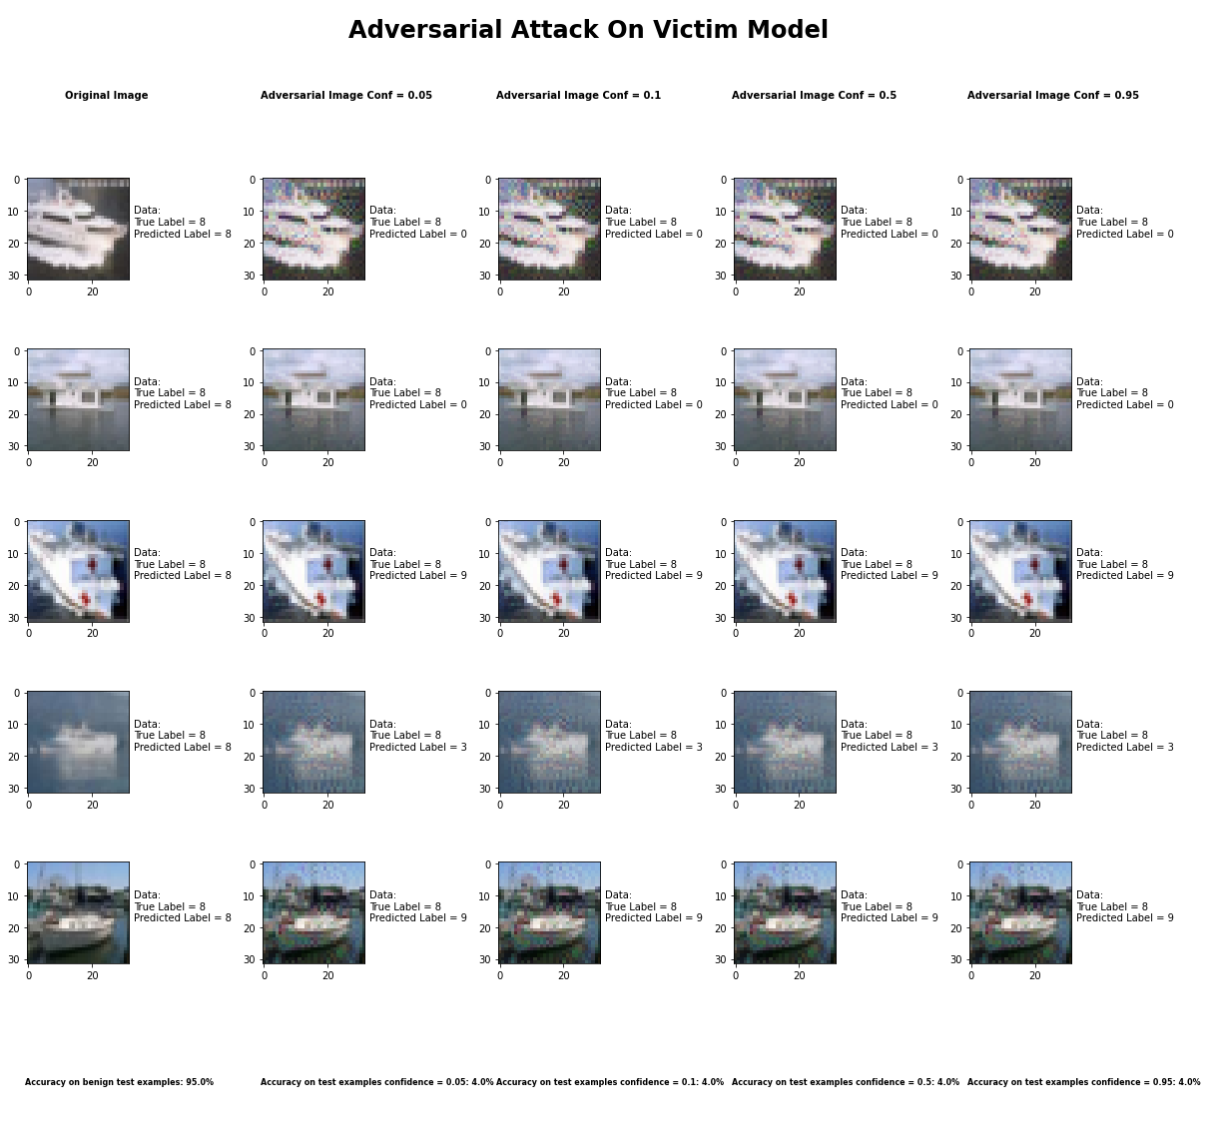

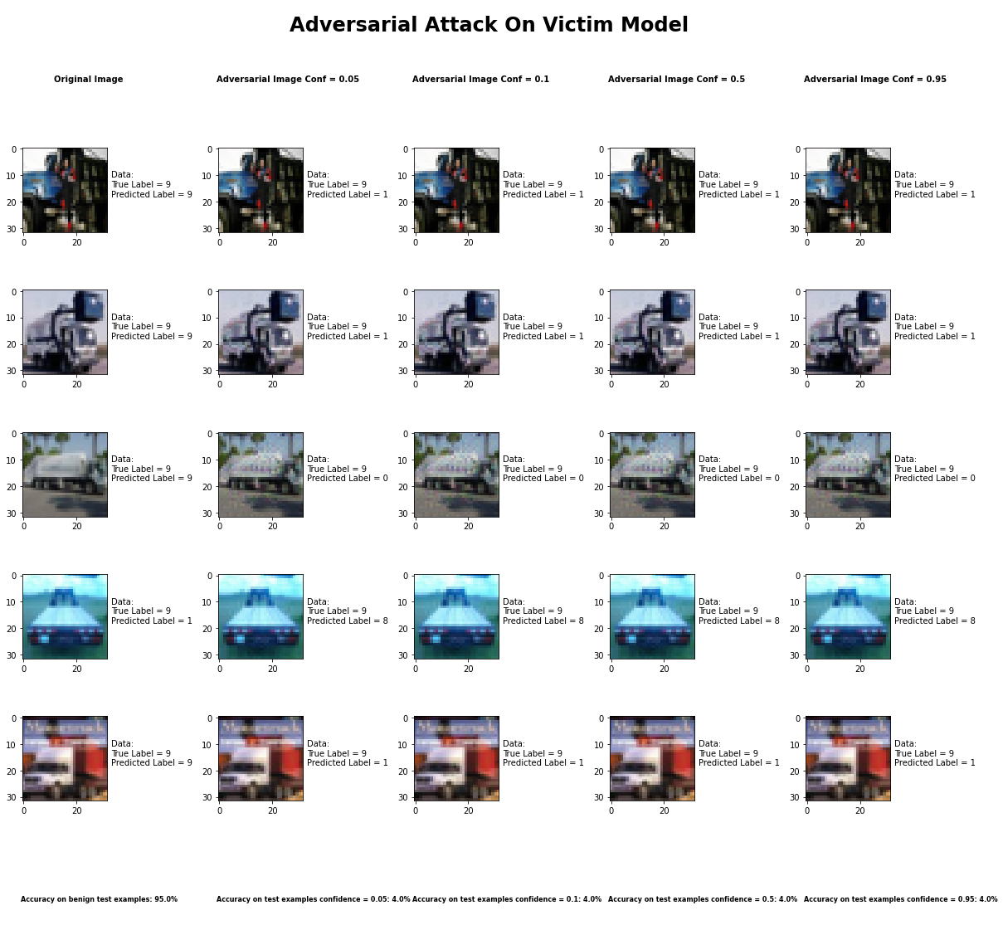

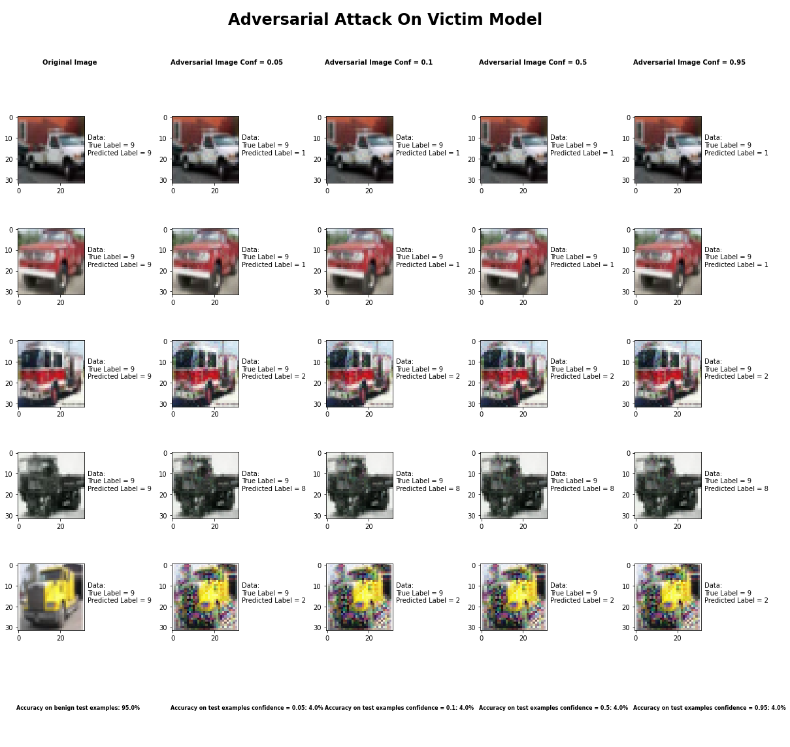

Accuracy on benign test examples: 94.52000000000001%

Average Accuracy on adversarial test examples with confidence = 0.05: 4.5%

Average Accuracy on adversarial test examples with confidence = 0.1: 4.5%

Average Accuracy on adversarial test examples with confidence = 0.5: 4.5%

Average Accuracy on adversarial test examples with confidence = 0.95: 4.5%

Classifier with benign example has Airplane recognition average accuracy of = 96%

Carlini L2 Method with confidence = 0.05 has Airplane recognition average accuracy of = 2%

Carlini L2 Method with confidence = 0.10 has Airplane recognition average accuracy of = 2%

Carlini L2 Method with confidence = 0.50 has Airplane recognition average accuracy of = 2%

Carlini L2 Method with confidence = 0.95 has Airplane recognition average accuracy of = 2%

Classifier with benign example has Automobile recognition average accuracy of = 99%

Carlini L2 Method with confidence = 0.05 has Automobile recognition average accuracy of = 0%

Carlini L2 Method with confidence = 0.10 has Automobile recognition average accuracy of = 0%

Carlini L2 Method with confidence = 0.50 has Automobile recognition average accuracy of = 0%

Carlini L2 Method with confidence = 0.95 has Automobile recognition average accuracy of = 0%

Classifier with benign example has Bird recognition average accuracy of = 93%

Carlini L2 Method with confidence = 0.05 has Bird recognition average accuracy of = 7%

Carlini L2 Method with confidence = 0.10 has Bird recognition average accuracy of = 7%

Carlini L2 Method with confidence = 0.50 has Bird recognition average accuracy of = 7%

Carlini L2 Method with confidence = 0.95 has Bird recognition average accuracy of = 7%

Classifier with benign example has Cat recognition average accuracy of = 83%

Carlini L2 Method with confidence = 0.05 has Cat recognition average accuracy of = 13%

Carlini L2 Method with confidence = 0.10 has Cat recognition average accuracy of = 13%

Carlini L2 Method with confidence = 0.50 has Cat recognition average accuracy of = 13%

Carlini L2 Method with confidence = 0.95 has Cat recognition average accuracy of = 13%

Classifier with benign example has Deer recognition average accuracy of = 97%

Carlini L2 Method with confidence = 0.05 has Deer recognition average accuracy of = 2%

Carlini L2 Method with confidence = 0.10 has Deer recognition average accuracy of = 2%

Carlini L2 Method with confidence = 0.50 has Deer recognition average accuracy of = 2%

Carlini L2 Method with confidence = 0.95 has Deer recognition average accuracy of = 2%

Classifier with benign example has Dog recognition average accuracy of = 89%

Carlini L2 Method with confidence = 0.05 has Dog recognition average accuracy of = 8%

Carlini L2 Method with confidence = 0.10 has Dog recognition average accuracy of = 8%

Carlini L2 Method with confidence = 0.50 has Dog recognition average accuracy of = 8%

Carlini L2 Method with confidence = 0.95 has Dog recognition average accuracy of = 8%

Classifier with benign example has Frog recognition average accuracy of = 100%

Carlini L2 Method with confidence = 0.05 has Frog recognition average accuracy of = 0%

Carlini L2 Method with confidence = 0.10 has Frog recognition average accuracy of = 0%

Carlini L2 Method with confidence = 0.50 has Frog recognition average accuracy of = 0%

Carlini L2 Method with confidence = 0.95 has Frog recognition average accuracy of = 0%

Classifier with benign example has Horse recognition average accuracy of = 95%

Carlini L2 Method with confidence = 0.05 has Horse recognition average accuracy of = 2%

Carlini L2 Method with confidence = 0.10 has Horse recognition average accuracy of = 2%

Carlini L2 Method with confidence = 0.50 has Horse recognition average accuracy of = 2%

Carlini L2 Method with confidence = 0.95 has Horse recognition average accuracy of = 2%

Classifier with benign example has Ship recognition average accuracy of = 93%

Carlini L2 Method with confidence = 0.05 has Ship recognition average accuracy of = 5%

Carlini L2 Method with confidence = 0.10 has Ship recognition average accuracy of = 5%

Carlini L2 Method with confidence = 0.50 has Ship recognition average accuracy of = 5%

Carlini L2 Method with confidence = 0.95 has Ship recognition average accuracy of = 5%

Classifier with benign example has Truck recognition average accuracy of = 92%

Carlini L2 Method with confidence = 0.05 has Truck recognition average accuracy of = 6%

Carlini L2 Method with confidence = 0.10 has Truck recognition average accuracy of = 6%

Carlini L2 Method with confidence = 0.50 has Truck recognition average accuracy of = 6%

Carlini L2 Method with confidence = 0.95 has Truck recognition average accuracy of = 6%

## Carlini L2 Method



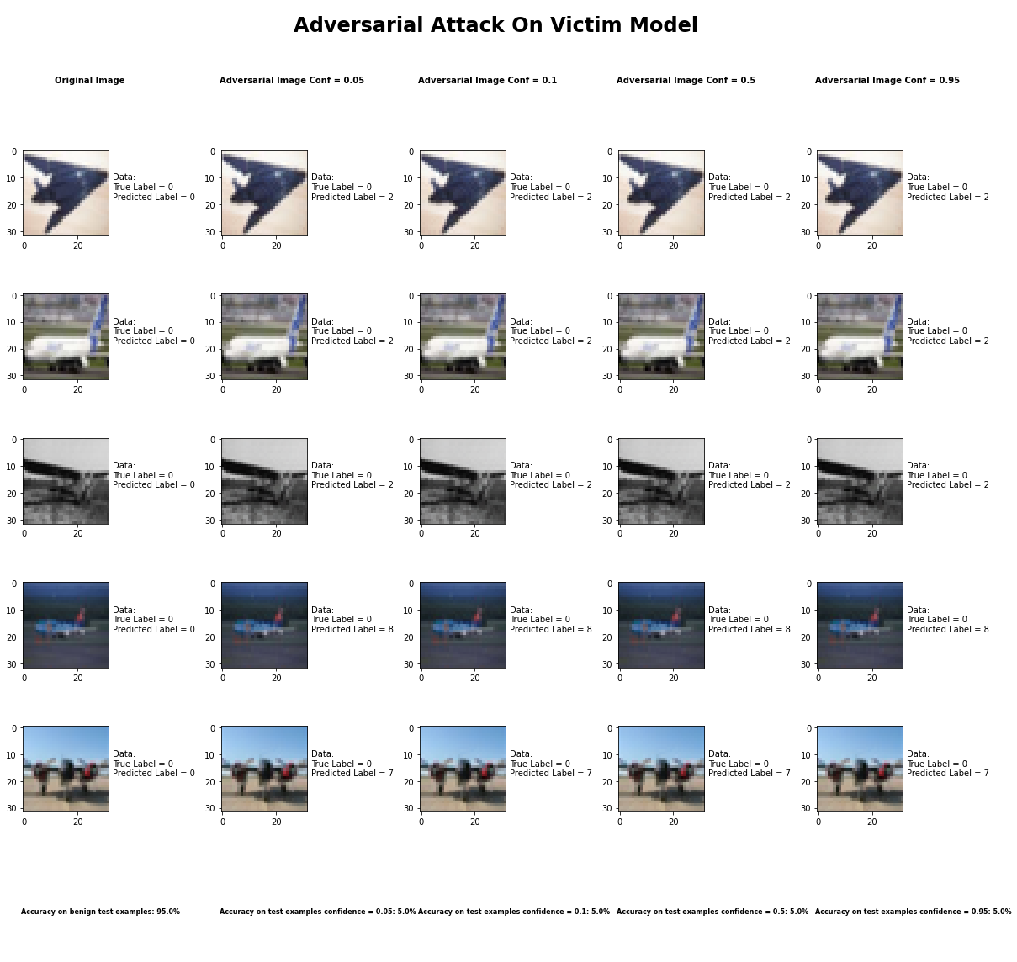

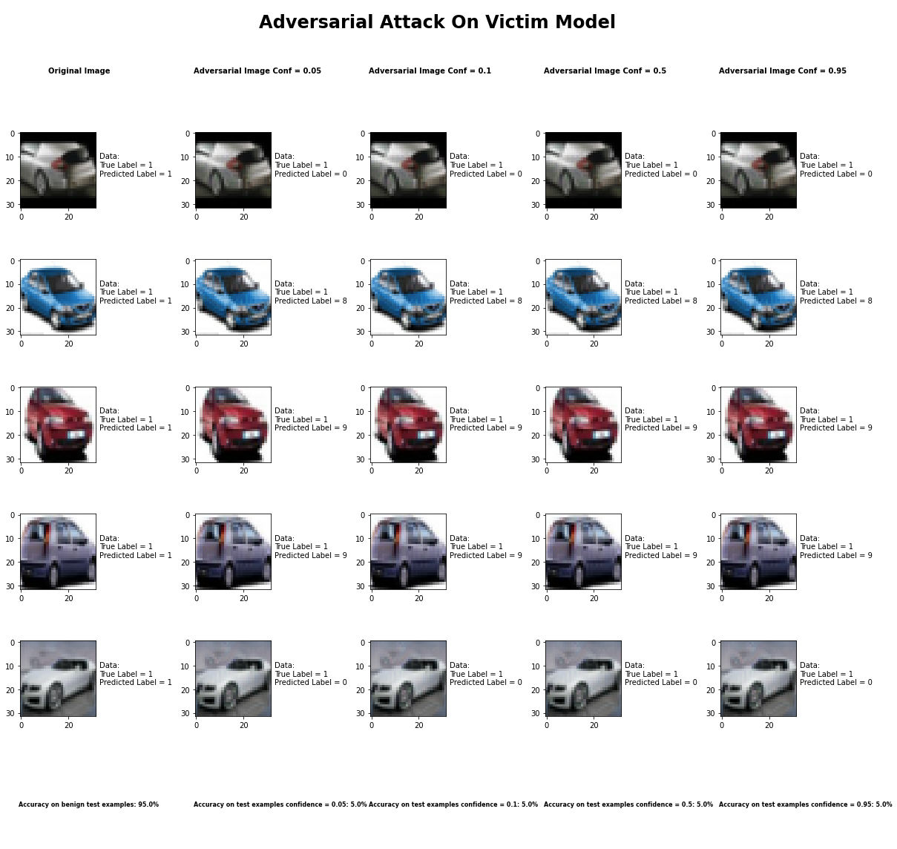

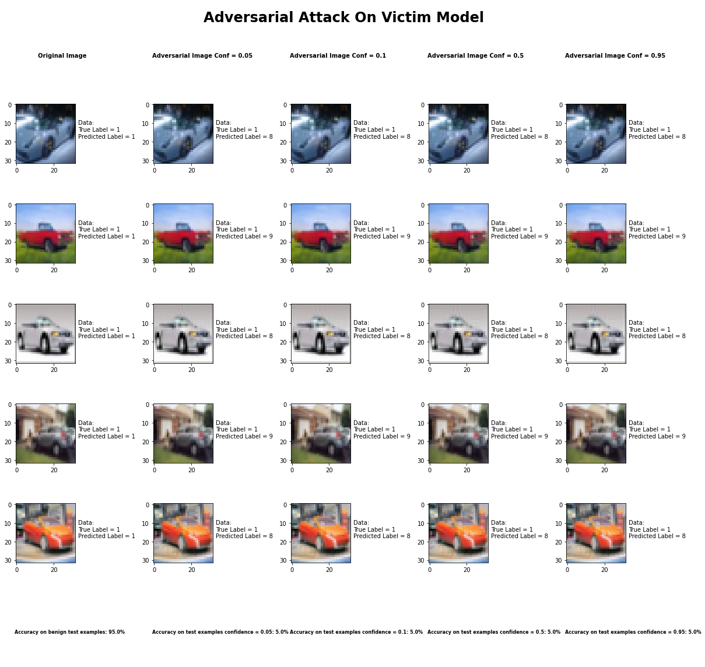

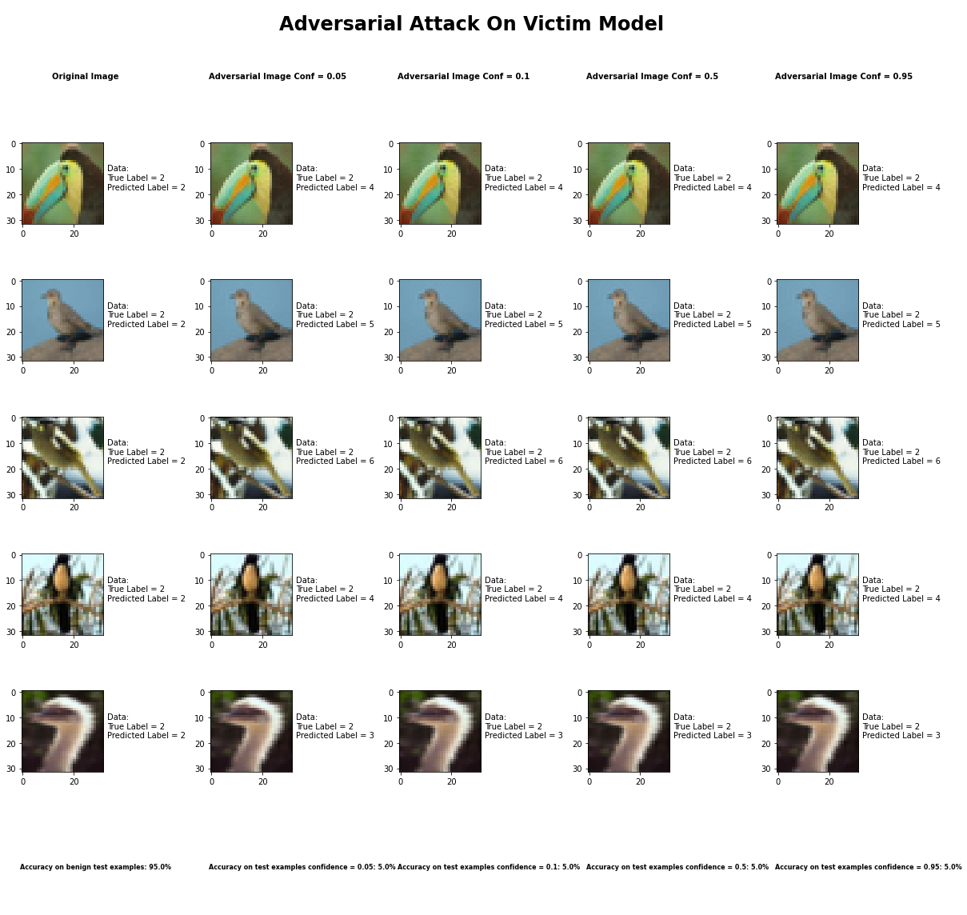

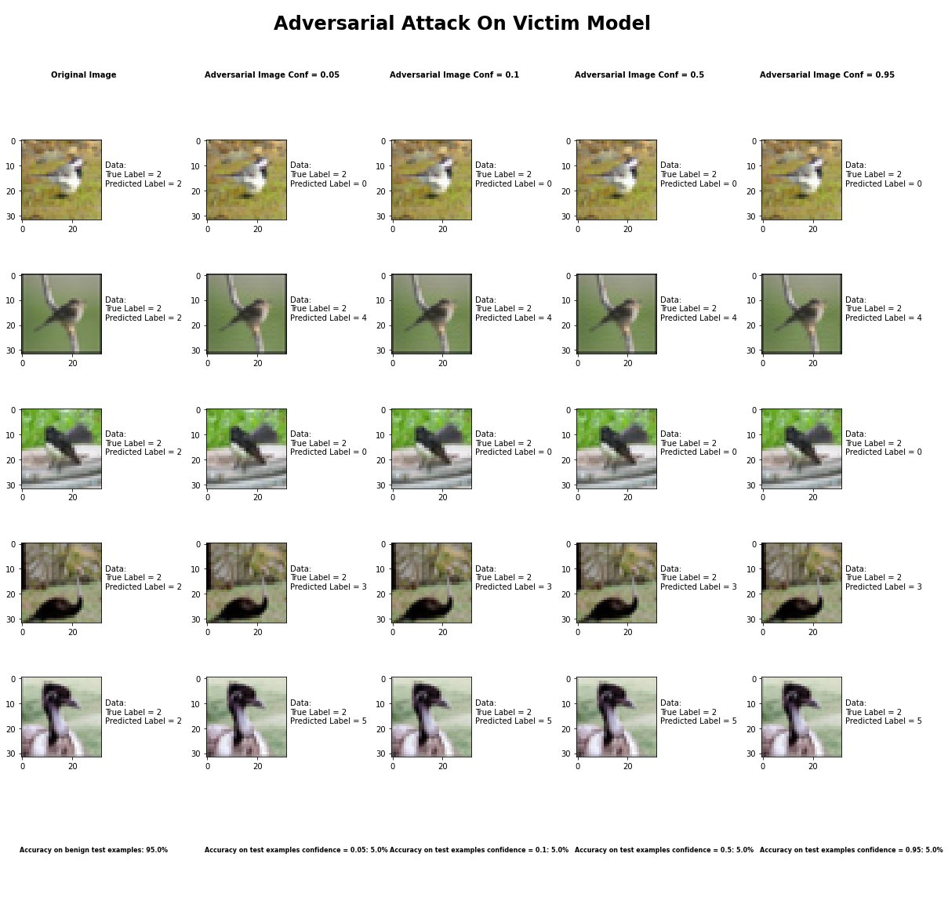

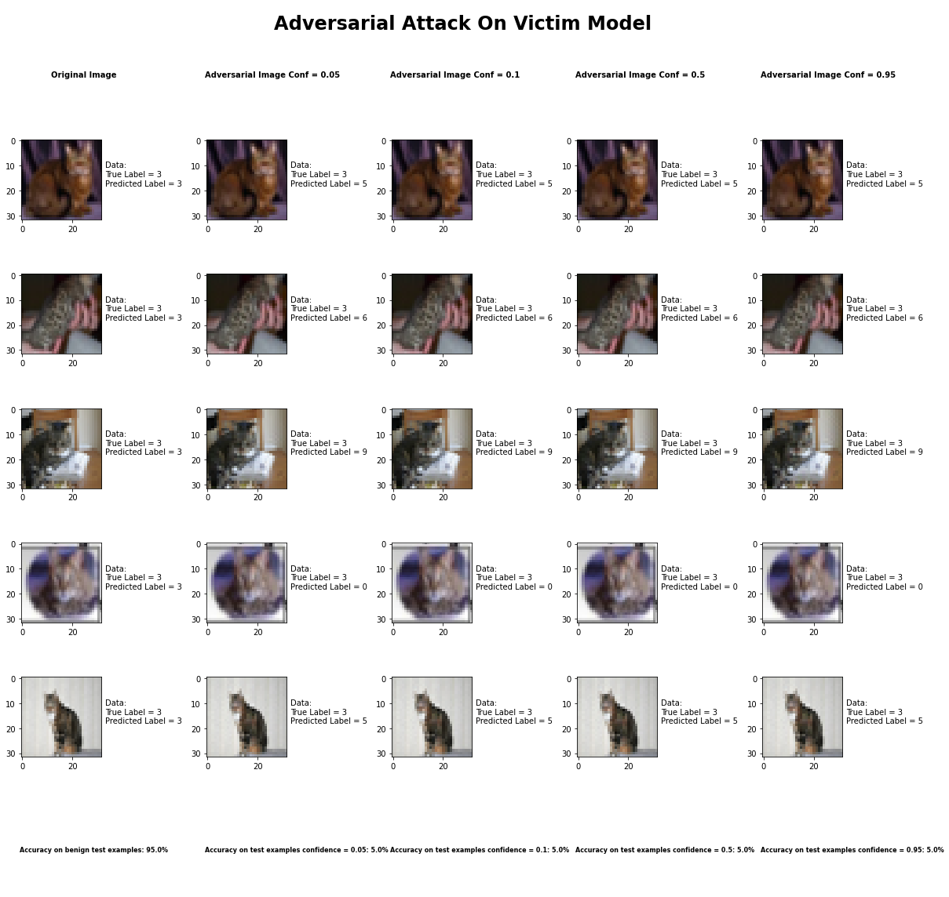

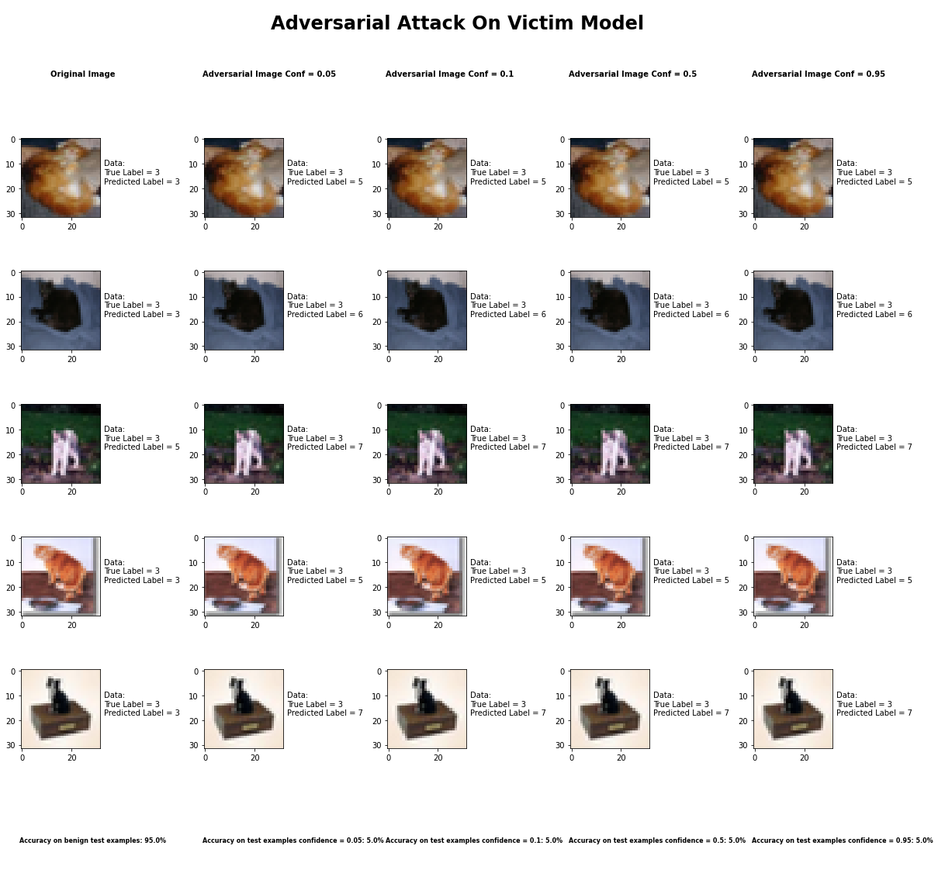

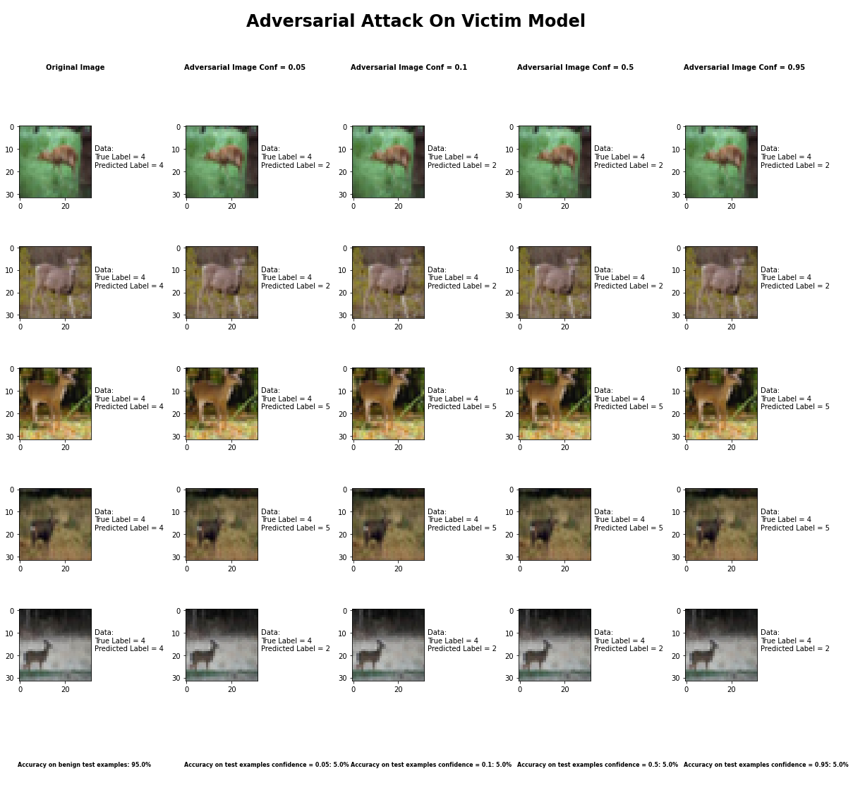

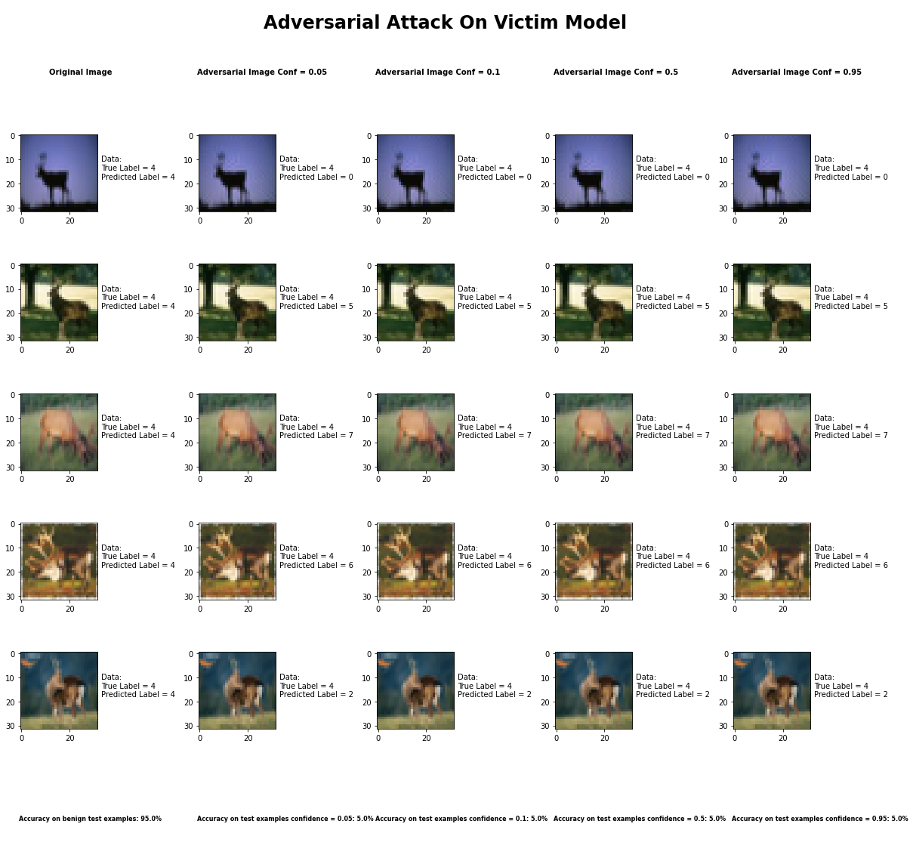

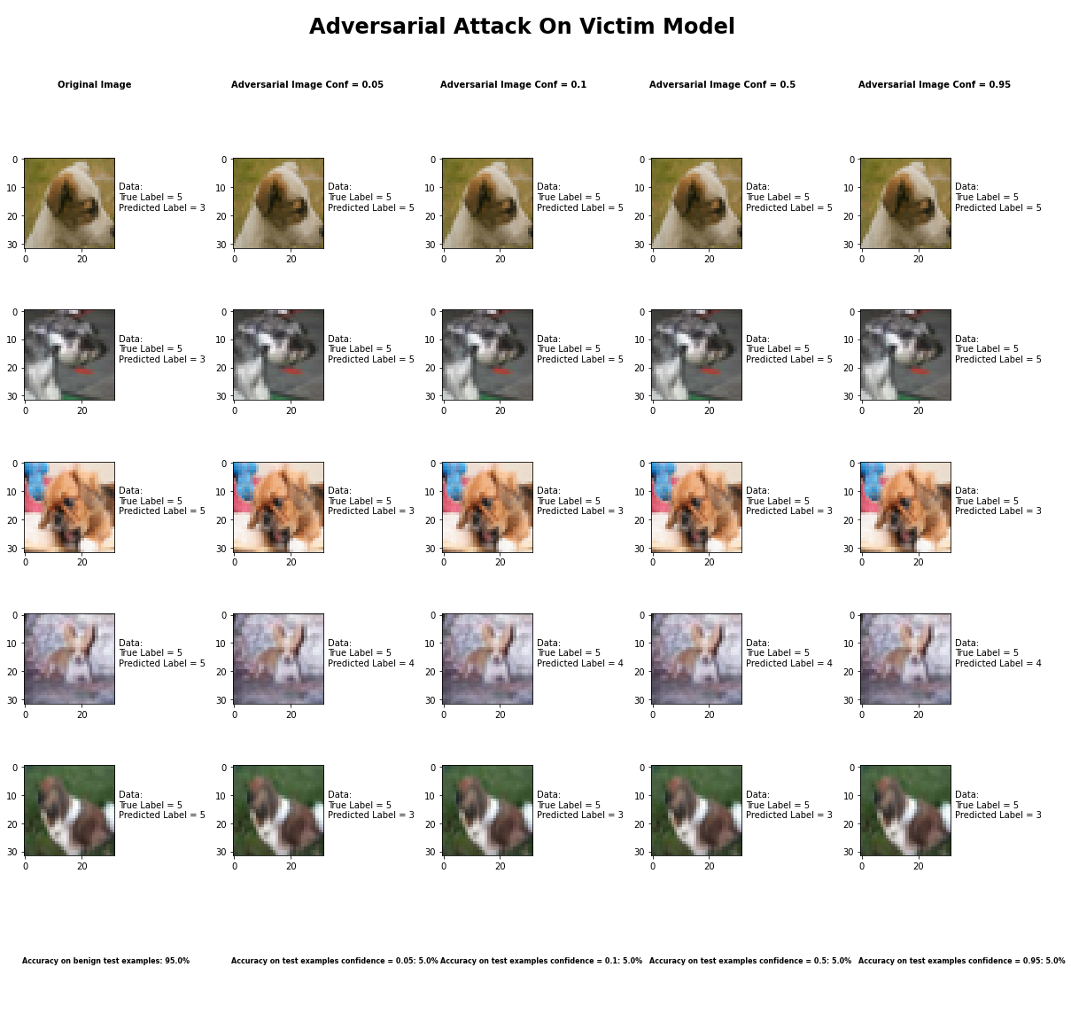

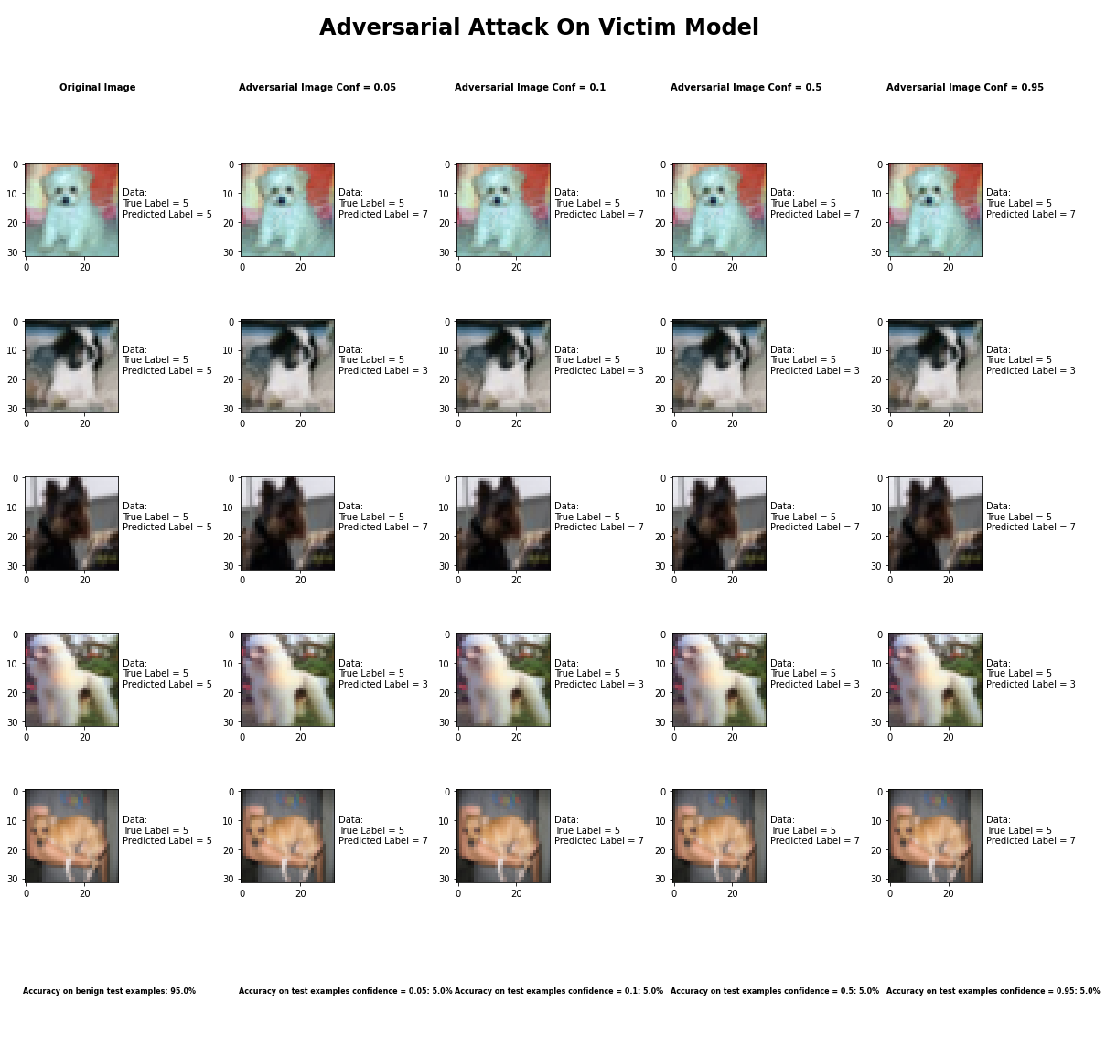

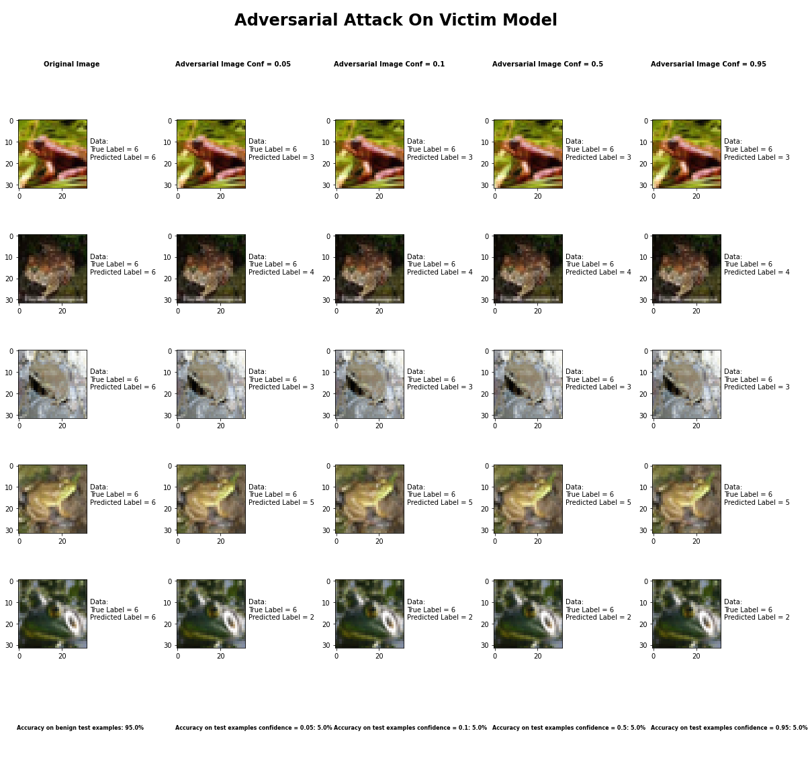

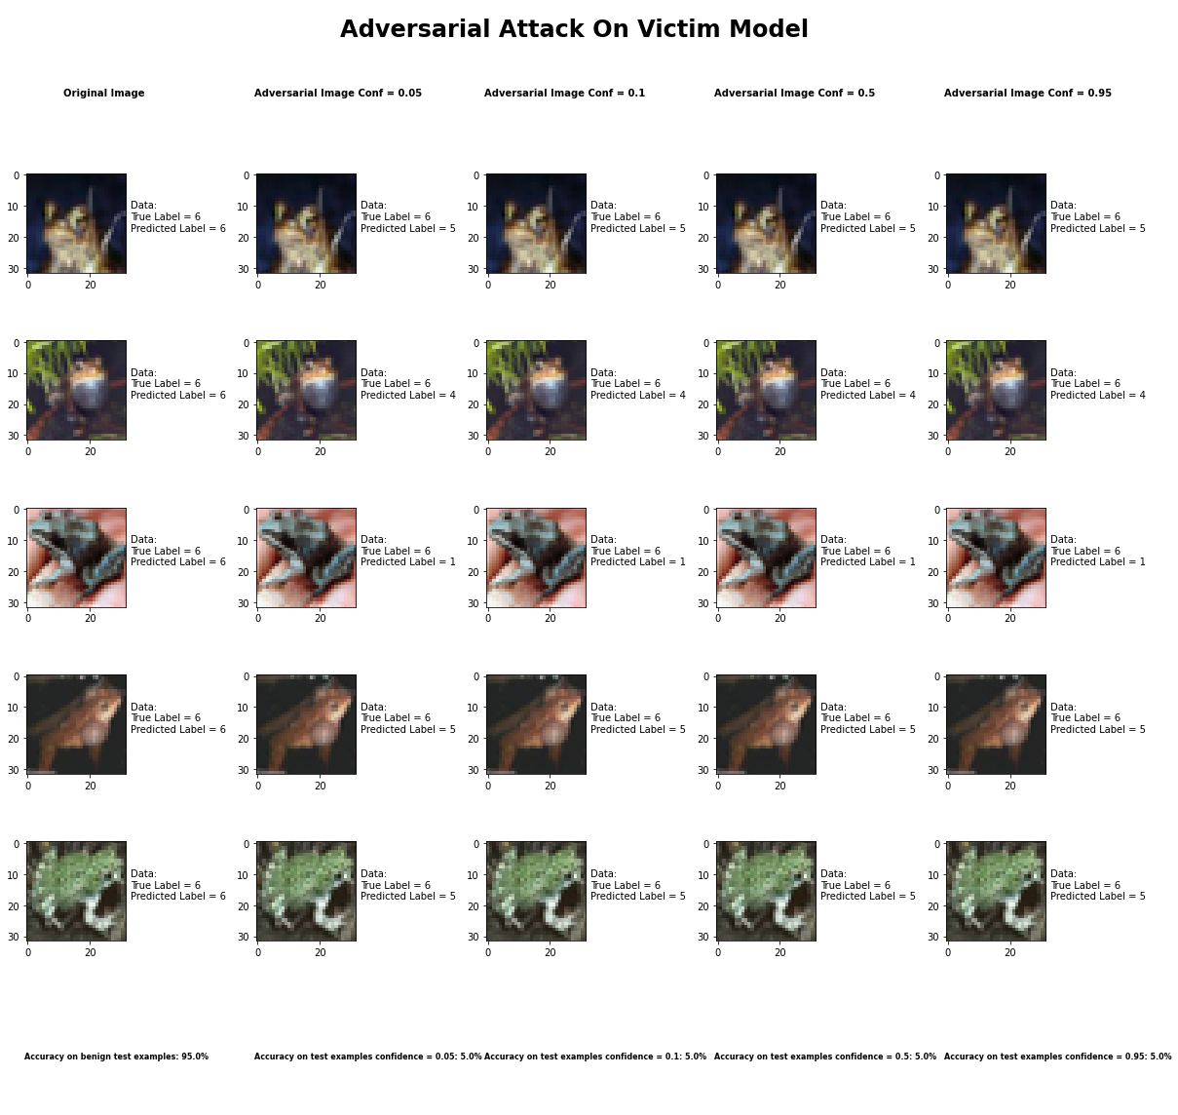

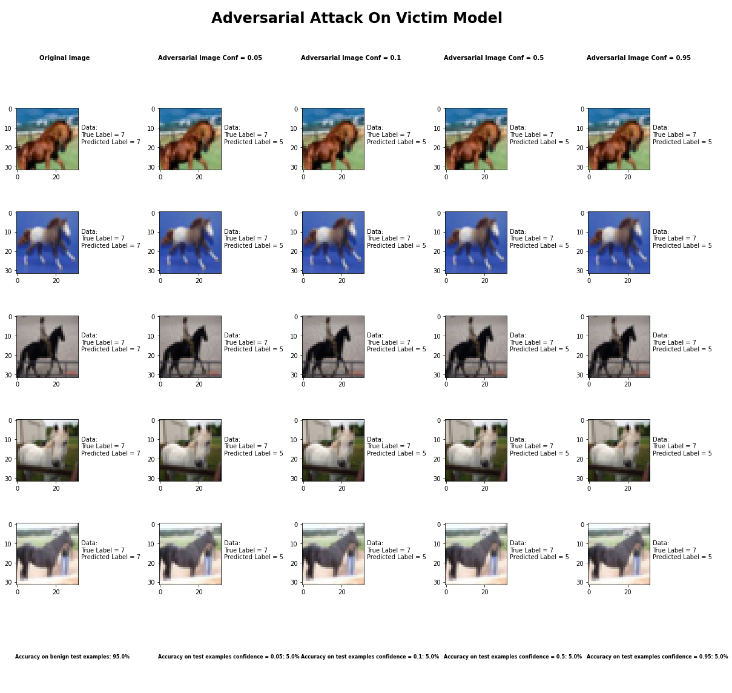

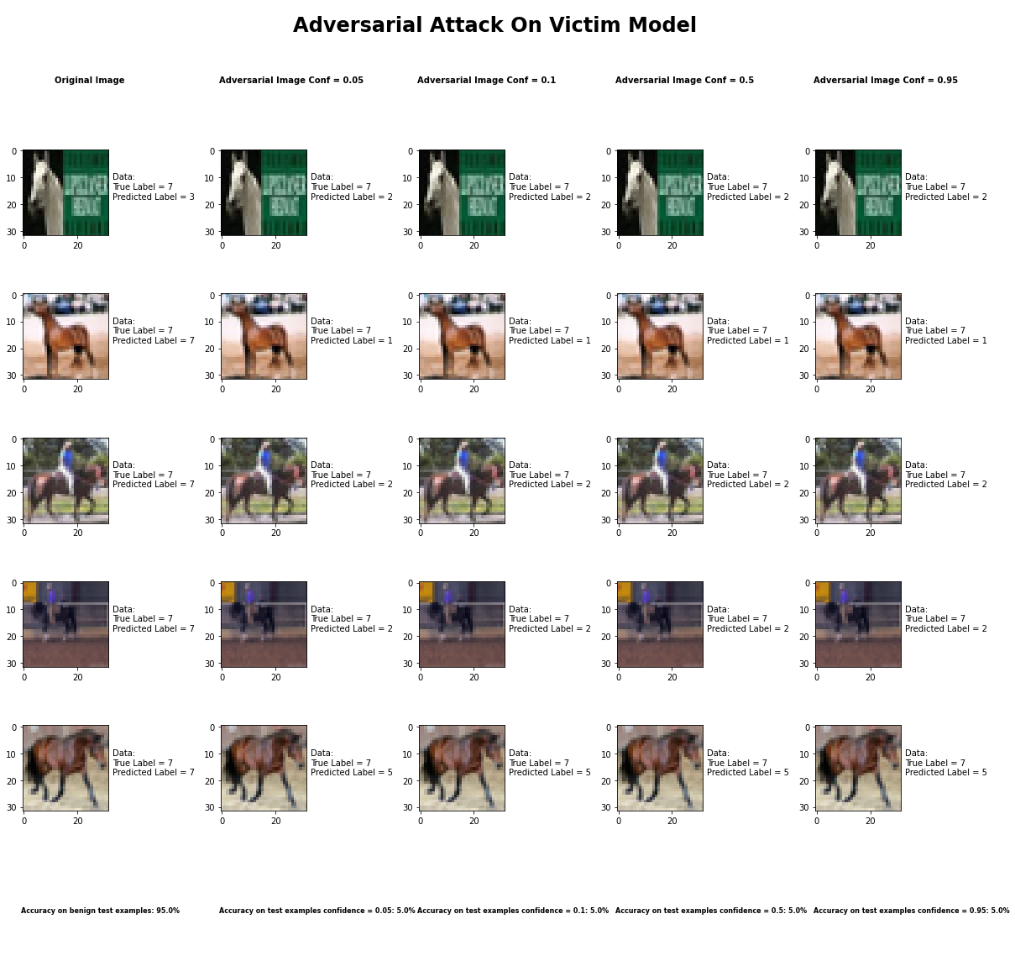

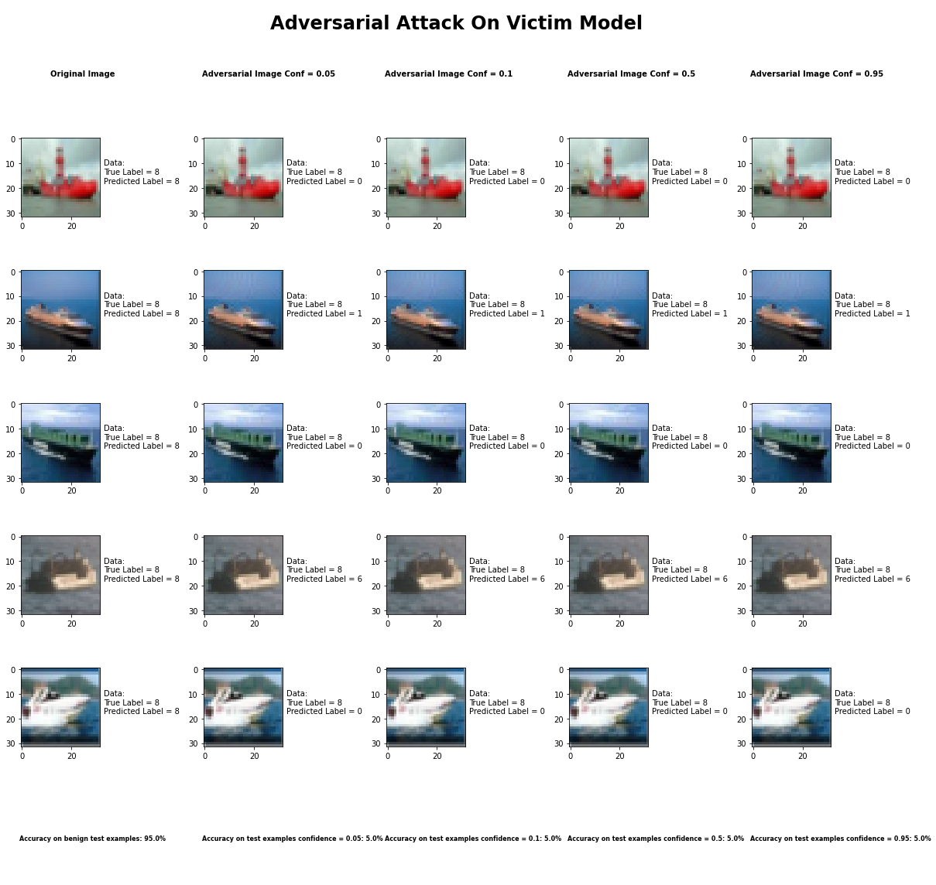

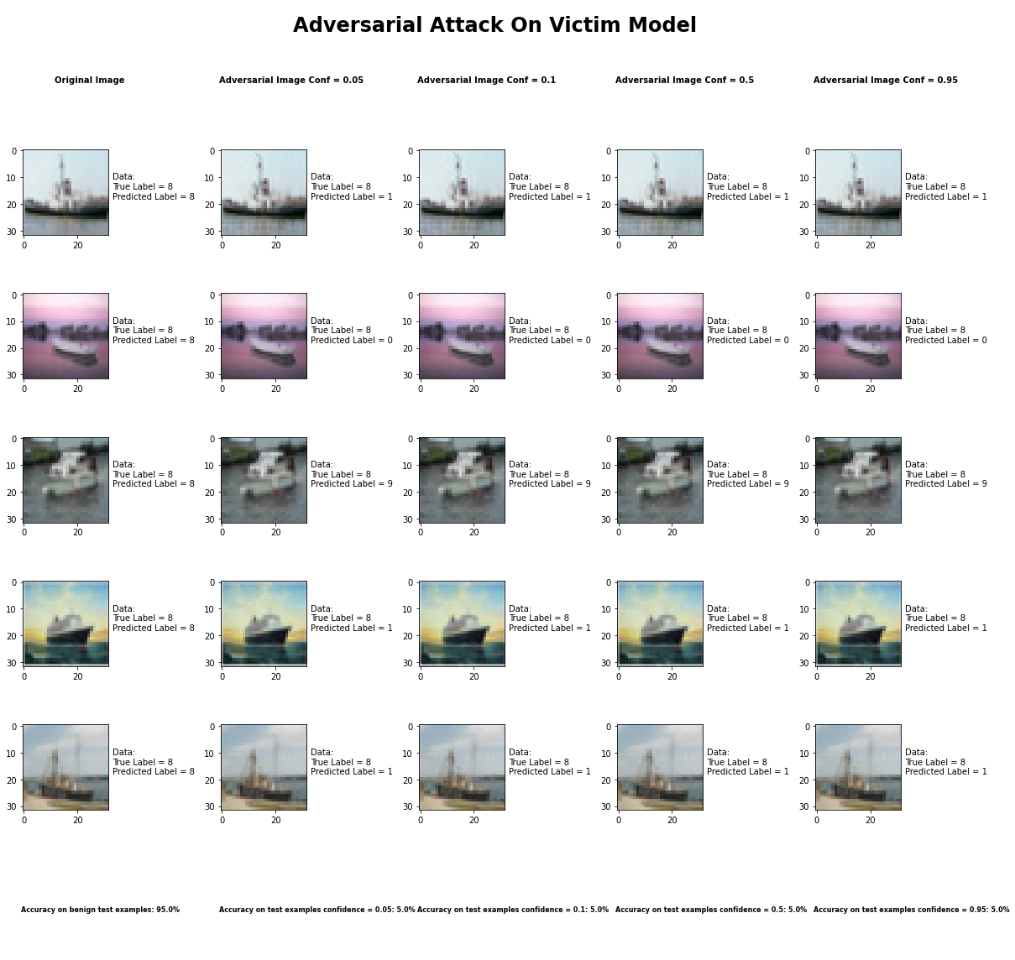

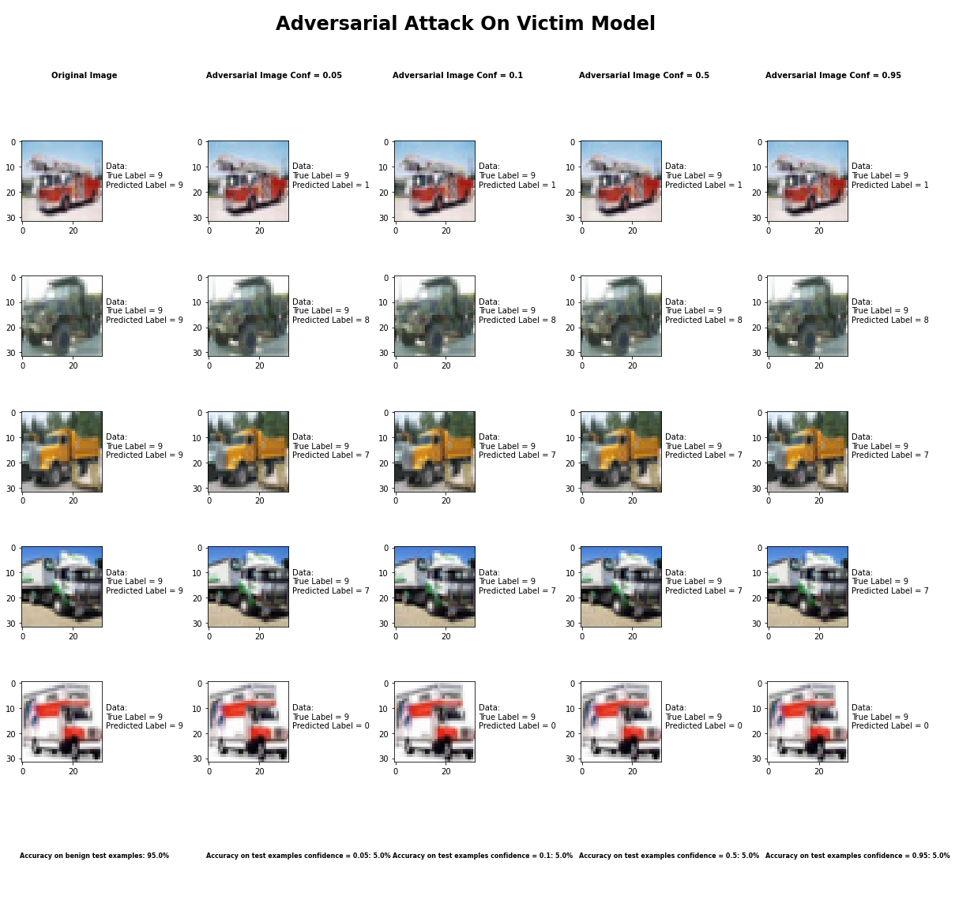

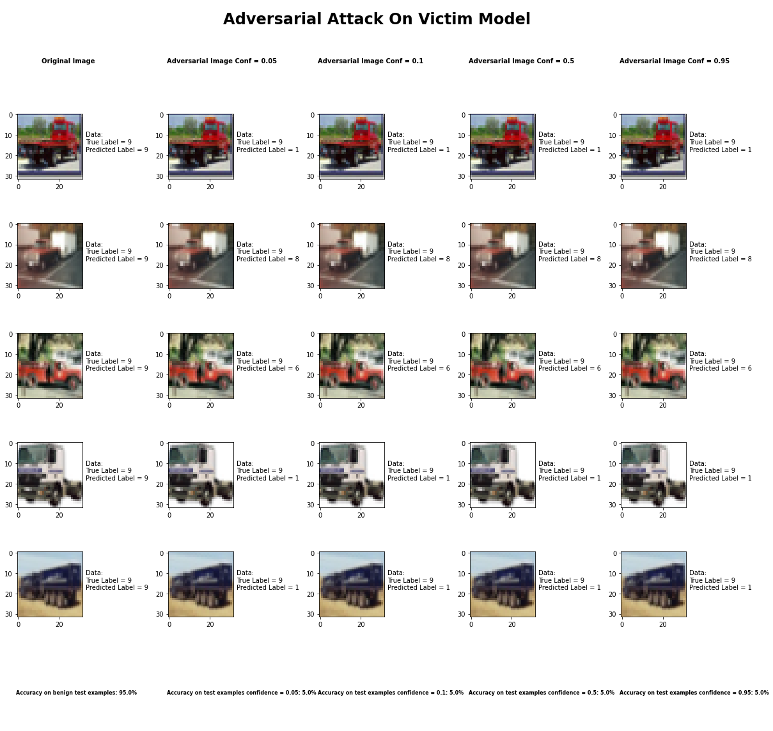

Accuracy on benign test examples: 94.52000000000001%

Average Accuracy on adversarial test examples with confidence = 0.05: 4.8%

Average Accuracy on adversarial test examples with confidence = 0.1: 4.8%

Average Accuracy on adversarial test examples with confidence = 0.5: 4.8%

Average Accuracy on adversarial test examples with confidence = 0.95: 4.8%

Classifier with benign example has Airplane recognition average accuracy of = 97%

Carlini L2 Method with confidence = 0.05 has Airplane recognition average accuracy of = 1%

Carlini L2 Method with confidence = 0.10 has Airplane recognition average accuracy of = 1%

Carlini L2 Method with confidence = 0.50 has Airplane recognition average accuracy of = 1%

Carlini L2 Method with confidence = 0.95 has Airplane recognition average accuracy of = 1%

Classifier with benign example has Automobile recognition average accuracy of = 97%

Carlini L2 Method with confidence = 0.05 has Automobile recognition average accuracy of = 2%

Carlini L2 Method with confidence = 0.10 has Automobile recognition average accuracy of = 2%

Carlini L2 Method with confidence = 0.50 has Automobile recognition average accuracy of = 2%

Carlini L2 Method with confidence = 0.95 has Automobile recognition average accuracy of = 2%

Classifier with benign example has Bird recognition average accuracy of = 91%

Carlini L2 Method with confidence = 0.05 has Bird recognition average accuracy of = 6%

Carlini L2 Method with confidence = 0.10 has Bird recognition average accuracy of = 6%

Carlini L2 Method with confidence = 0.50 has Bird recognition average accuracy of = 6%

Carlini L2 Method with confidence = 0.95 has Bird recognition average accuracy of = 6%

Classifier with benign example has Cat recognition average accuracy of = 83%

Carlini L2 Method with confidence = 0.05 has Cat recognition average accuracy of = 8%

Carlini L2 Method with confidence = 0.10 has Cat recognition average accuracy of = 8%

Carlini L2 Method with confidence = 0.50 has Cat recognition average accuracy of = 8%

Carlini L2 Method with confidence = 0.95 has Cat recognition average accuracy of = 8%

Classifier with benign example has Deer recognition average accuracy of = 89%

Carlini L2 Method with confidence = 0.05 has Deer recognition average accuracy of = 9%

Carlini L2 Method with confidence = 0.10 has Deer recognition average accuracy of = 9%

Carlini L2 Method with confidence = 0.50 has Deer recognition average accuracy of = 9%

Carlini L2 Method with confidence = 0.95 has Deer recognition average accuracy of = 9%

Classifier with benign example has Dog recognition average accuracy of = 84%

Carlini L2 Method with confidence = 0.05 has Dog recognition average accuracy of = 12%

Carlini L2 Method with confidence = 0.10 has Dog recognition average accuracy of = 12%

Carlini L2 Method with confidence = 0.50 has Dog recognition average accuracy of = 12%

Carlini L2 Method with confidence = 0.95 has Dog recognition average accuracy of = 12%

Classifier with benign example has Frog recognition average accuracy of = 97%

Carlini L2 Method with confidence = 0.05 has Frog recognition average accuracy of = 3%

Carlini L2 Method with confidence = 0.10 has Frog recognition average accuracy of = 3%

Carlini L2 Method with confidence = 0.50 has Frog recognition average accuracy of = 3%

Carlini L2 Method with confidence = 0.95 has Frog recognition average accuracy of = 3%

Classifier with benign example has Horse recognition average accuracy of = 94%

Carlini L2 Method with confidence = 0.05 has Horse recognition average accuracy of = 1%

Carlini L2 Method with confidence = 0.10 has Horse recognition average accuracy of = 1%

Carlini L2 Method with confidence = 0.50 has Horse recognition average accuracy of = 1%

Carlini L2 Method with confidence = 0.95 has Horse recognition average accuracy of = 1%

Classifier with benign example has Ship recognition average accuracy of = 96%

Carlini L2 Method with confidence = 0.05 has Ship recognition average accuracy of = 4%

Carlini L2 Method with confidence = 0.10 has Ship recognition average accuracy of = 4%

Carlini L2 Method with confidence = 0.50 has Ship recognition average accuracy of = 4%

Carlini L2 Method with confidence = 0.95 has Ship recognition average accuracy of = 4%

Classifier with benign example has Truck recognition average accuracy of = 98%

Carlini L2 Method with confidence = 0.05 has Truck recognition average accuracy of = 2%

Carlini L2 Method with confidence = 0.10 has Truck recognition average accuracy of = 2%

Carlini L2 Method with confidence = 0.50 has Truck recognition average accuracy of = 2%

Carlini L2 Method with confidence = 0.95 has Truck recognition average accuracy of = 2%

## Basic Iterative Method



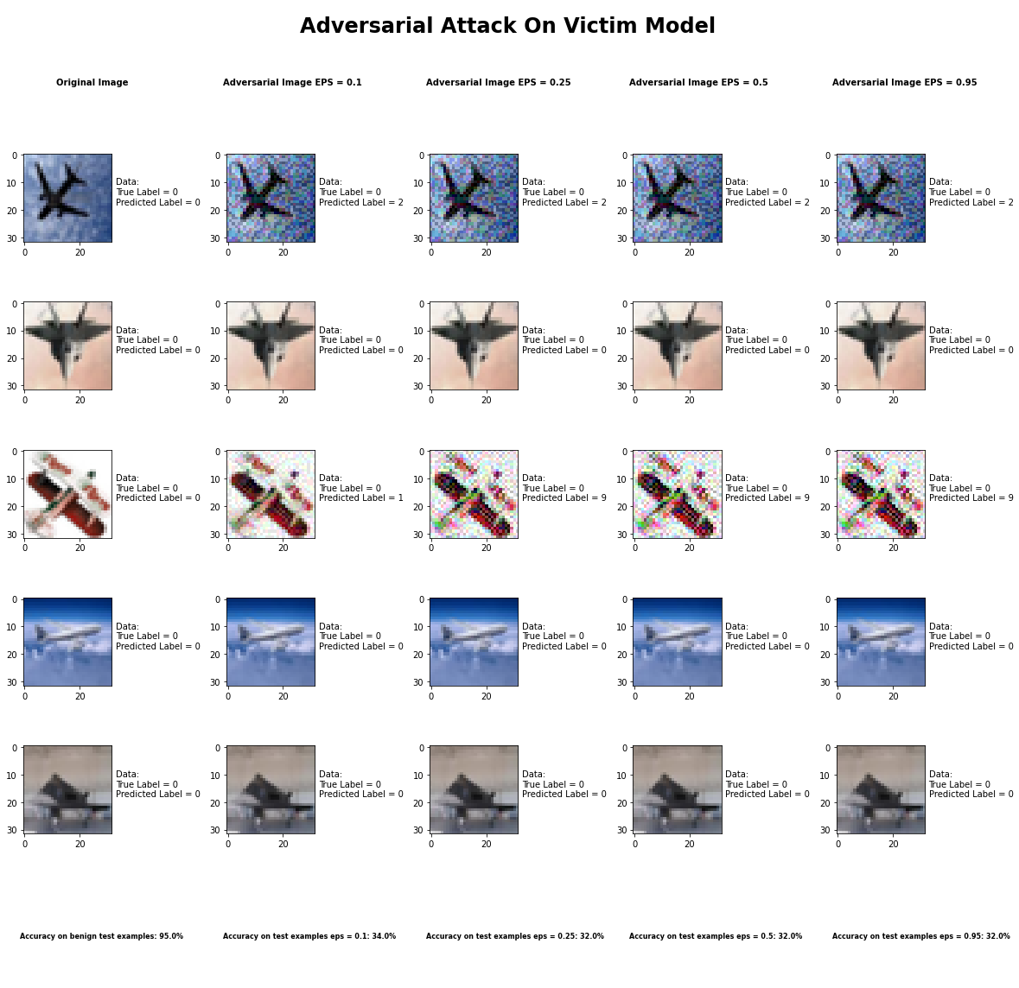

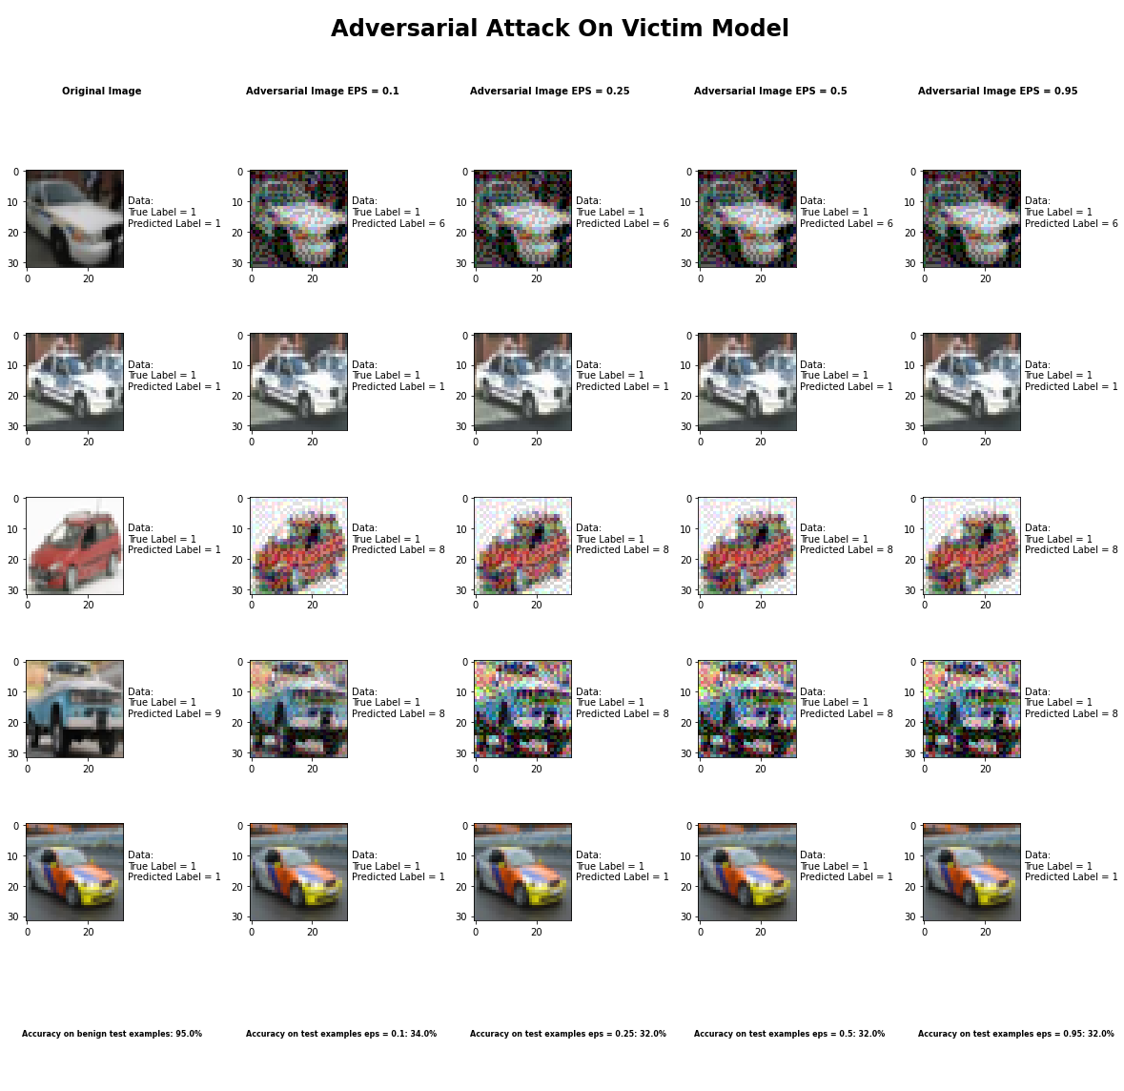

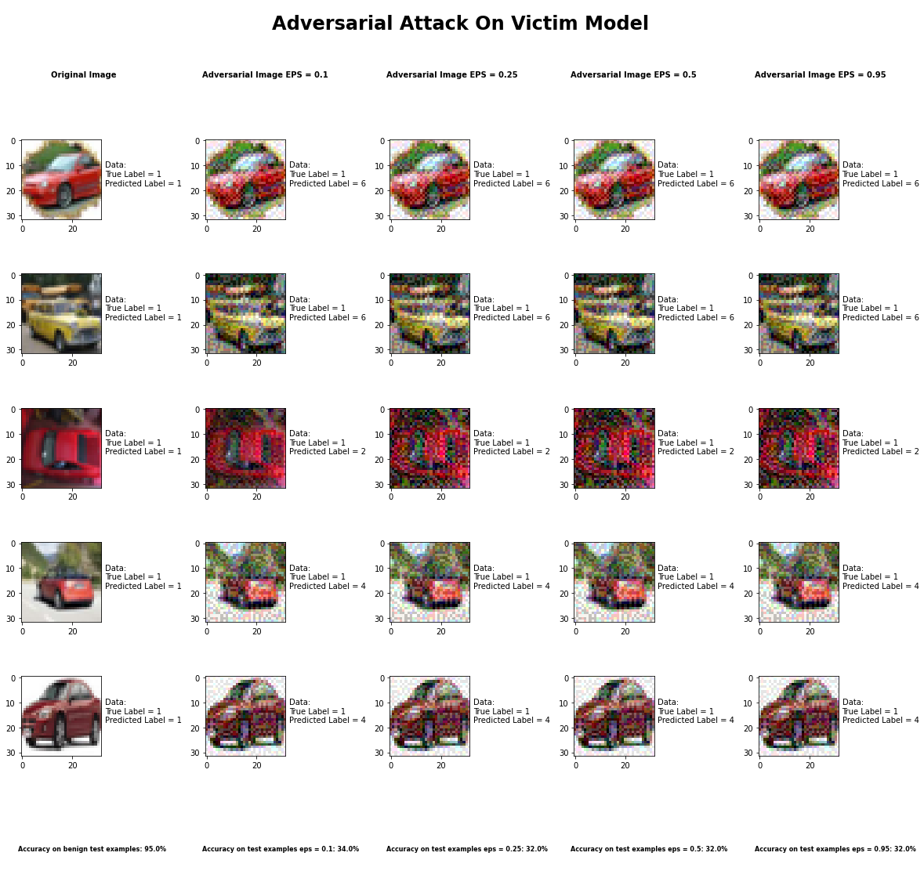

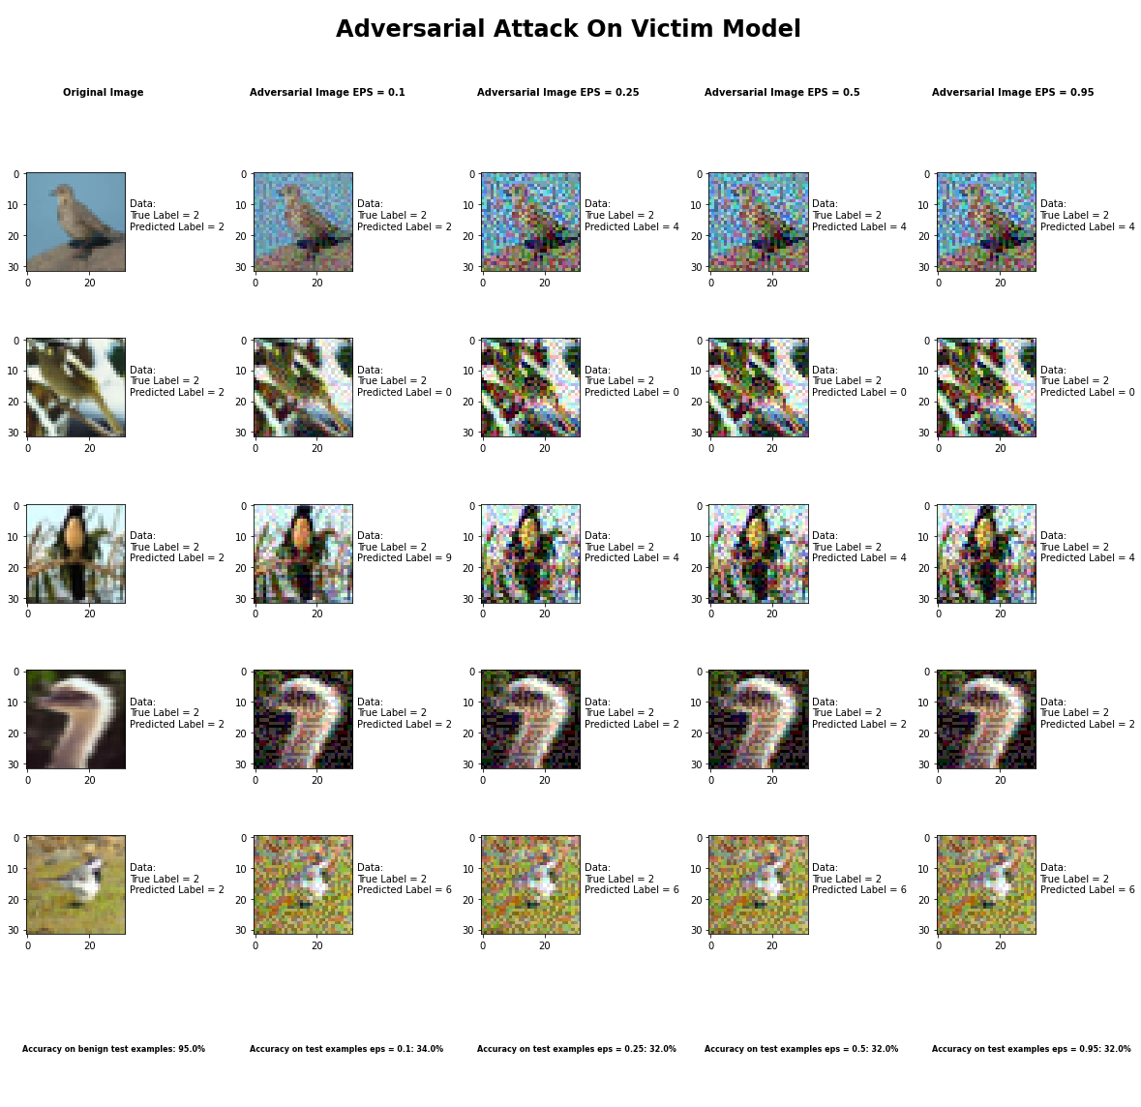

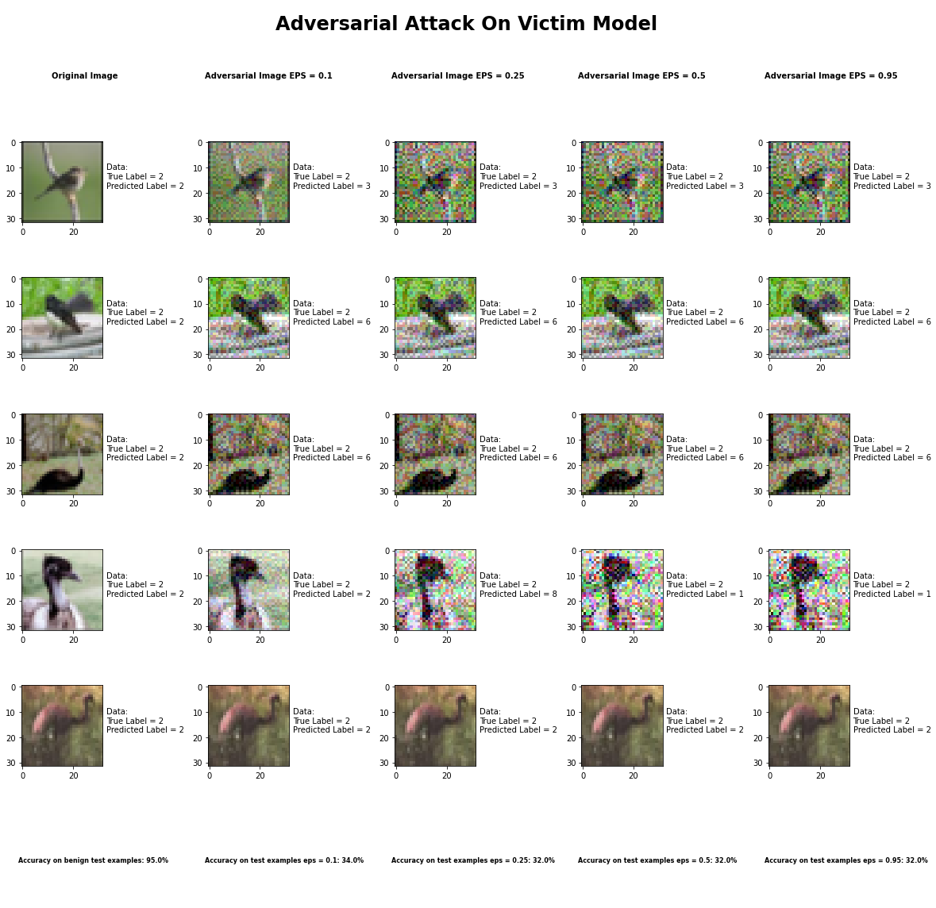

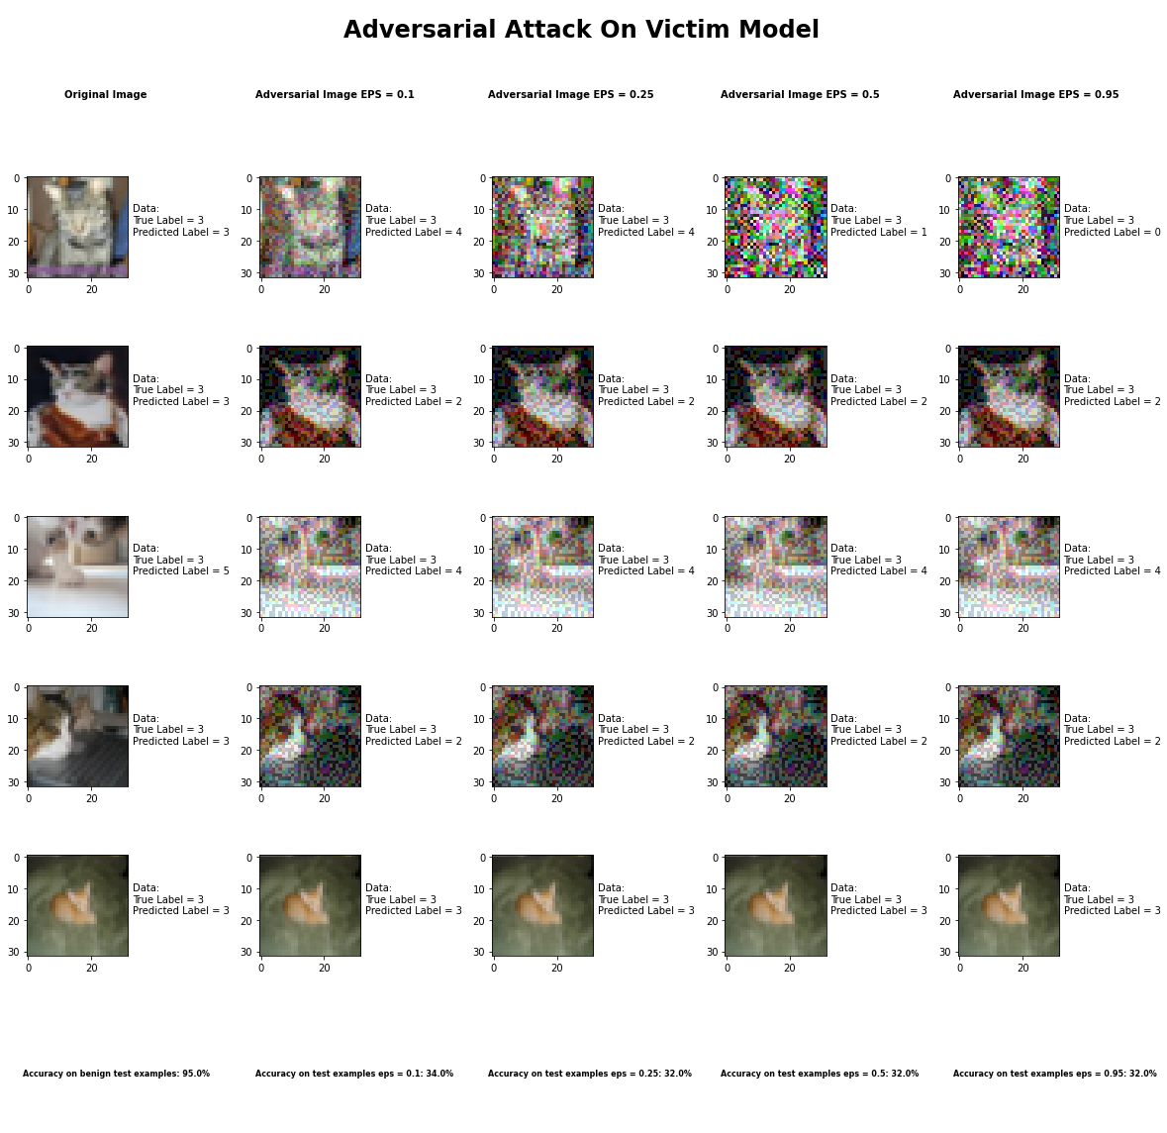

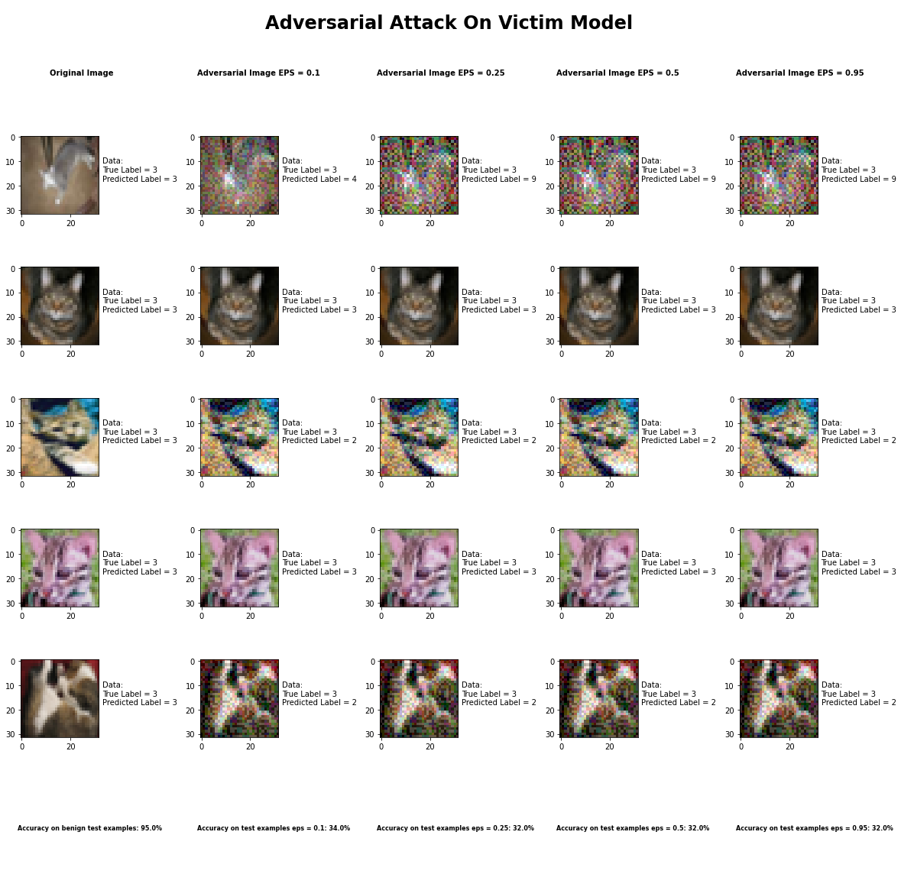

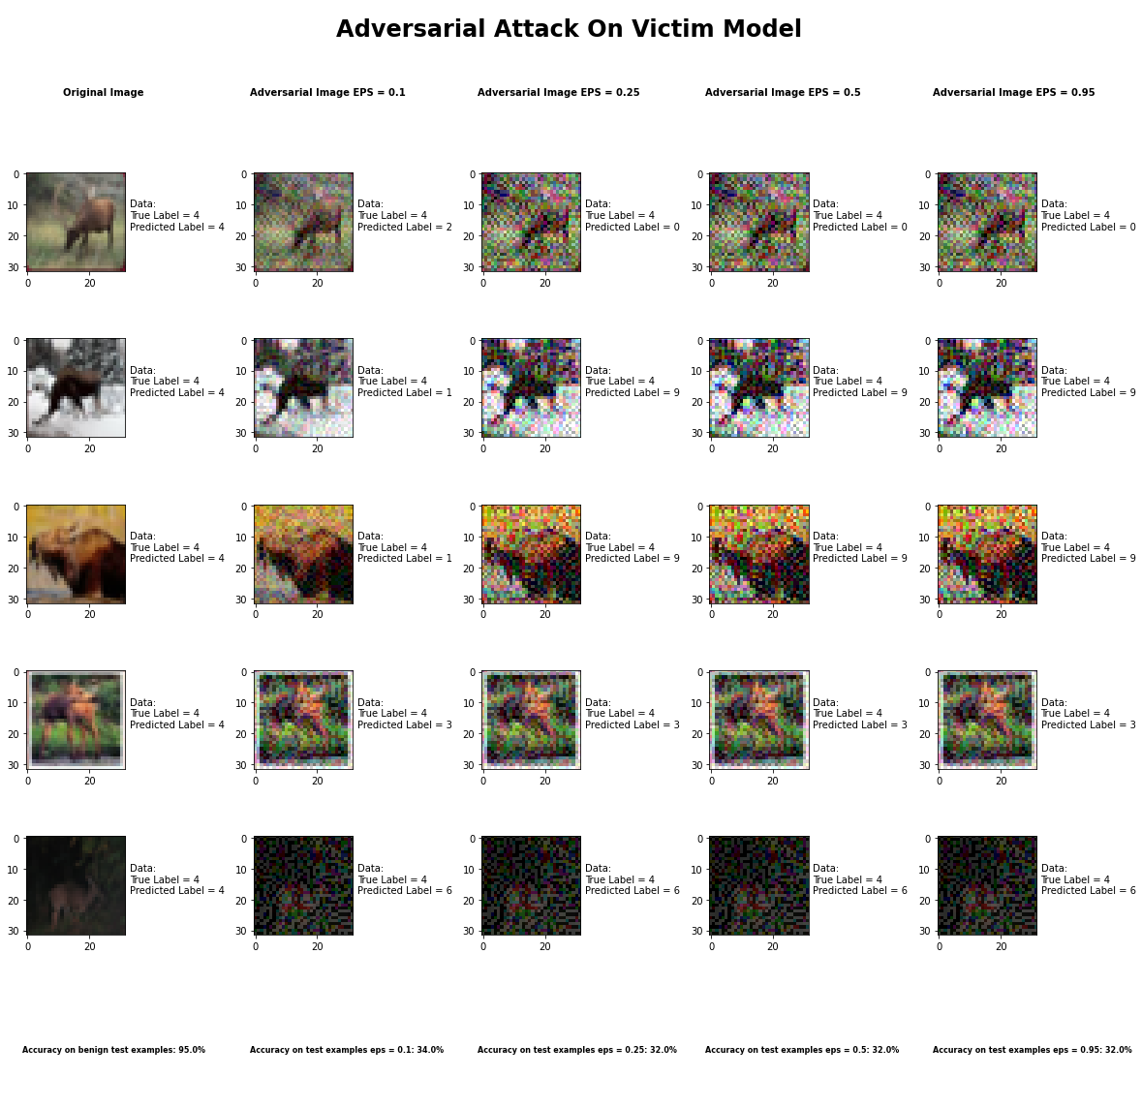

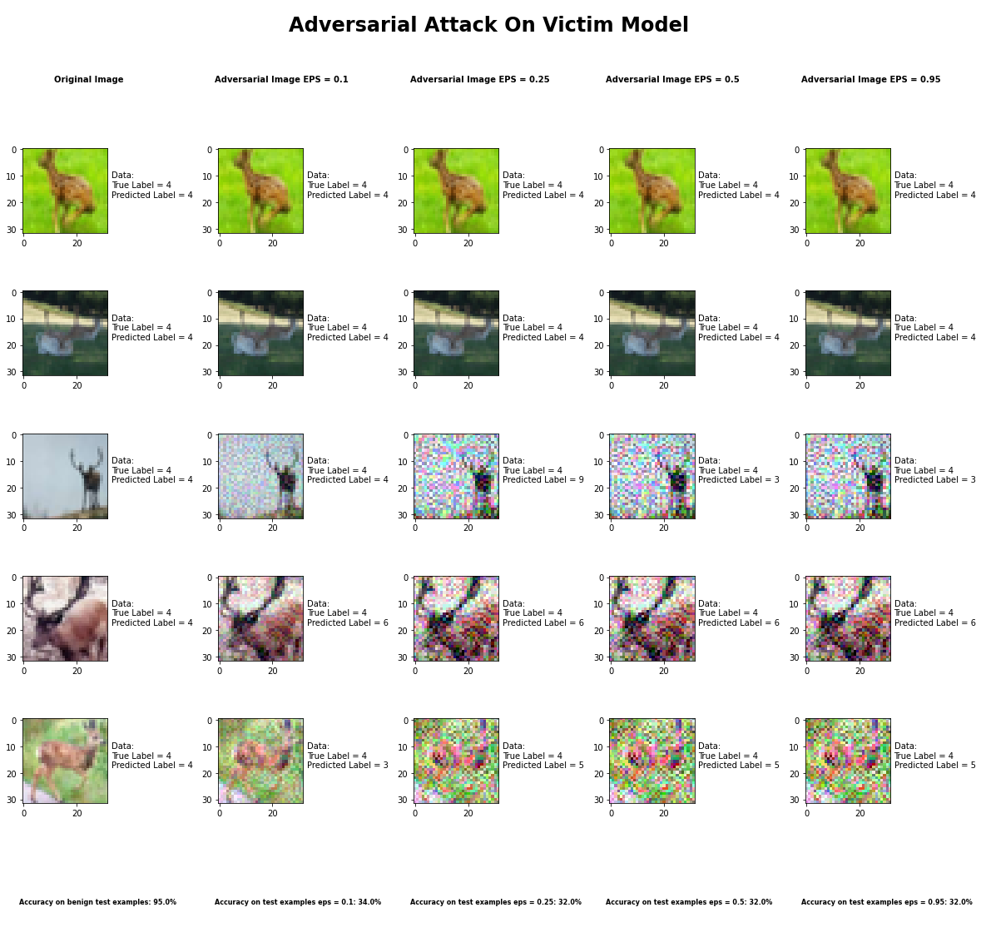

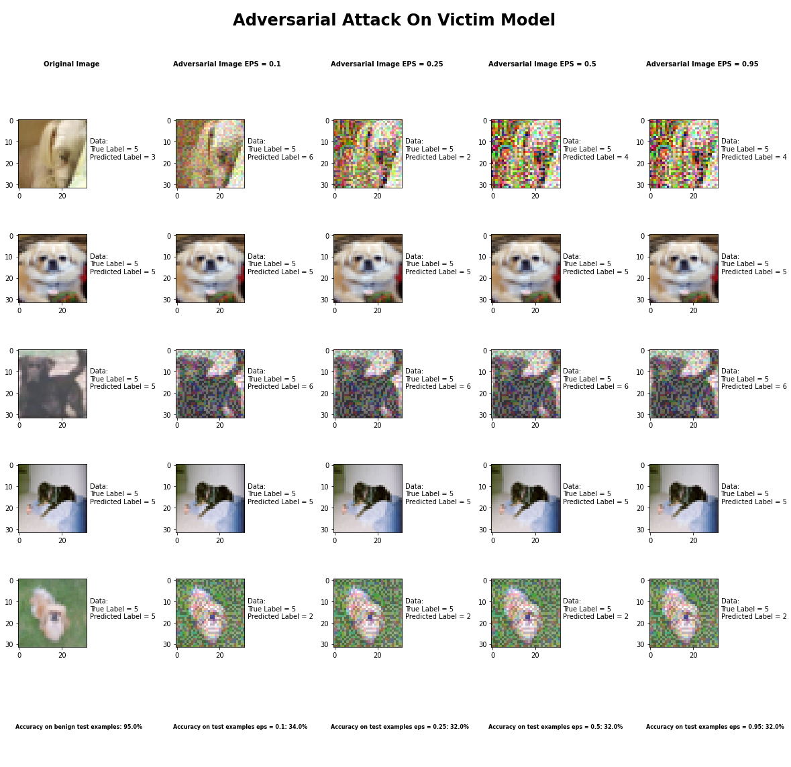

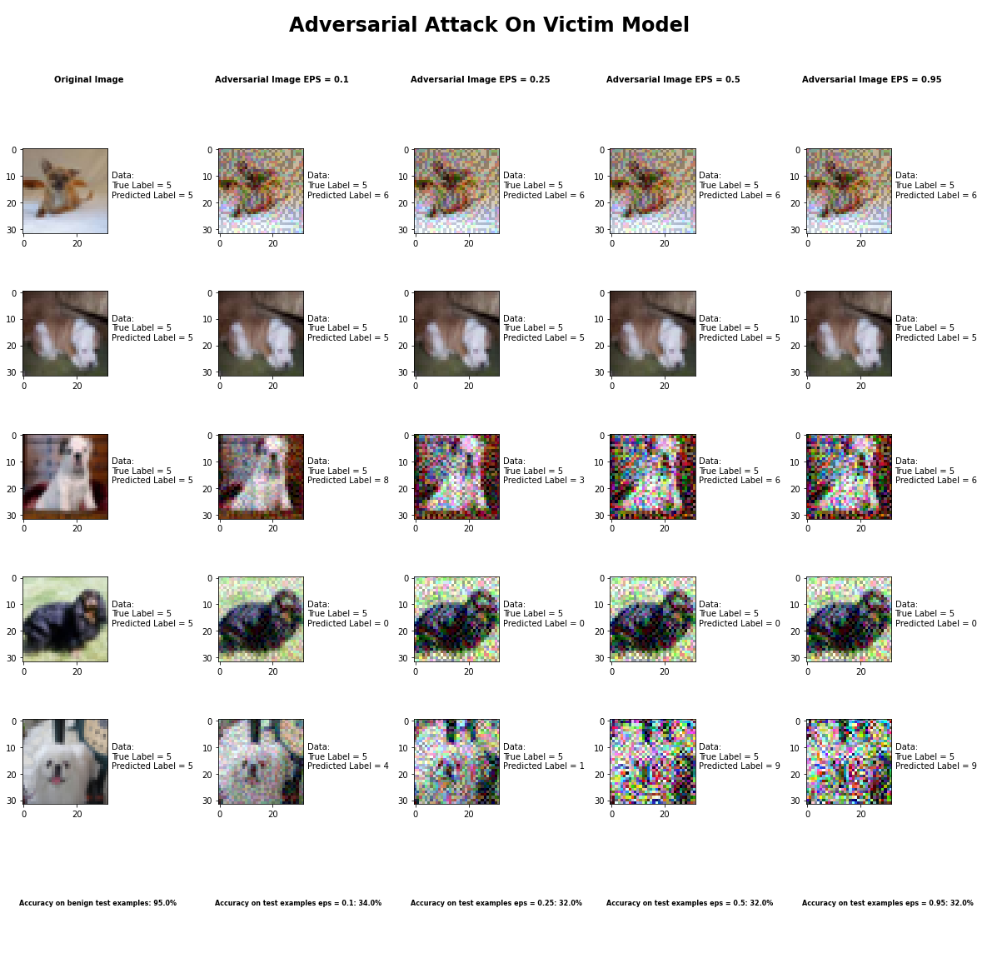

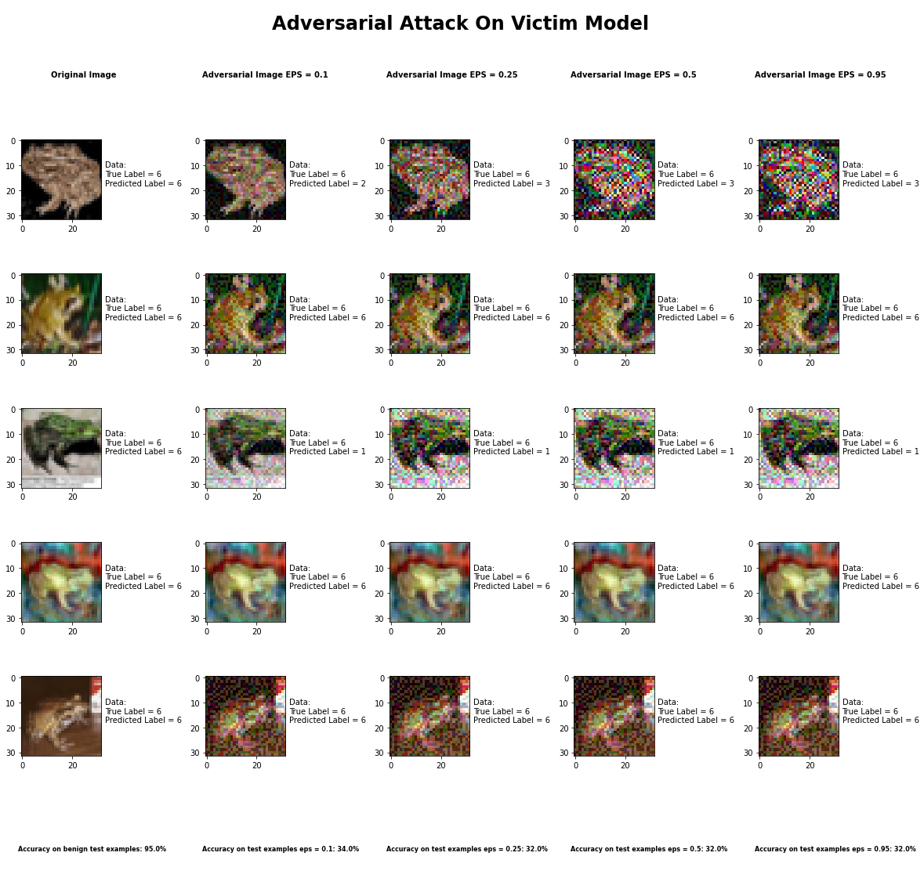

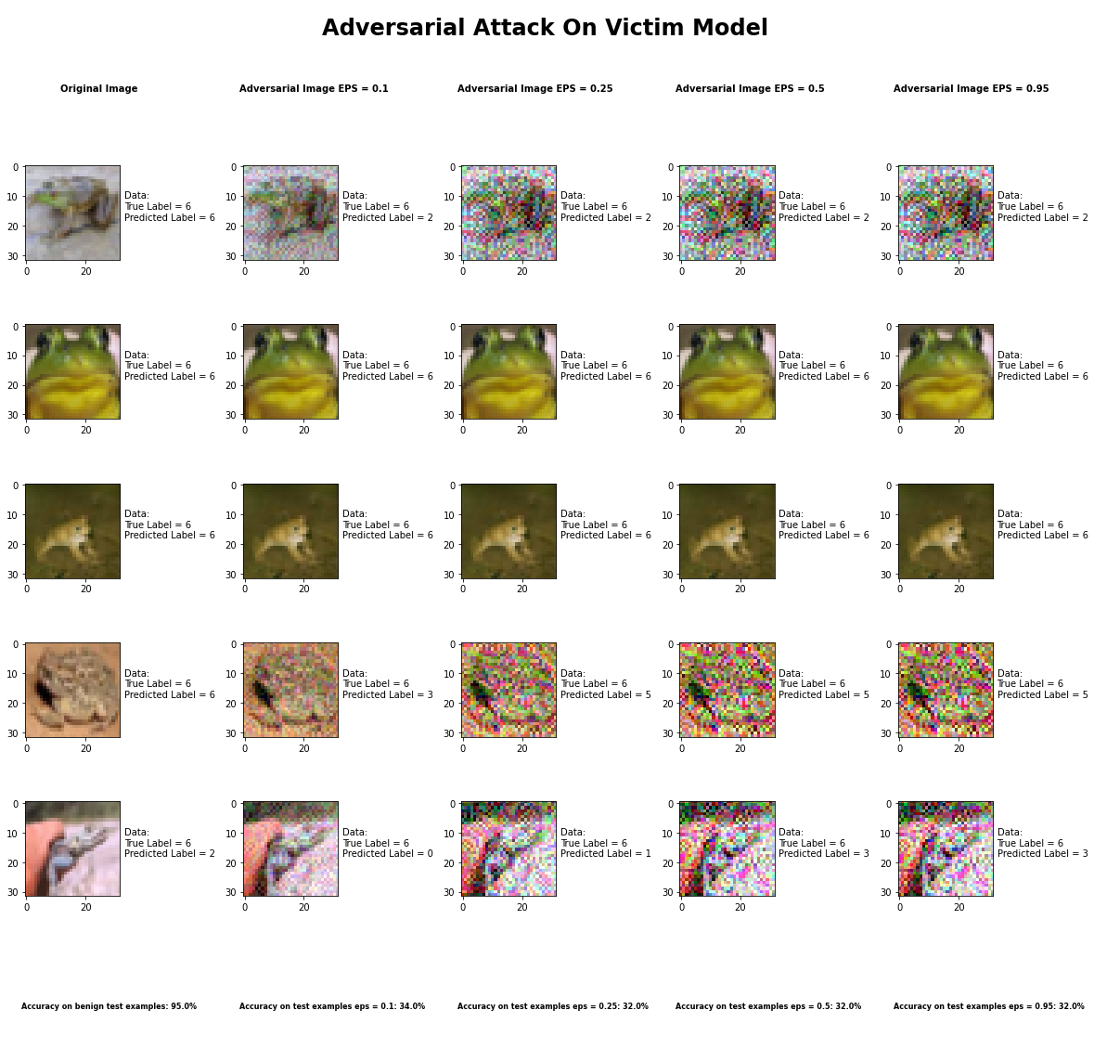

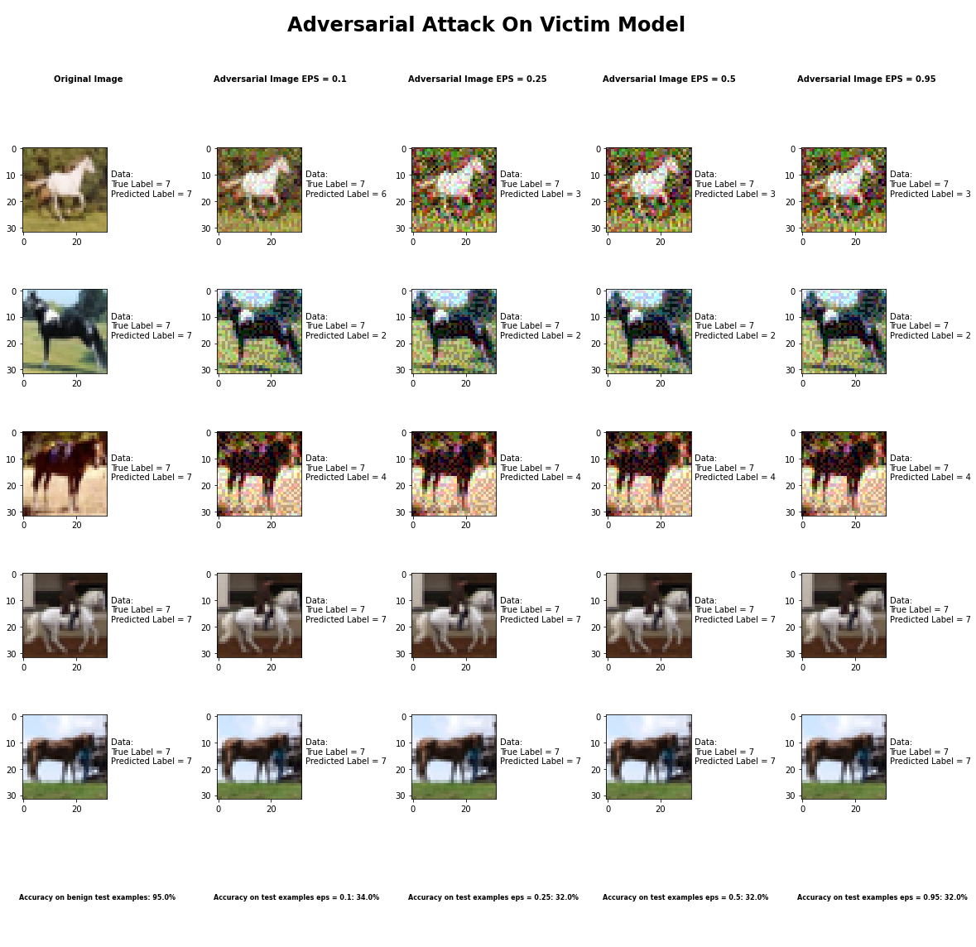

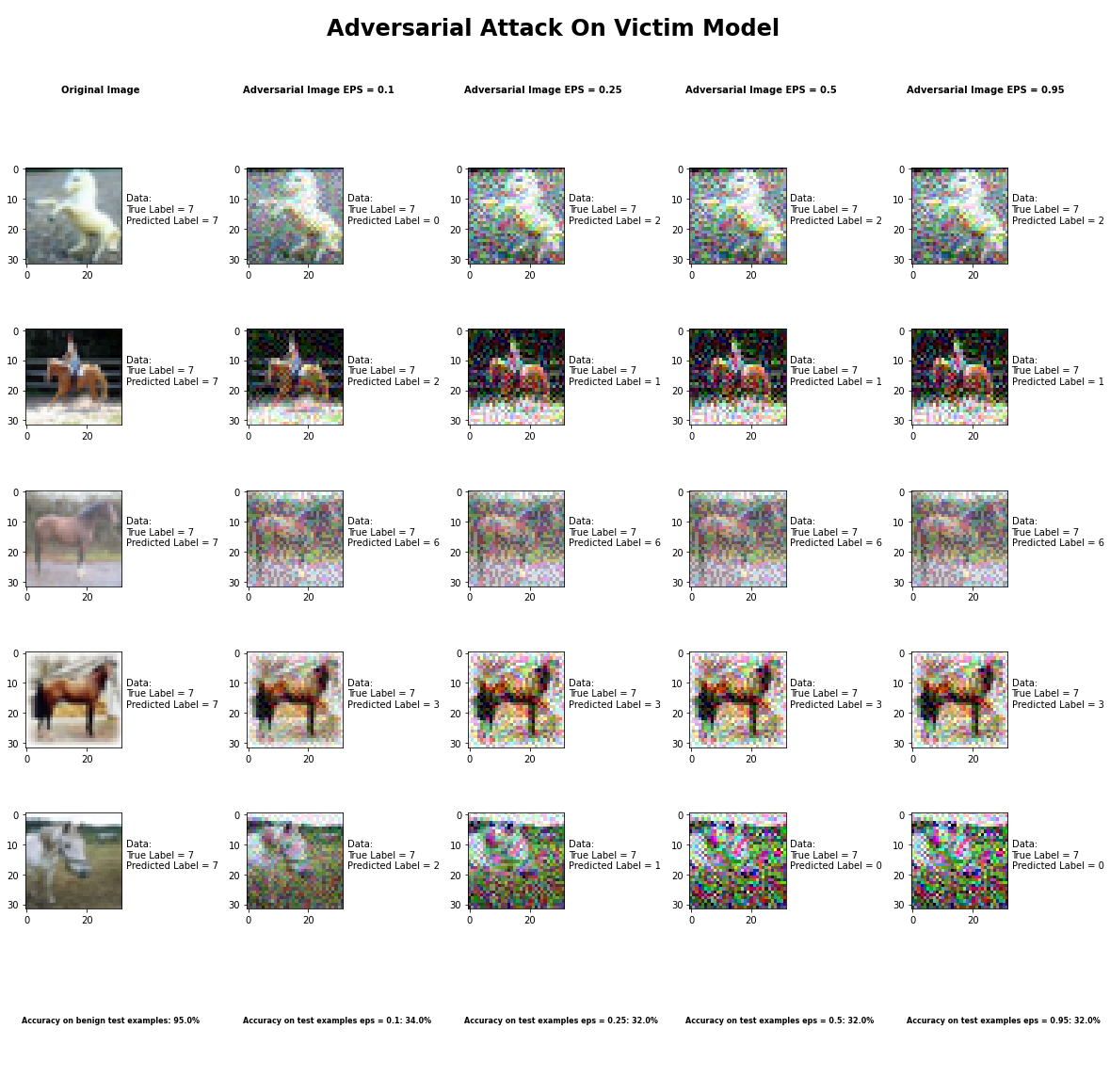

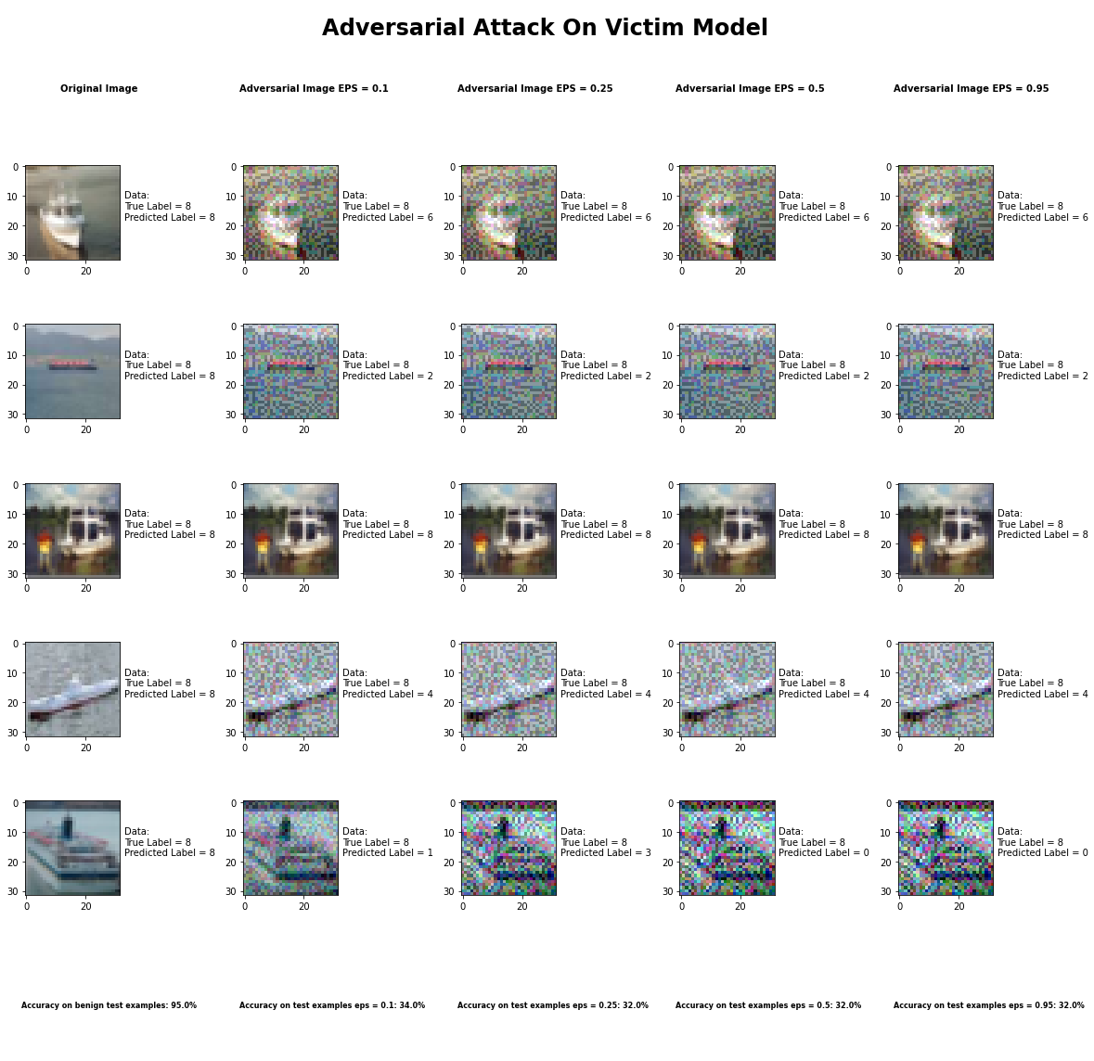

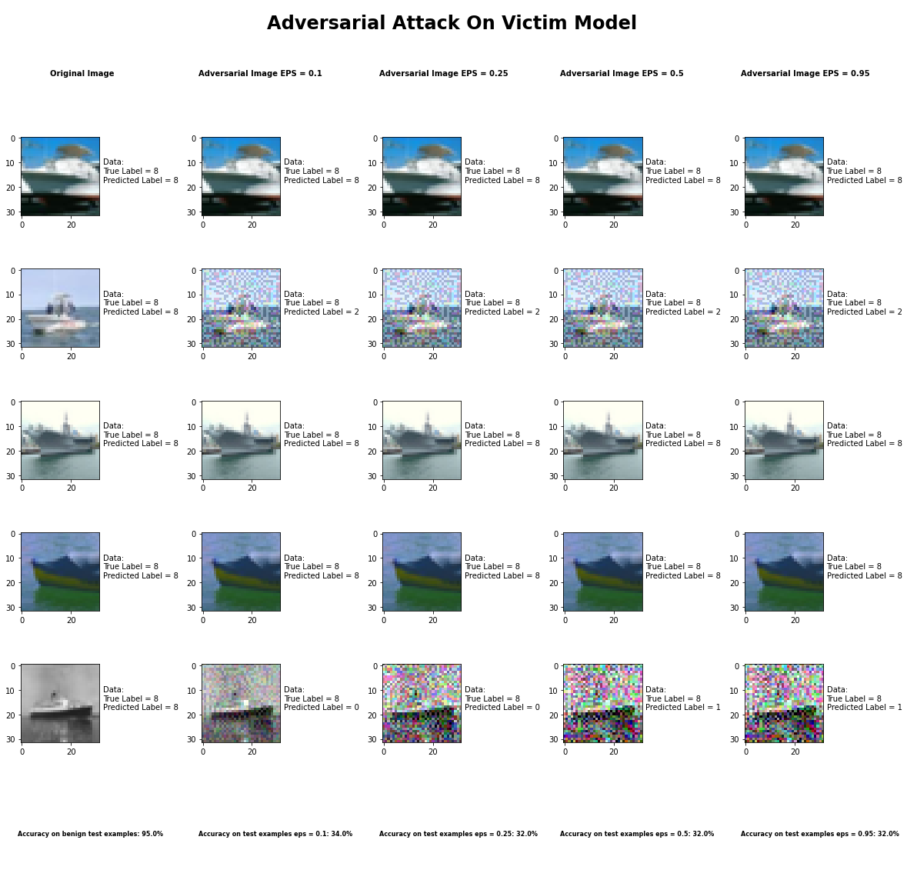

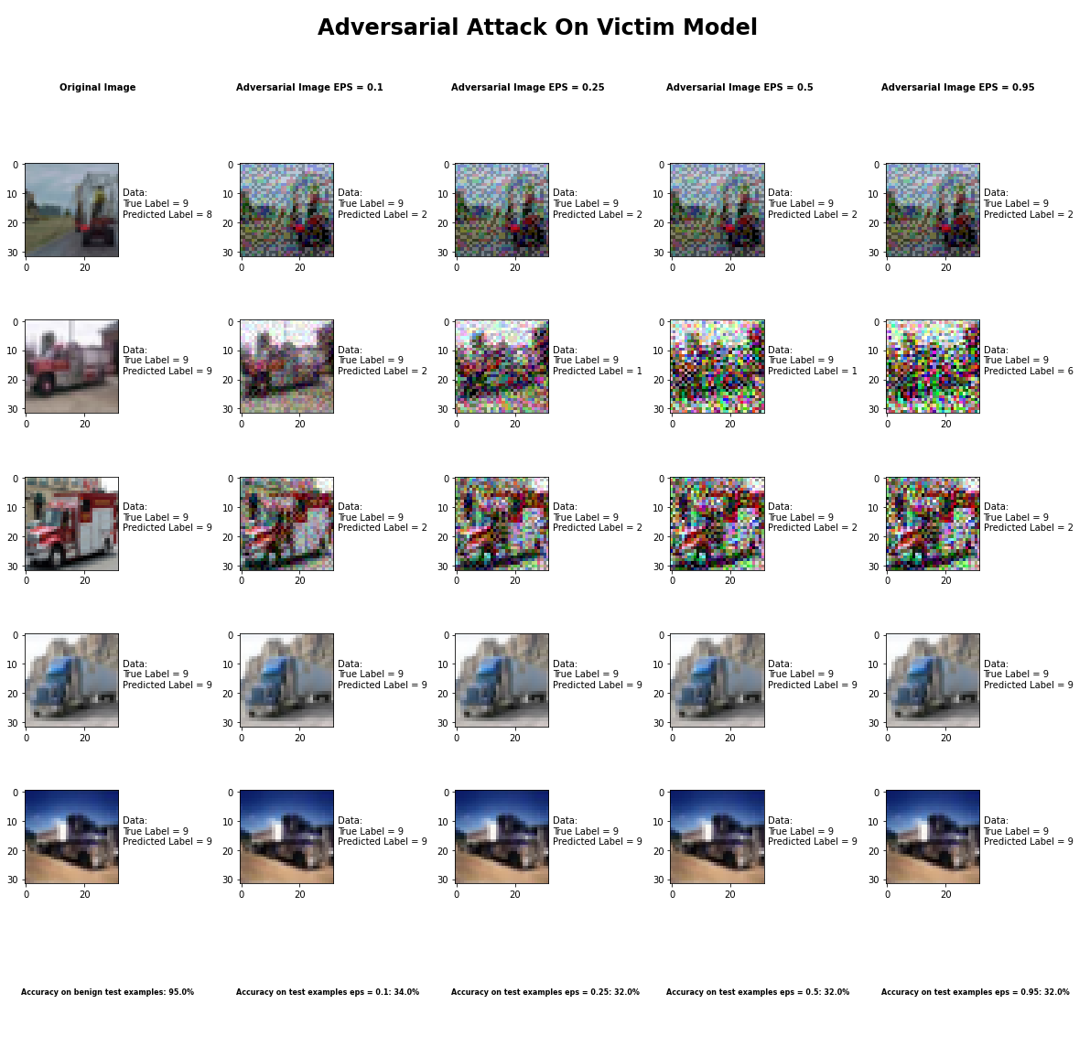

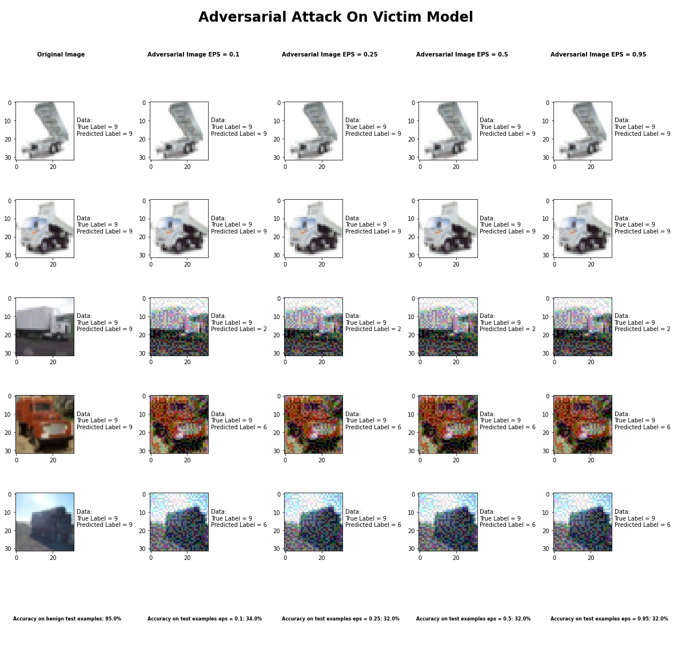 Accuracy on benign test examples: 94.52000000000001%

Average Accuracy on adversarial test examples with eps = 0.10: 34.0%

Average Accuracy on adversarial test examples with eps = 0.25: 32.3%

Average Accuracy on adversarial test examples with eps = 0.50: 32.0%

Average Accuracy on adversarial test examples with eps = 0.95: 32.1%

Classifier with benign example has Airplane recognition average accuracy of = 99%

Basic Iterative Method with eps = 0.10 has Airplane recognition average accuracy of = 35%

Basic Iterative Method with eps = 0.25 has Airplane recognition average accuracy of = 35%

Basic Iterative Method with eps = 0.50 has Airplane recognition average accuracy of = 35%

Basic Iterative Method with eps = 0.95 has Airplane recognition average accuracy of = 36%

Classifier with benign example has Automobile recognition average accuracy of = 96%

Basic Iterative Method with eps = 0.10 has Automobile recognition average accuracy of = 30%

Basic Iterative Method with eps = 0.25 has Automobile recognition average accuracy of = 28%

Basic Iterative Method with eps = 0.50 has Automobile recognition average accuracy of = 28%

Basic Iterative Method with eps = 0.95 has Automobile recognition average accuracy of = 28%

Classifier with benign example has Bird recognition average accuracy of = 94%

Basic Iterative Method with eps = 0.10 has Bird recognition average accuracy of = 44%

Basic Iterative Method with eps = 0.25 has Bird recognition average accuracy of = 41%

Basic Iterative Method with eps = 0.50 has Bird recognition average accuracy of = 40%

Basic Iterative Method with eps = 0.95 has Bird recognition average accuracy of = 40%

Classifier with benign example has Cat recognition average accuracy of = 87%

Basic Iterative Method with eps = 0.10 has Cat recognition average accuracy of = 27%

Basic Iterative Method with eps = 0.25 has Cat recognition average accuracy of = 27%

Basic Iterative Method with eps = 0.50 has Cat recognition average accuracy of = 25%

Basic Iterative Method with eps = 0.95 has Cat recognition average accuracy of = 25%

Classifier with benign example has Deer recognition average accuracy of = 97%

Basic Iterative Method with eps = 0.10 has Deer recognition average accuracy of = 29%

Basic Iterative Method with eps = 0.25 has Deer recognition average accuracy of = 28%

Basic Iterative Method with eps = 0.50 has Deer recognition average accuracy of = 28%

Basic Iterative Method with eps = 0.95 has Deer recognition average accuracy of = 28%

Classifier with benign example has Dog recognition average accuracy of = 88%

Basic Iterative Method with eps = 0.10 has Dog recognition average accuracy of = 22%

Basic Iterative Method with eps = 0.25 has Dog recognition average accuracy of = 22%

Basic Iterative Method with eps = 0.50 has Dog recognition average accuracy of = 22%

Basic Iterative Method with eps = 0.95 has Dog recognition average accuracy of = 22%

Classifier with benign example has Frog recognition average accuracy of = 95%

Basic Iterative Method with eps = 0.10 has Frog recognition average accuracy of = 54%

Basic Iterative Method with eps = 0.25 has Frog recognition average accuracy of = 47%

Basic Iterative Method with eps = 0.50 has Frog recognition average accuracy of = 47%

Basic Iterative Method with eps = 0.95 has Frog recognition average accuracy of = 47%

Classifier with benign example has Horse recognition average accuracy of = 97%

Basic Iterative Method with eps = 0.10 has Horse recognition average accuracy of = 30%

Basic Iterative Method with eps = 0.25 has Horse recognition average accuracy of = 30%

Basic Iterative Method with eps = 0.50 has Horse recognition average accuracy of = 30%

Basic Iterative Method with eps = 0.95 has Horse recognition average accuracy of = 30%

Classifier with benign example has Ship recognition average accuracy of = 93%

Basic Iterative Method with eps = 0.10 has Ship recognition average accuracy of = 33%

Basic Iterative Method with eps = 0.25 has Ship recognition average accuracy of = 31%

Basic Iterative Method with eps = 0.50 has Ship recognition average accuracy of = 31%

Basic Iterative Method with eps = 0.95 has Ship recognition average accuracy of = 31%

Classifier with benign example has Truck recognition average accuracy of = 93%

Basic Iterative Method with eps = 0.10 has Truck recognition average accuracy of = 36%

Basic Iterative Method with eps = 0.25 has Truck recognition average accuracy of = 34%

Basic Iterative Method with eps = 0.50 has Truck recognition average accuracy of = 34%

Basic Iterative Method with eps = 0.95 has Truck recognition average accuracy of = 34%

## Universal Perturbation Method



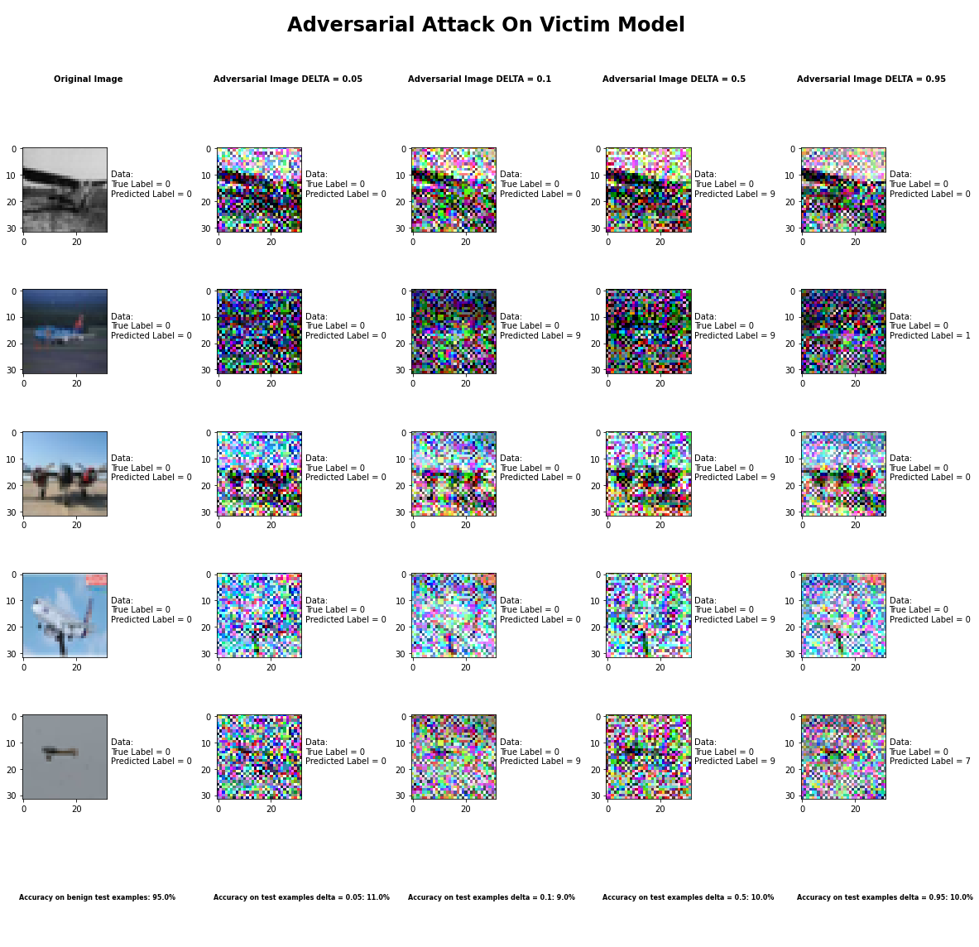

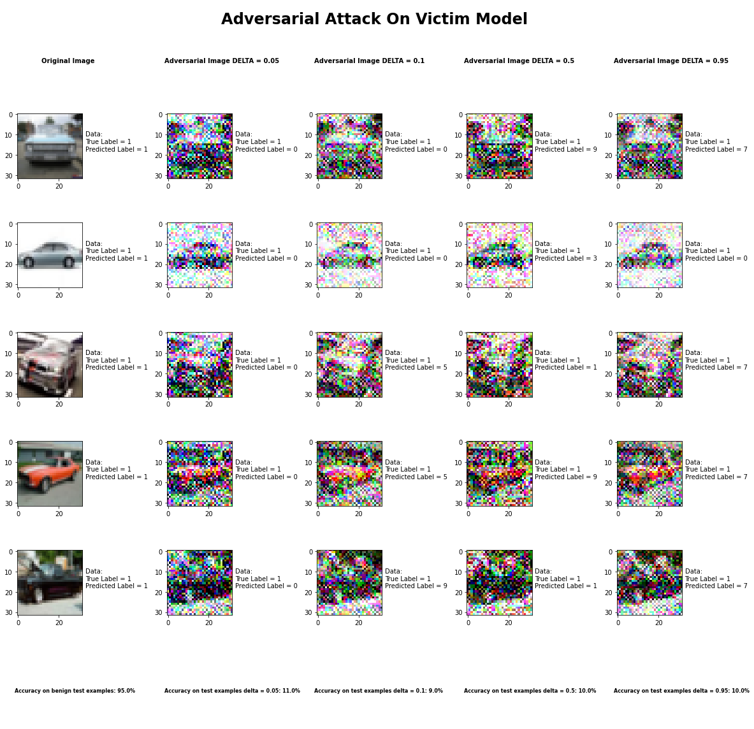

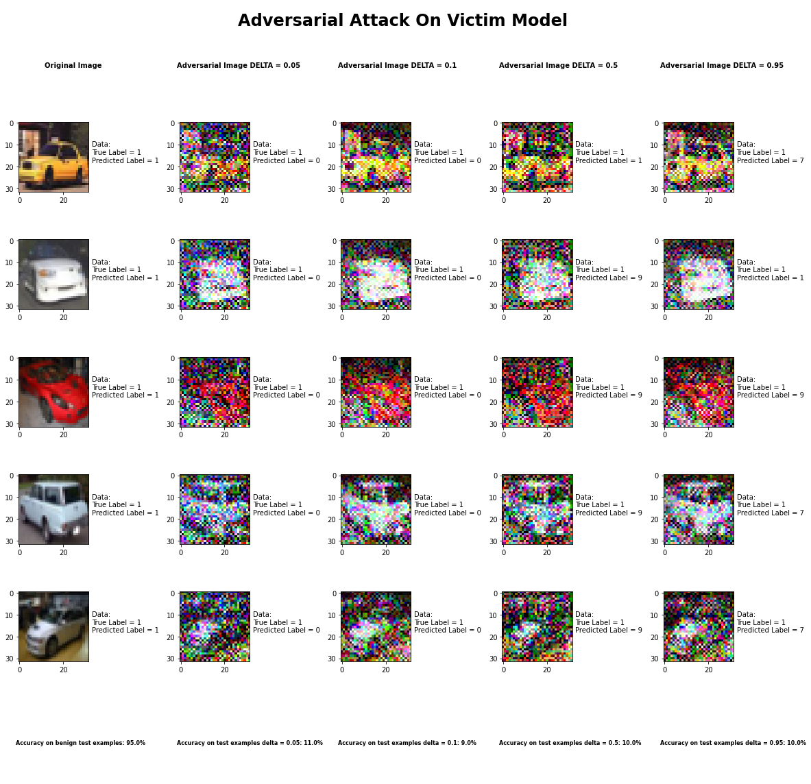

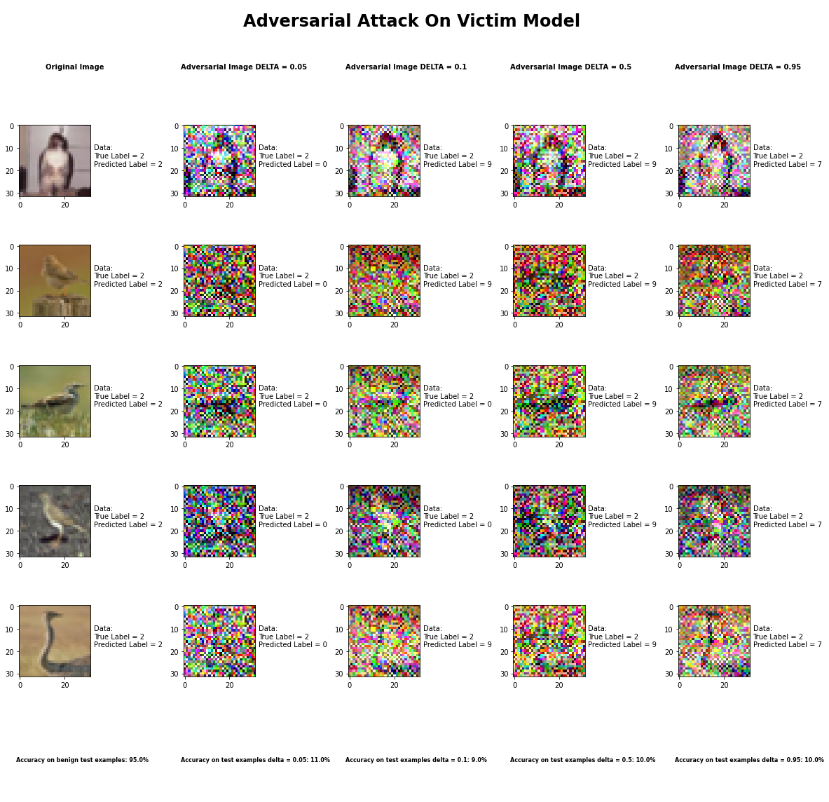

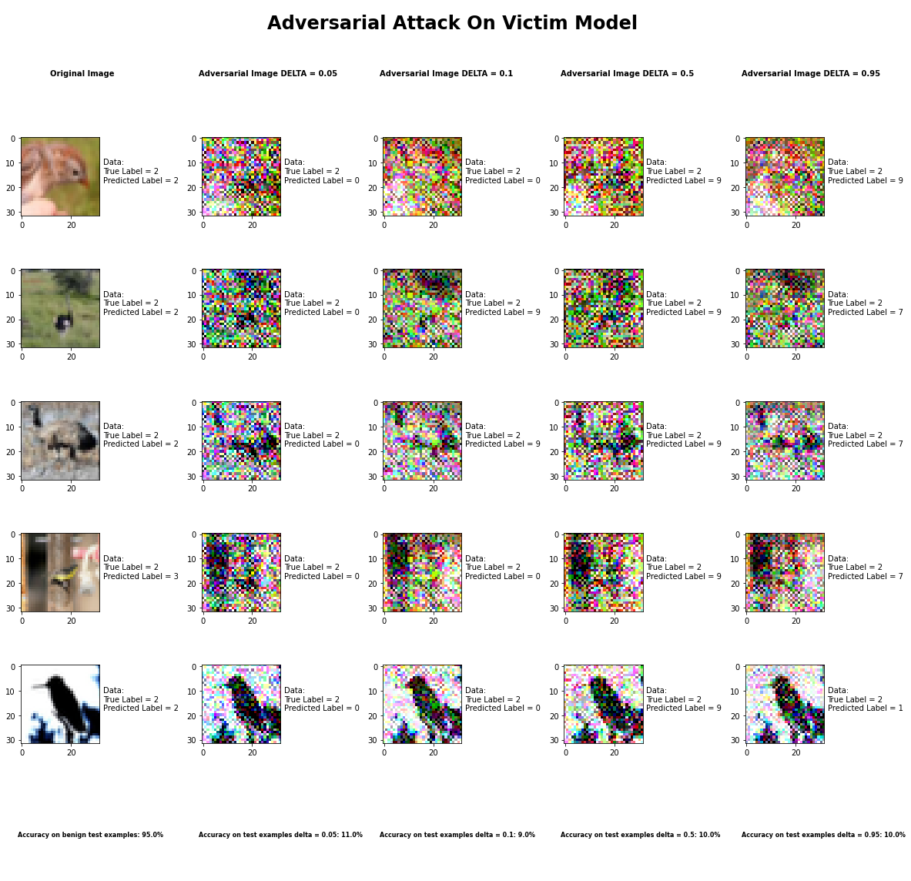

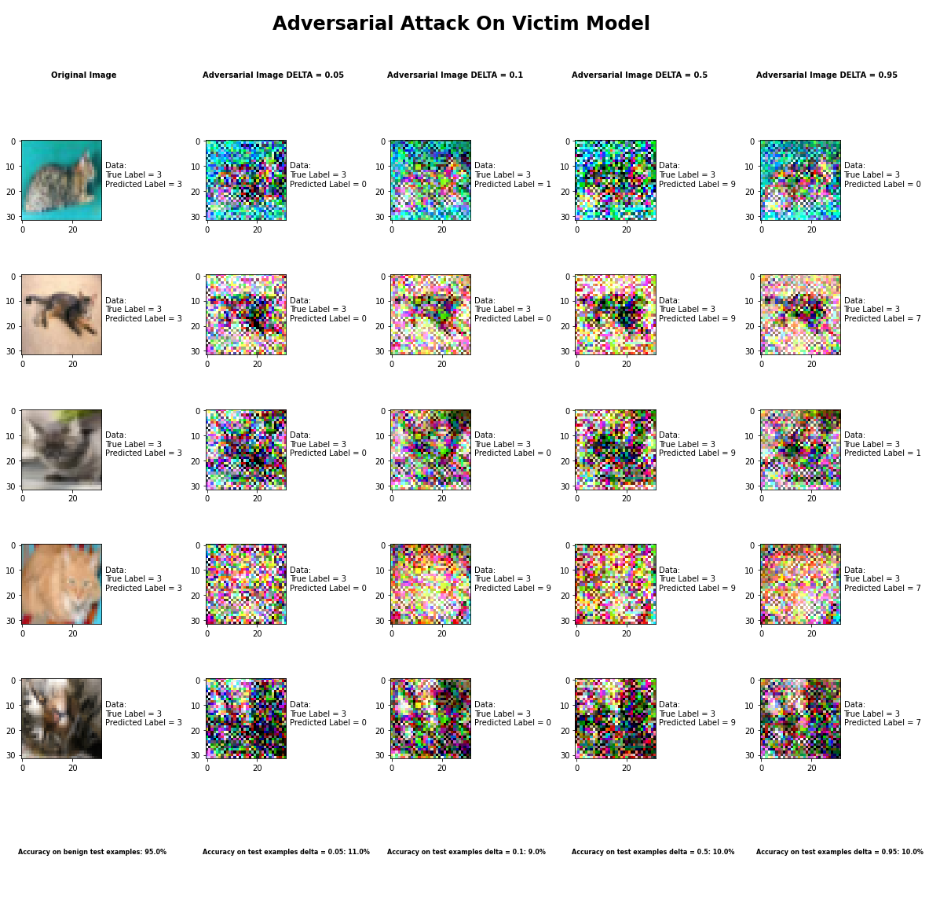

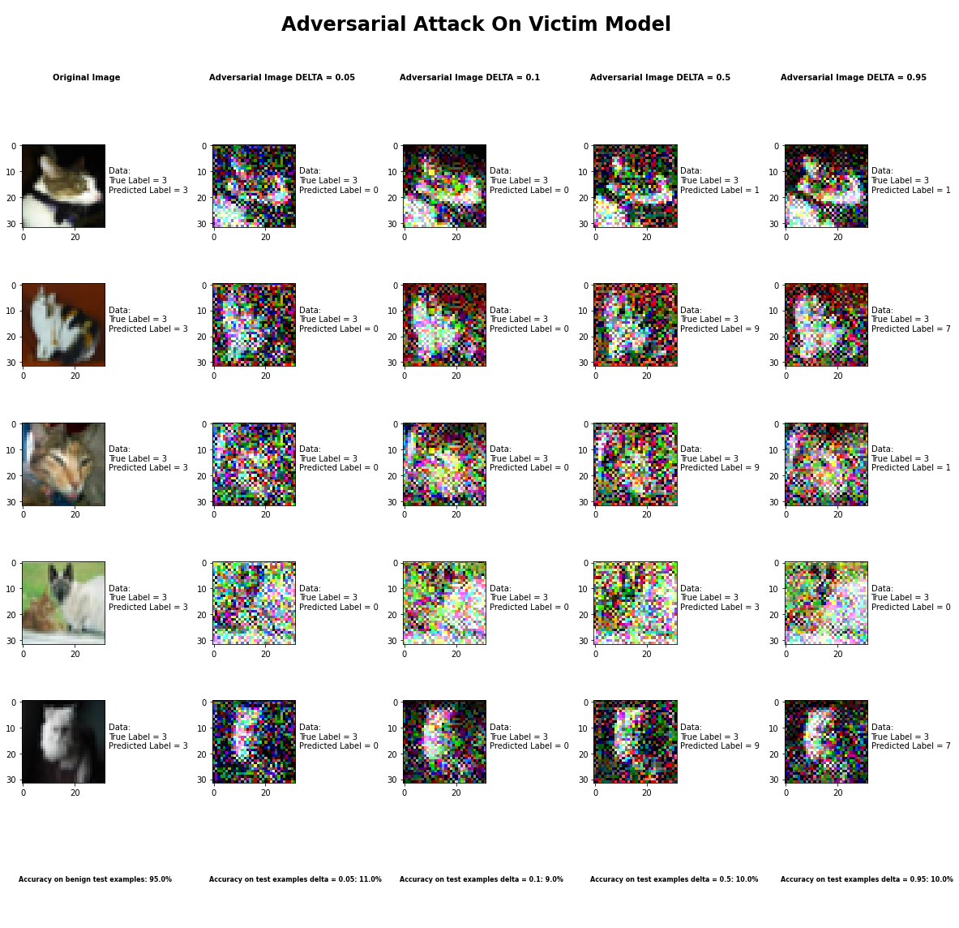

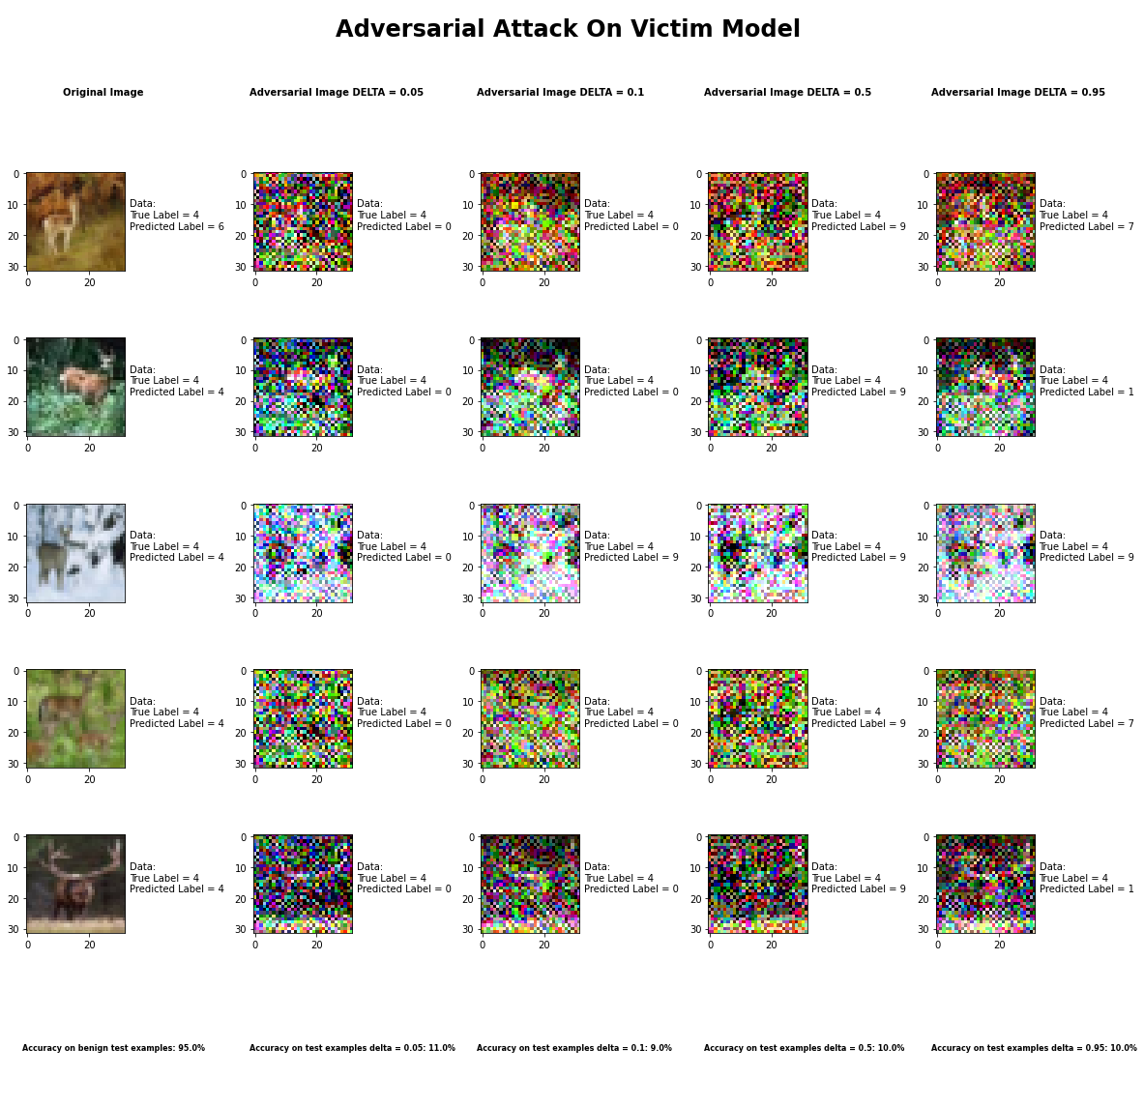

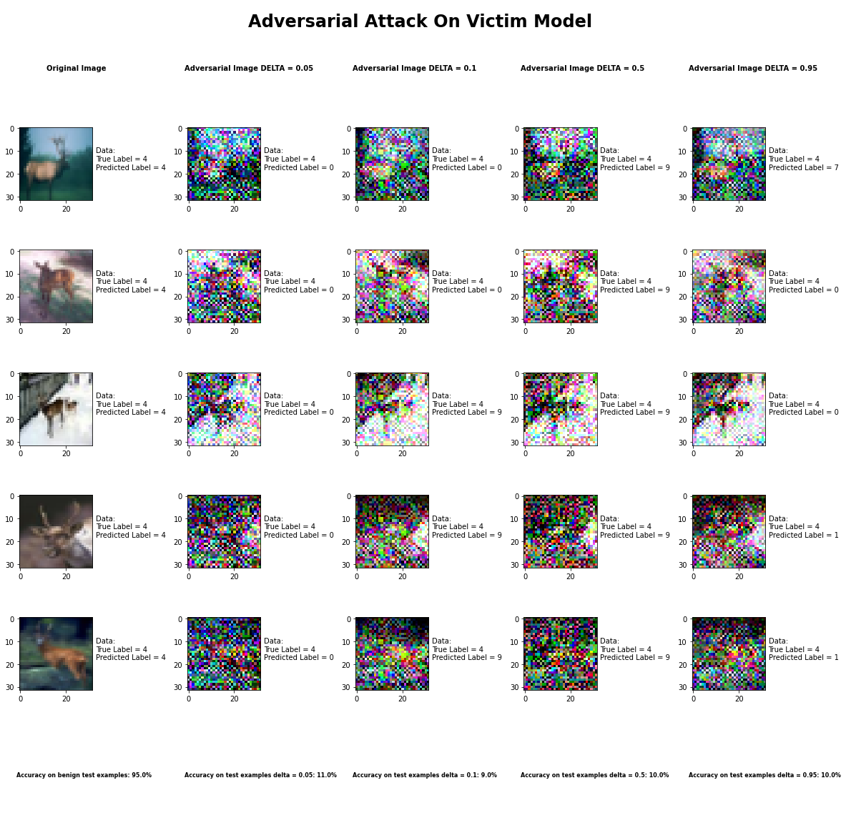

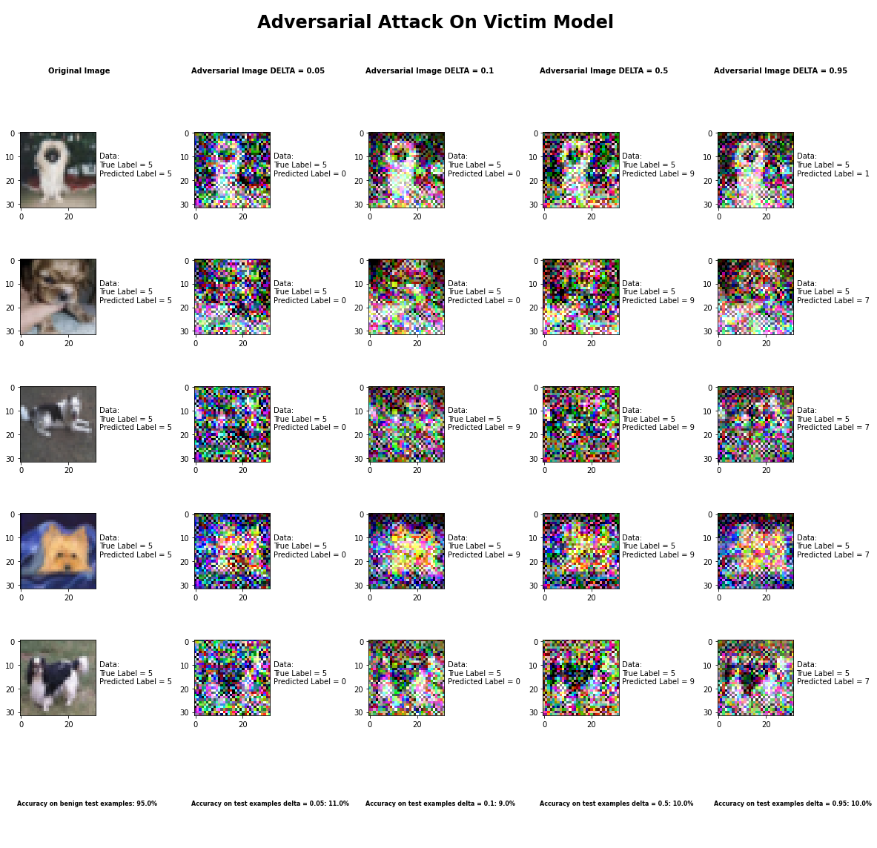

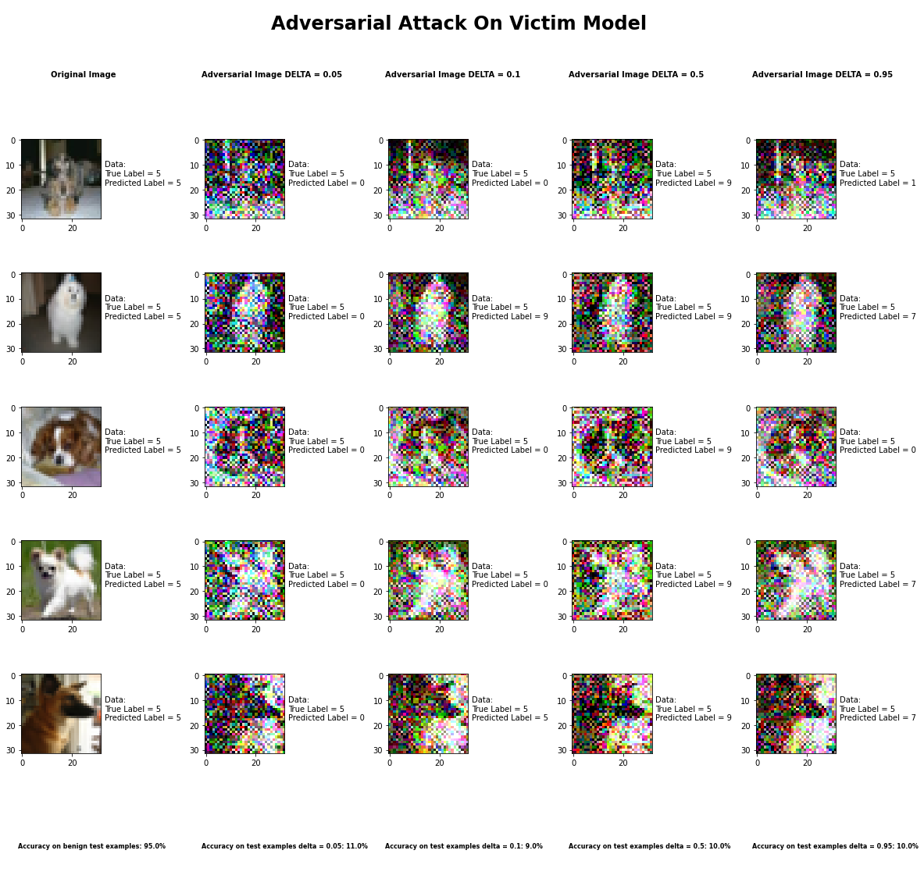

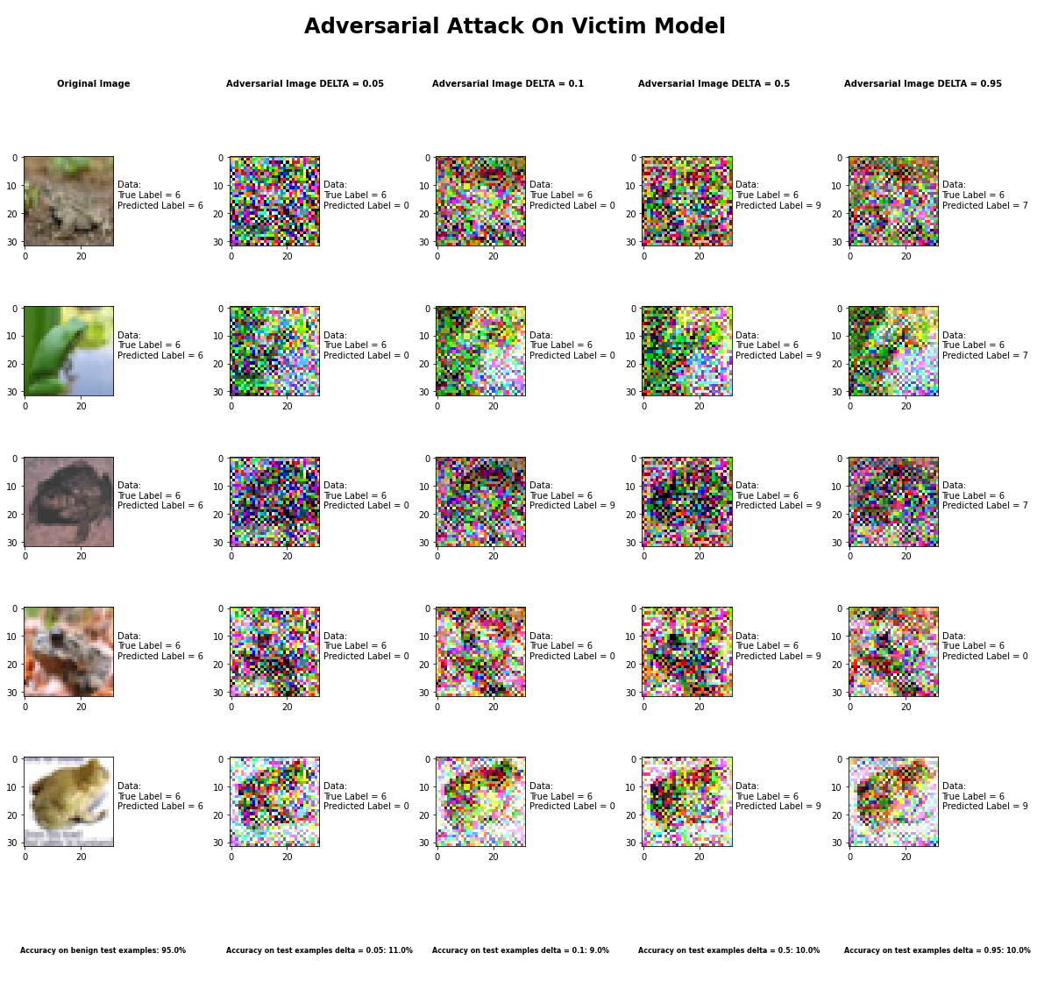

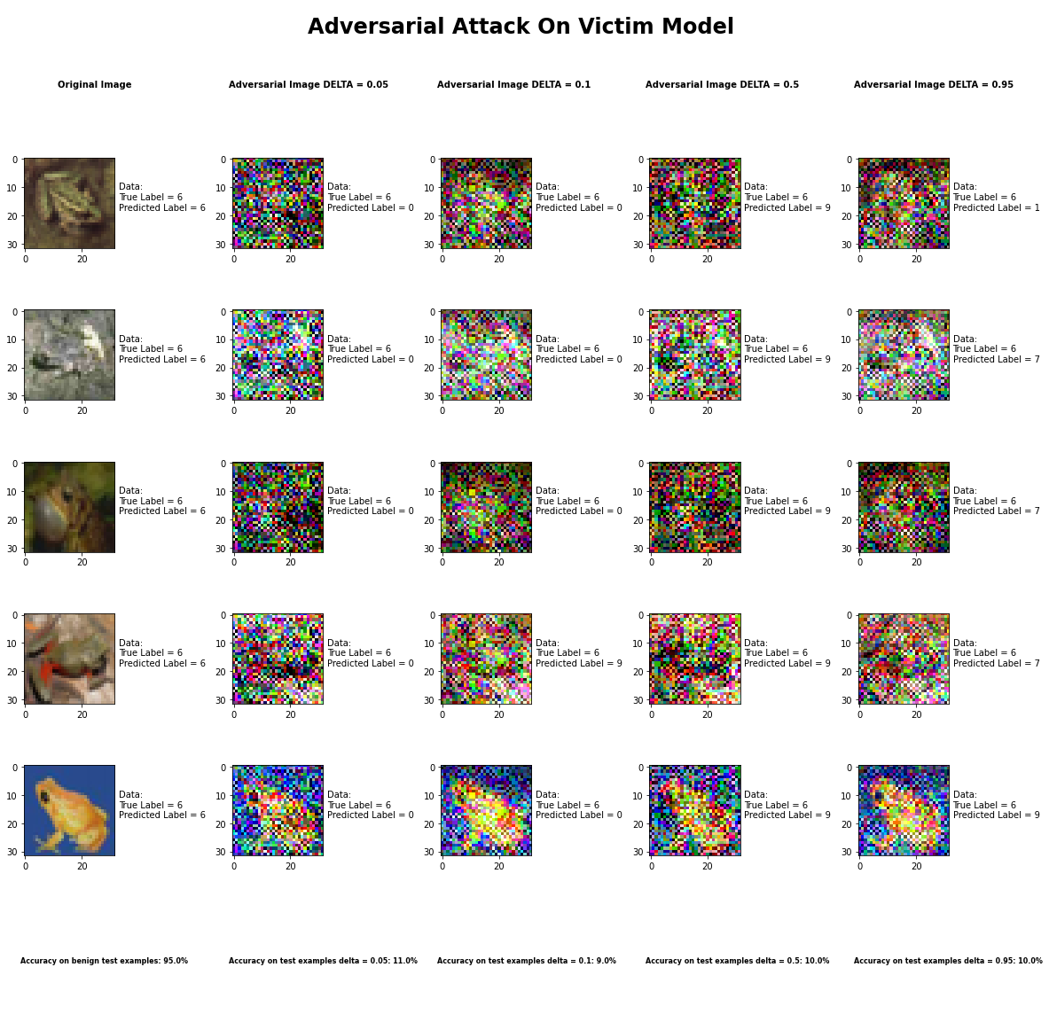

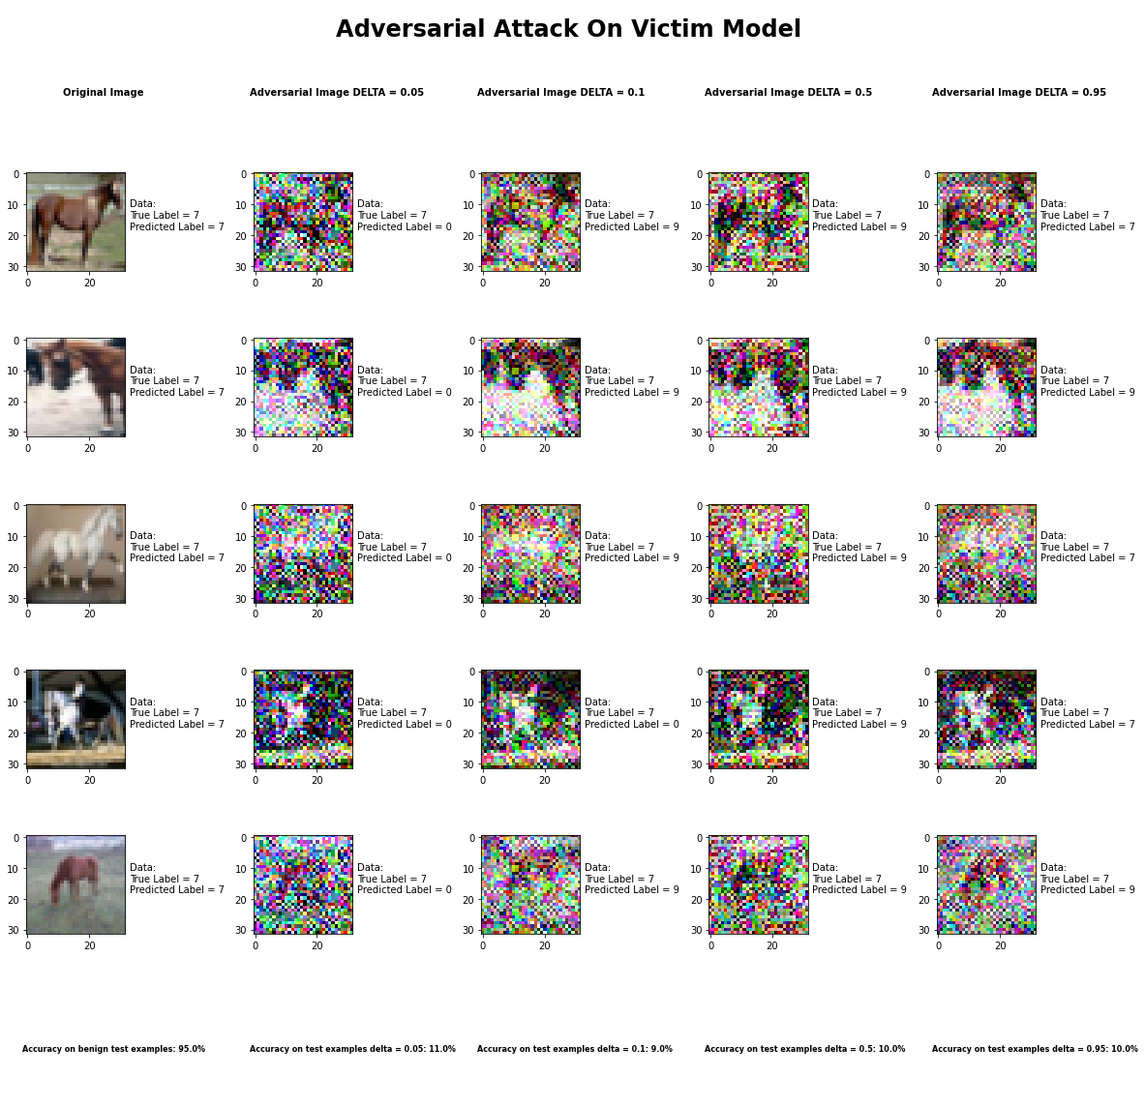

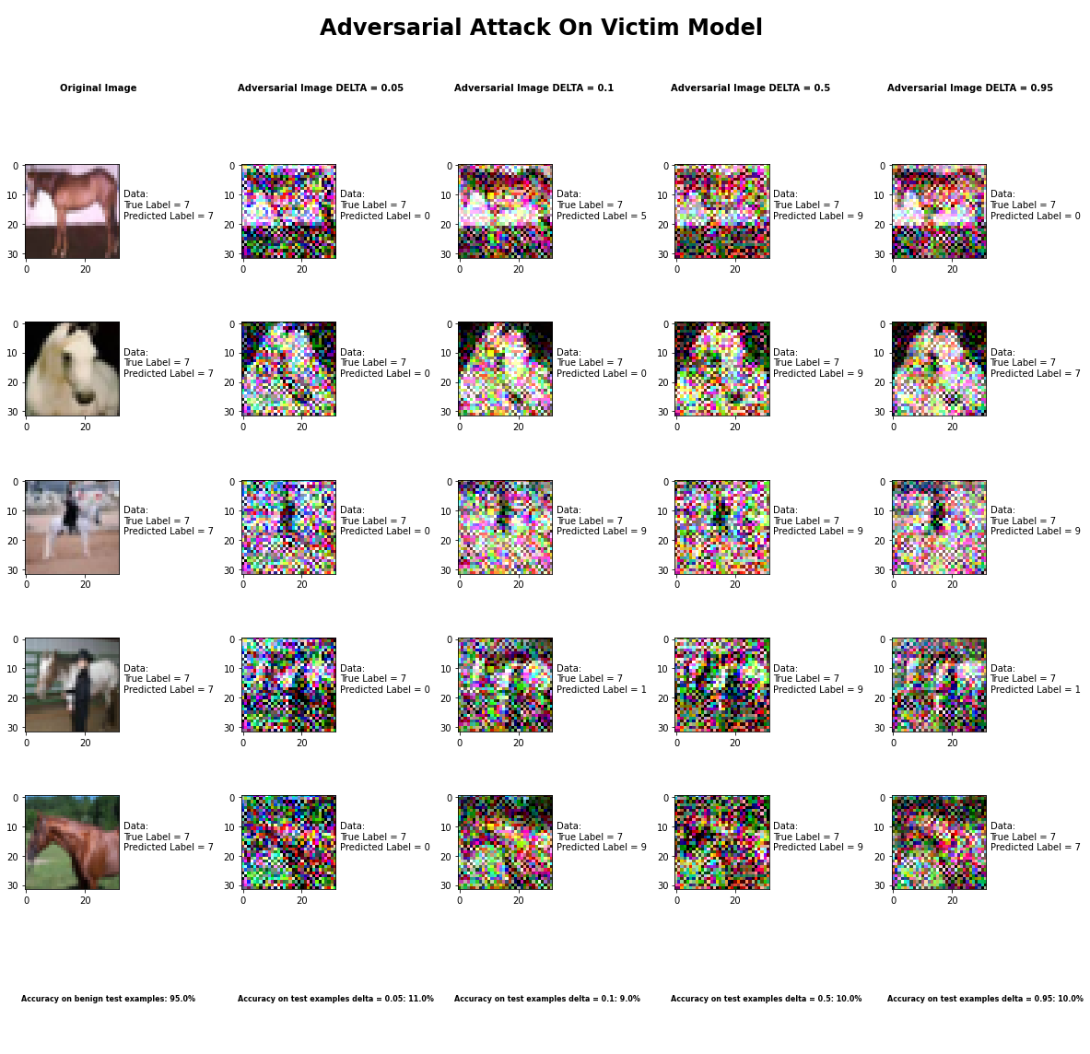

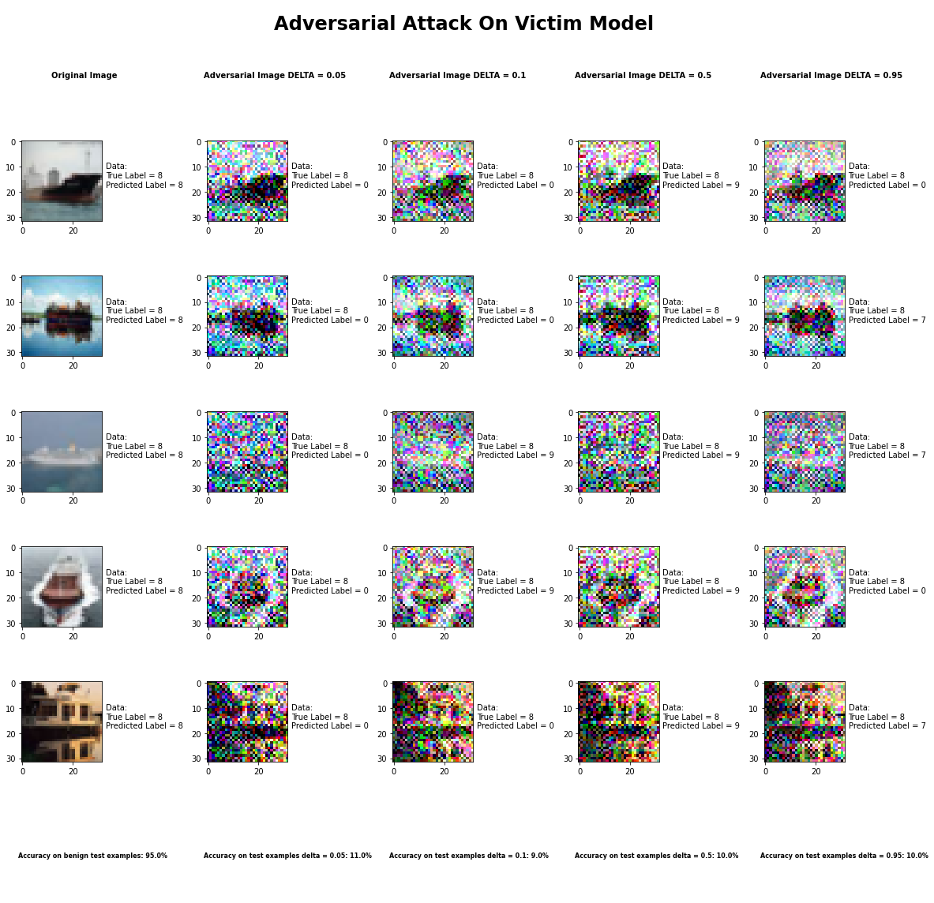

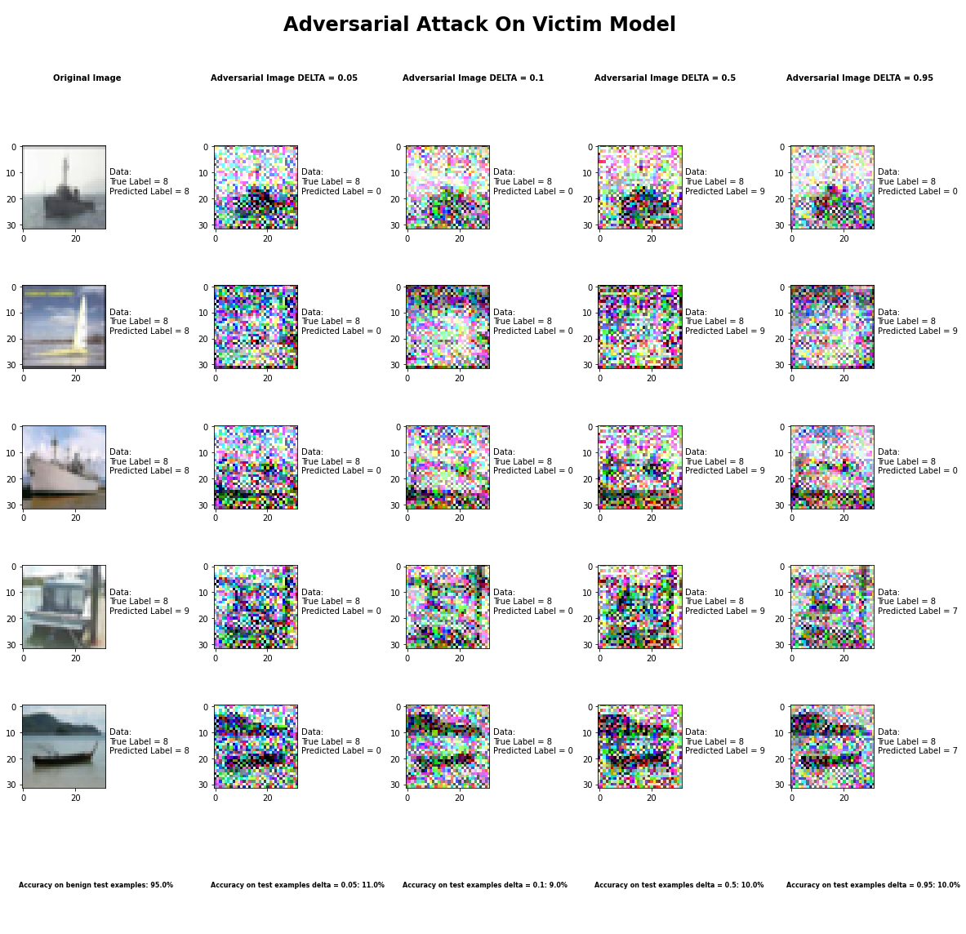

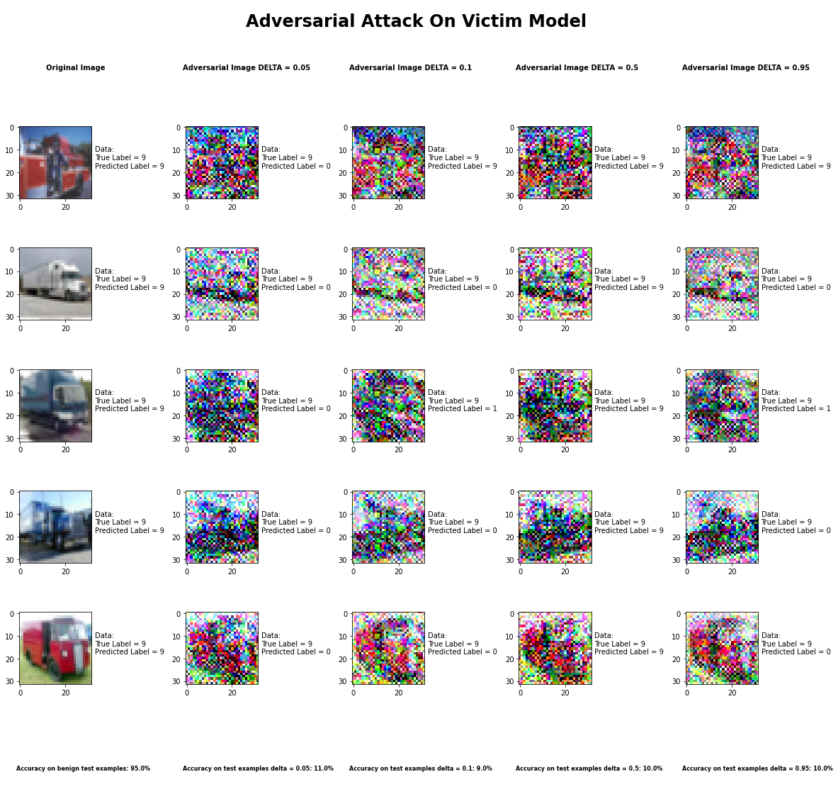

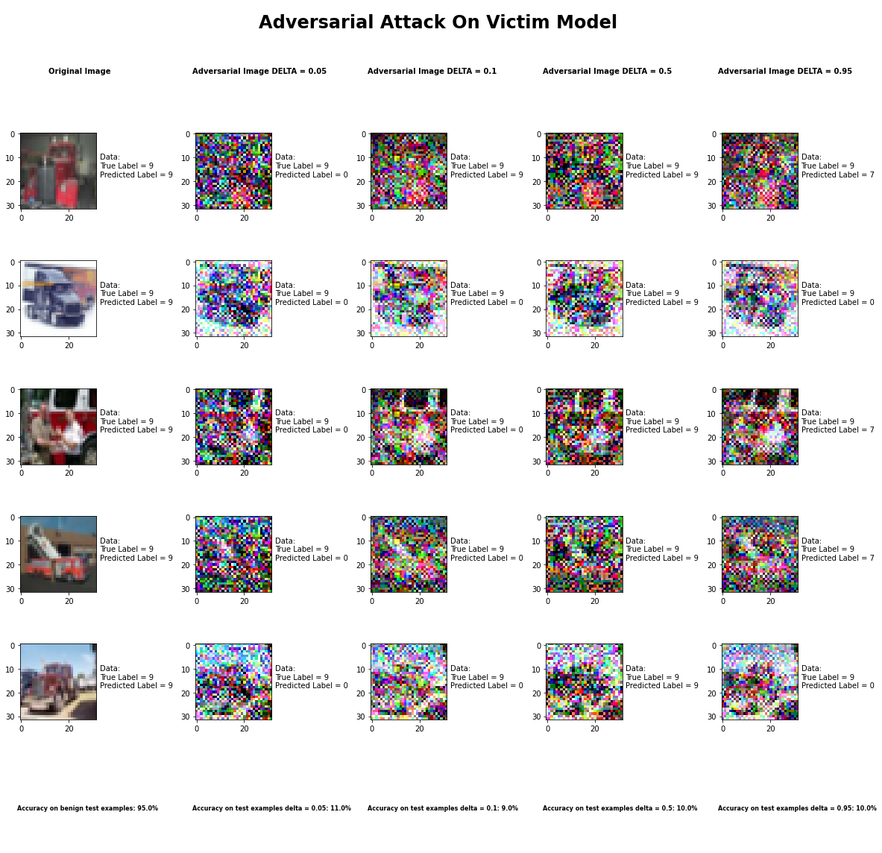

Accuracy on benign test examples: 94.52000000000001%

Average Accuracy on adversarial test examples with delta = 0.05: 10.6%

Average Accuracy on adversarial test examples with delta = 0.1: 9.1%

Average Accuracy on adversarial test examples with delta = 0.5: 10.5%

Average Accuracy on adversarial test examples with delta = 0.95: 10.4%

Classifier with benign example has Airplane recognition average accuracy of = 94%

Universal Perturbation Method with delta = 0.05 has Airplane recognition average accuracy of = 54%

Universal Perturbation Method with delta = 0.1 has Airplane recognition average accuracy of = 36%

Universal Perturbation Method with delta = 0.5 has Airplane recognition average accuracy of = 37%

Universal Perturbation Method with delta = 0.95 has Airplane recognition average accuracy of = 56%

Classifier with benign example has Automobile recognition average accuracy of = 97%

Universal Perturbation Method with delta = 0.05 has Automobile recognition average accuracy of = 1%

Universal Perturbation Method with delta = 0.1 has Automobile recognition average accuracy of = 2%

Universal Perturbation Method with delta = 0.5 has Automobile recognition average accuracy of = 21%

Universal Perturbation Method with delta = 0.95 has Automobile recognition average accuracy of = 5%

Classifier with benign example has Bird recognition average accuracy of = 93%

Universal Perturbation Method with delta = 0.05 has Bird recognition average accuracy of = 0%

Universal Perturbation Method with delta = 0.1 has Bird recognition average accuracy of = 0%

Universal Perturbation Method with delta = 0.5 has Bird recognition average accuracy of = 0%

Universal Perturbation Method with delta = 0.95 has Bird recognition average accuracy of = 0%

Classifier with benign example has Cat recognition average accuracy of = 95%

Universal Perturbation Method with delta = 0.05 has Cat recognition average accuracy of = 0%

Universal Perturbation Method with delta = 0.1 has Cat recognition average accuracy of = 11%

Universal Perturbation Method with delta = 0.5 has Cat recognition average accuracy of = 1%

Universal Perturbation Method with delta = 0.95 has Cat recognition average accuracy of = 2%

Classifier with benign example has Deer recognition average accuracy of = 97%

Universal Perturbation Method with delta = 0.05 has Deer recognition average accuracy of = 0%

Universal Perturbation Method with delta = 0.1 has Deer recognition average accuracy of = 0%

Universal Perturbation Method with delta = 0.5 has Deer recognition average accuracy of = 0%

Universal Perturbation Method with delta = 0.95 has Deer recognition average accuracy of = 0%

Classifier with benign example has Dog recognition average accuracy of = 90%

Universal Perturbation Method with delta = 0.05 has Dog recognition average accuracy of = 0%

Universal Perturbation Method with delta = 0.1 has Dog recognition average accuracy of = 1%

Universal Perturbation Method with delta = 0.5 has Dog recognition average accuracy of = 1%

Universal Perturbation Method with delta = 0.95 has Dog recognition average accuracy of = 1%

Classifier with benign example has Frog recognition average accuracy of = 96%

Universal Perturbation Method with delta = 0.05 has Frog recognition average accuracy of = 2%

Universal Perturbation Method with delta = 0.1 has Frog recognition average accuracy of = 0%

Universal Perturbation Method with delta = 0.5 has Frog recognition average accuracy of = 10%

Universal Perturbation Method with delta = 0.95 has Frog recognition average accuracy of = 3%

Classifier with benign example has Horse recognition average accuracy of = 98%

Universal Perturbation Method with delta = 0.05 has Horse recognition average accuracy of = 0%

Universal Perturbation Method with delta = 0.1 has Horse recognition average accuracy of = 0%

Universal Perturbation Method with delta = 0.5 has Horse recognition average accuracy of = 0%

Universal Perturbation Method with delta = 0.95 has Horse recognition average accuracy of = 9%

Classifier with benign example has Ship recognition average accuracy of = 94%

Universal Perturbation Method with delta = 0.05 has Ship recognition average accuracy of = 0%

Universal Perturbation Method with delta = 0.1 has Ship recognition average accuracy of = 0%

Universal Perturbation Method with delta = 0.5 has Ship recognition average accuracy of = 0%

Universal Perturbation Method with delta = 0.95 has Ship recognition average accuracy of = 0%

Classifier with benign example has Truck recognition average accuracy of = 96%

Universal Perturbation Method with delta = 0.05 has Truck recognition average accuracy of = 49%

Universal Perturbation Method with delta = 0.1 has Truck recognition average accuracy of = 41%

Universal Perturbation Method with delta = 0.5 has Truck recognition average accuracy of = 35%

Universal Perturbation Method with delta = 0.95 has Truck recognition average accuracy of = 28%

## Jacobian Saliency Method



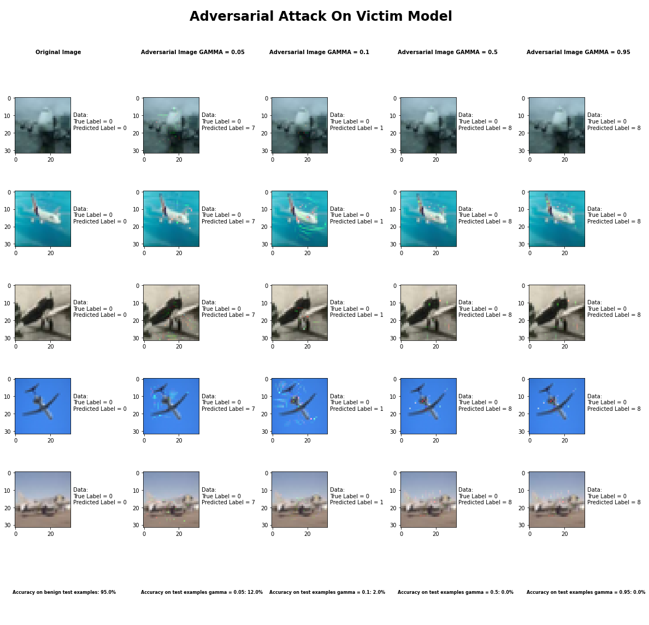

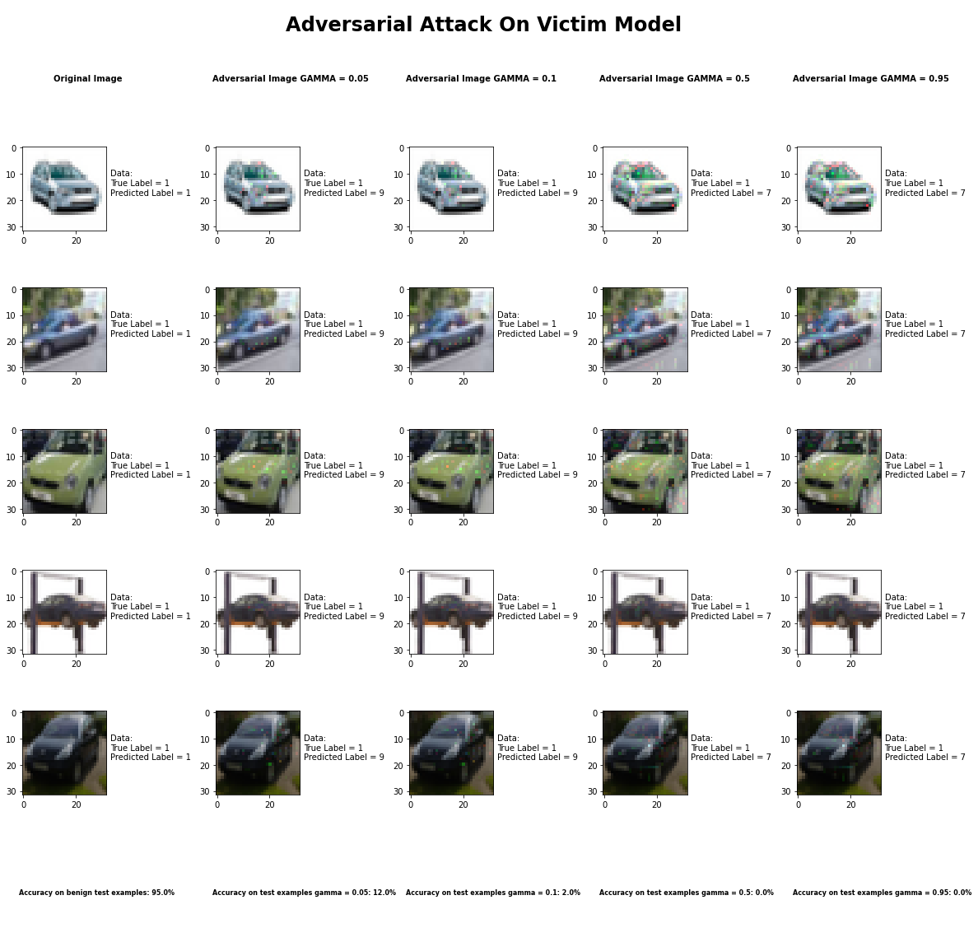

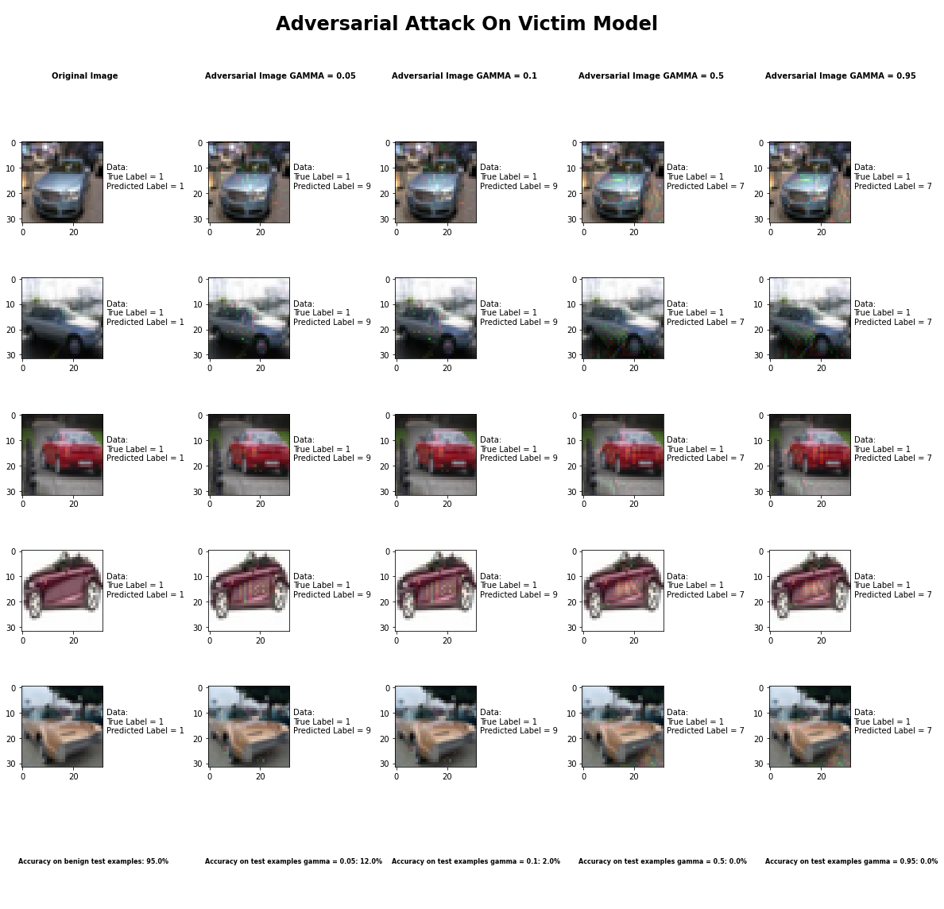

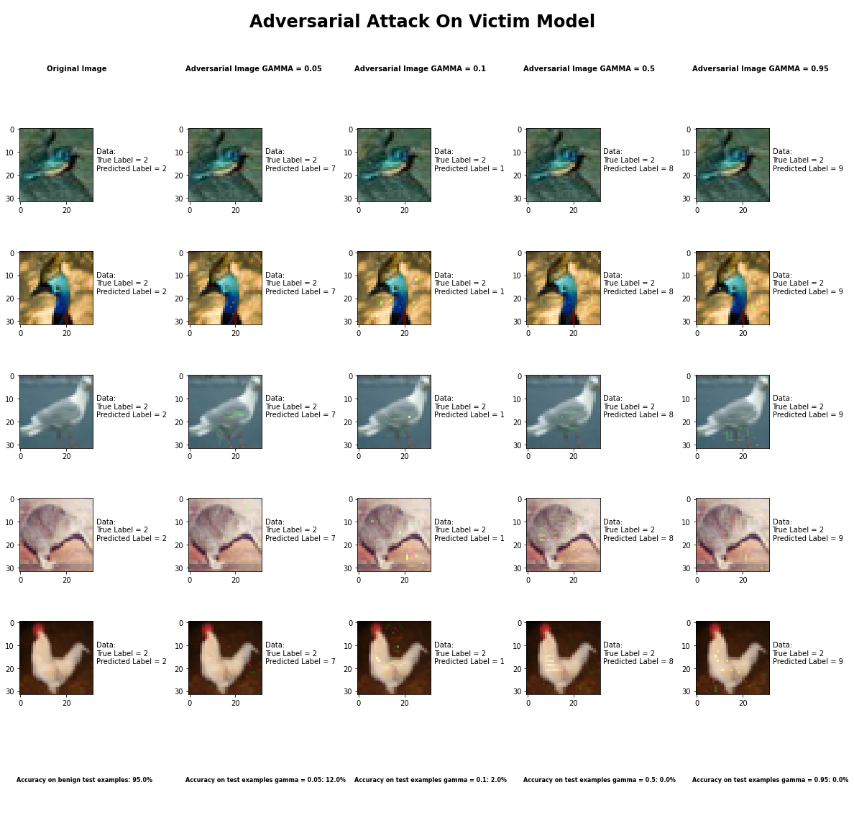

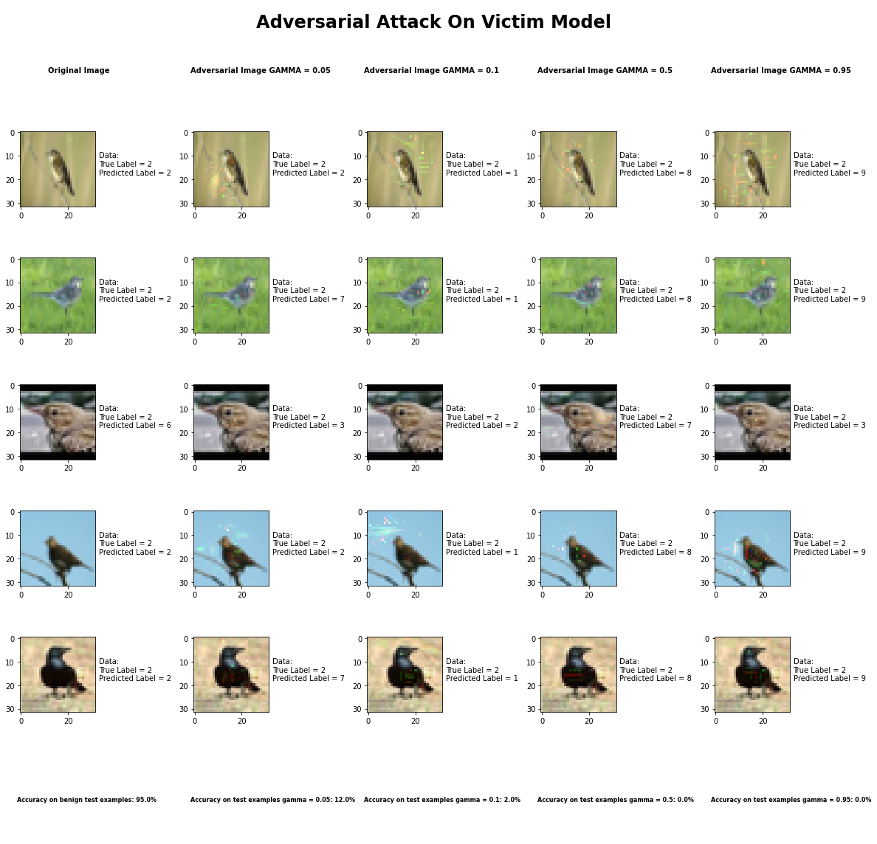

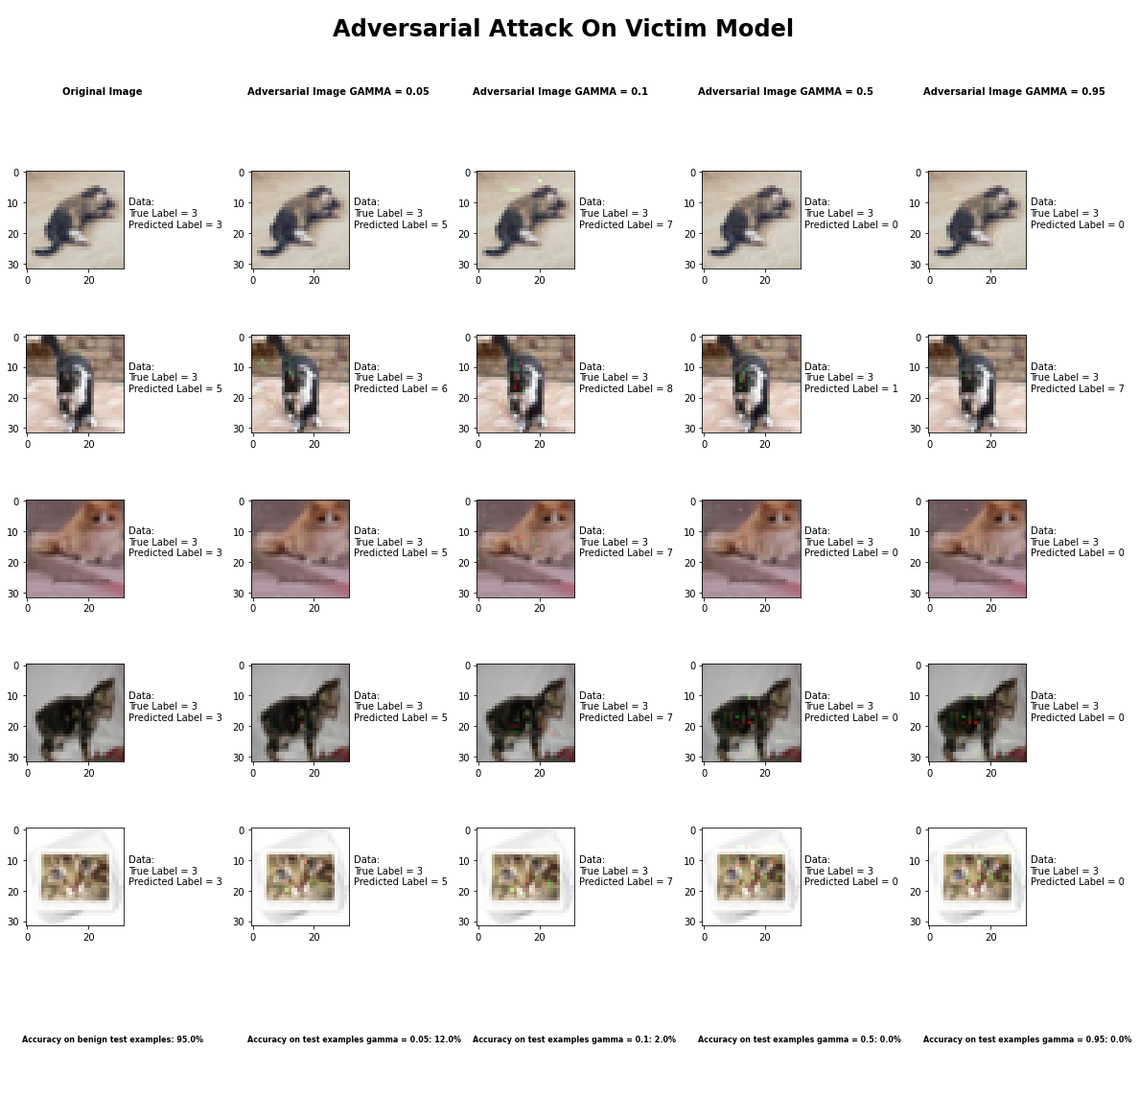

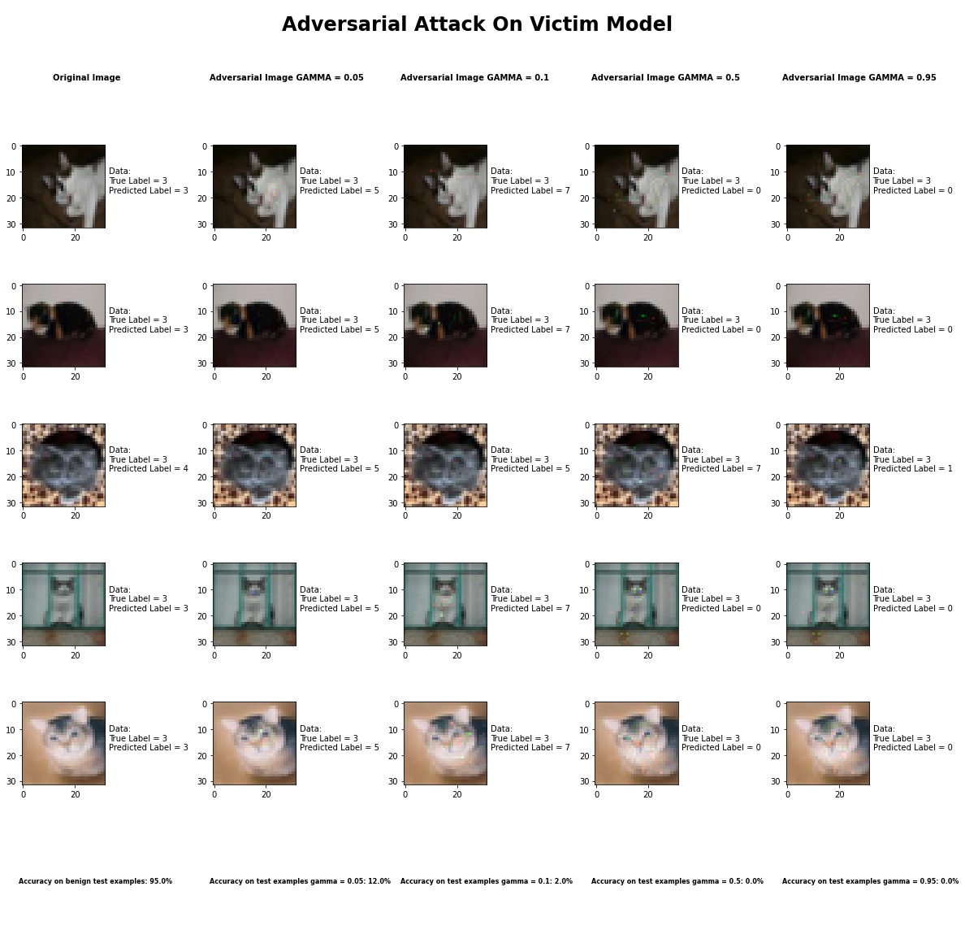

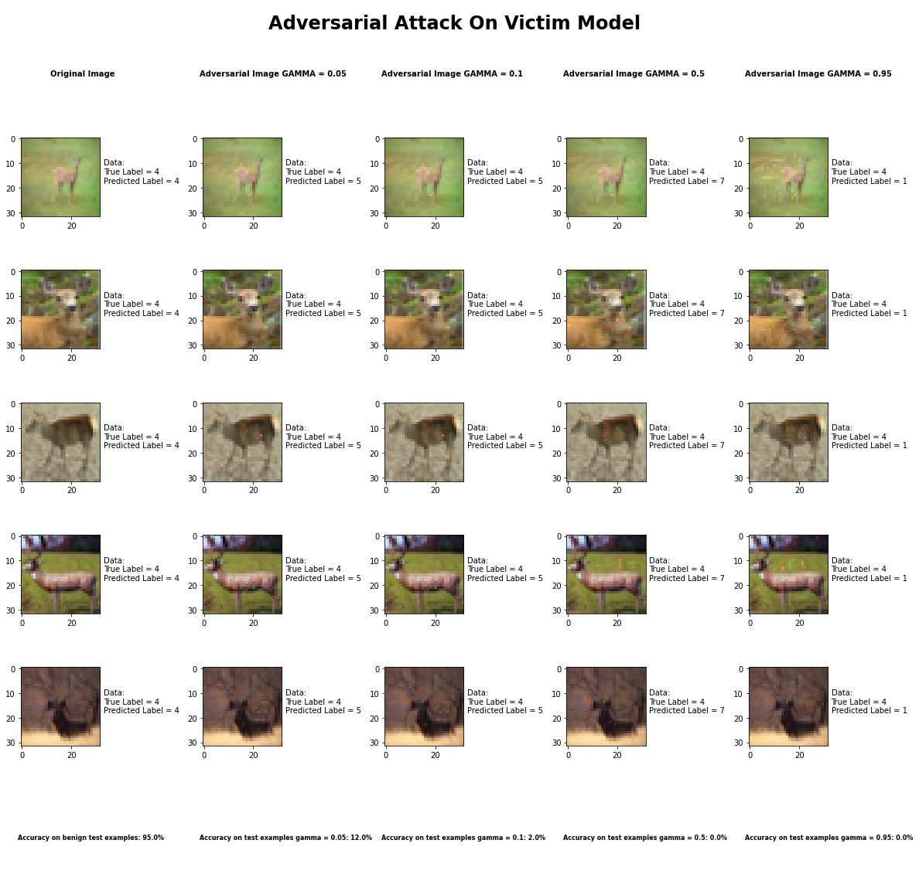

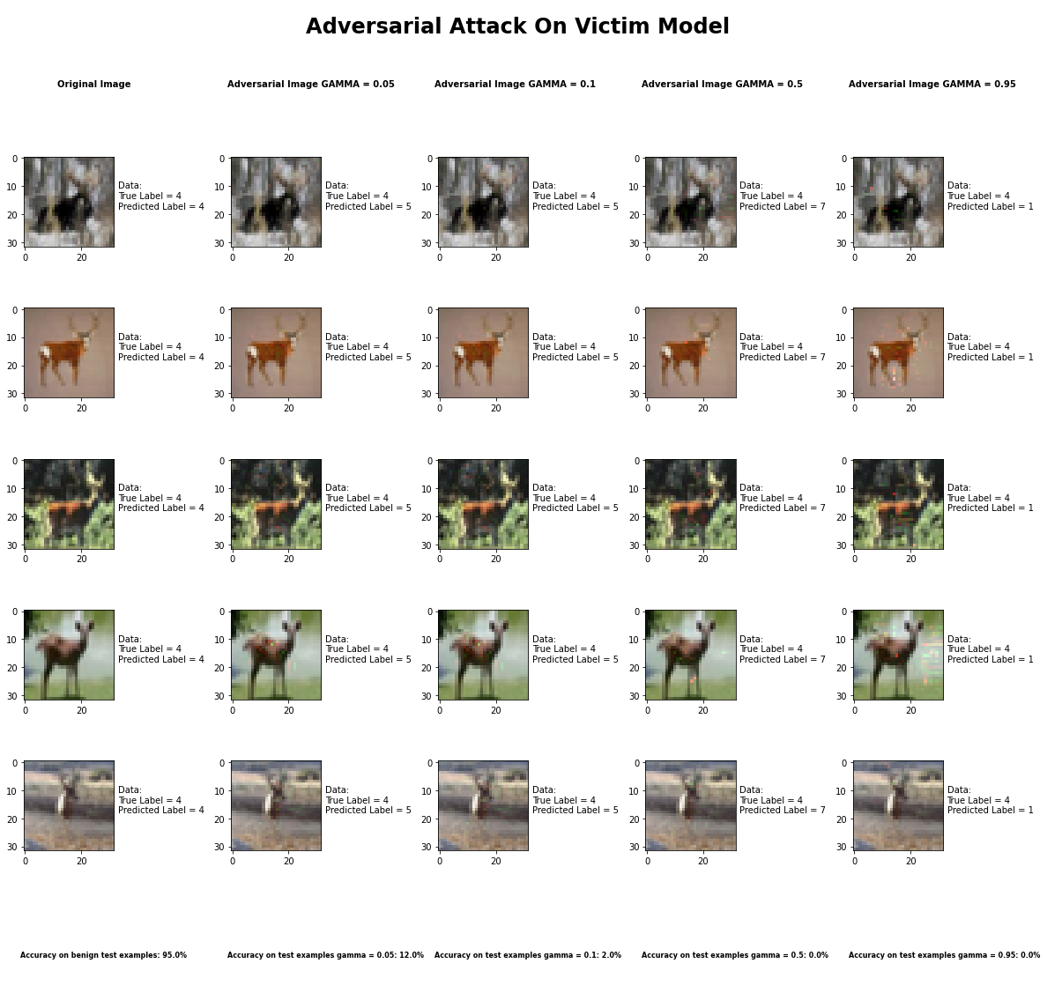

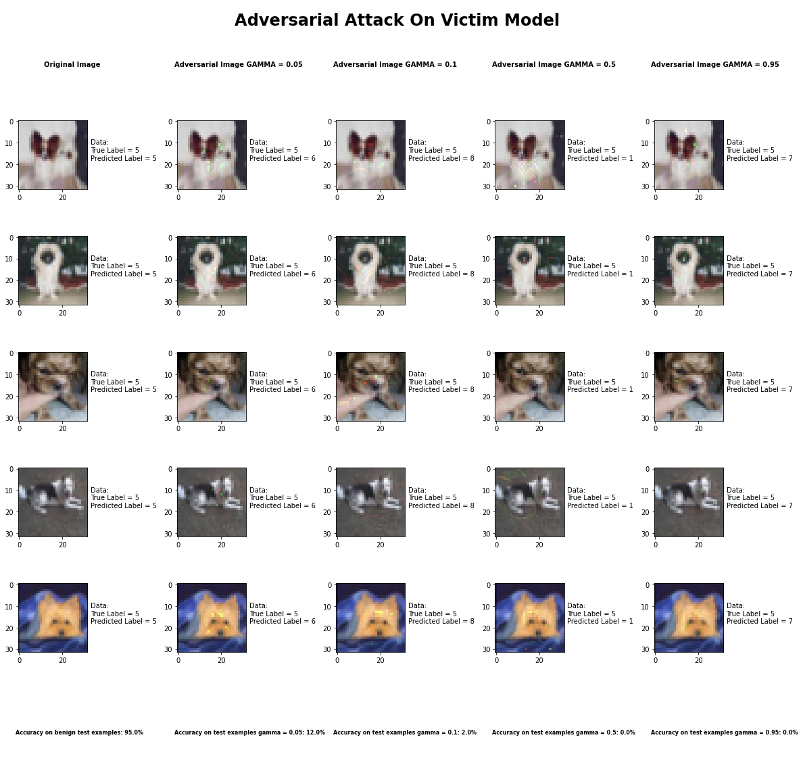

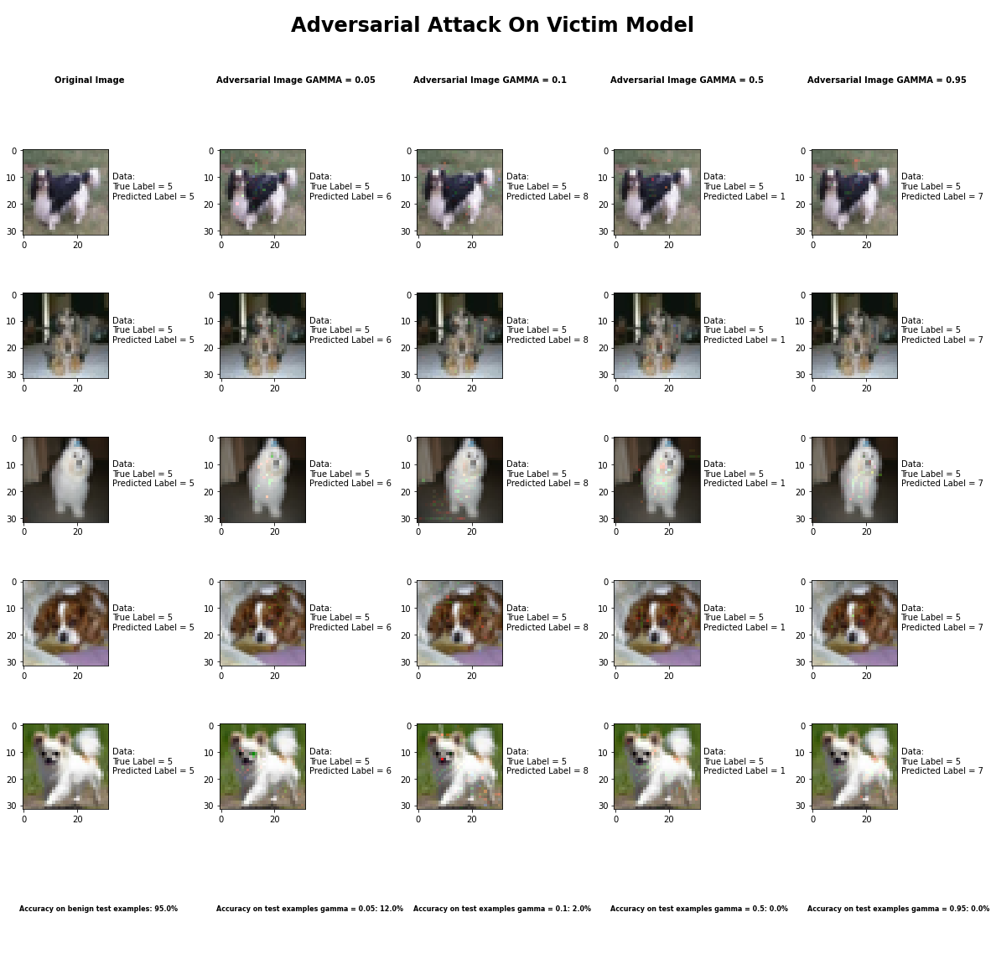

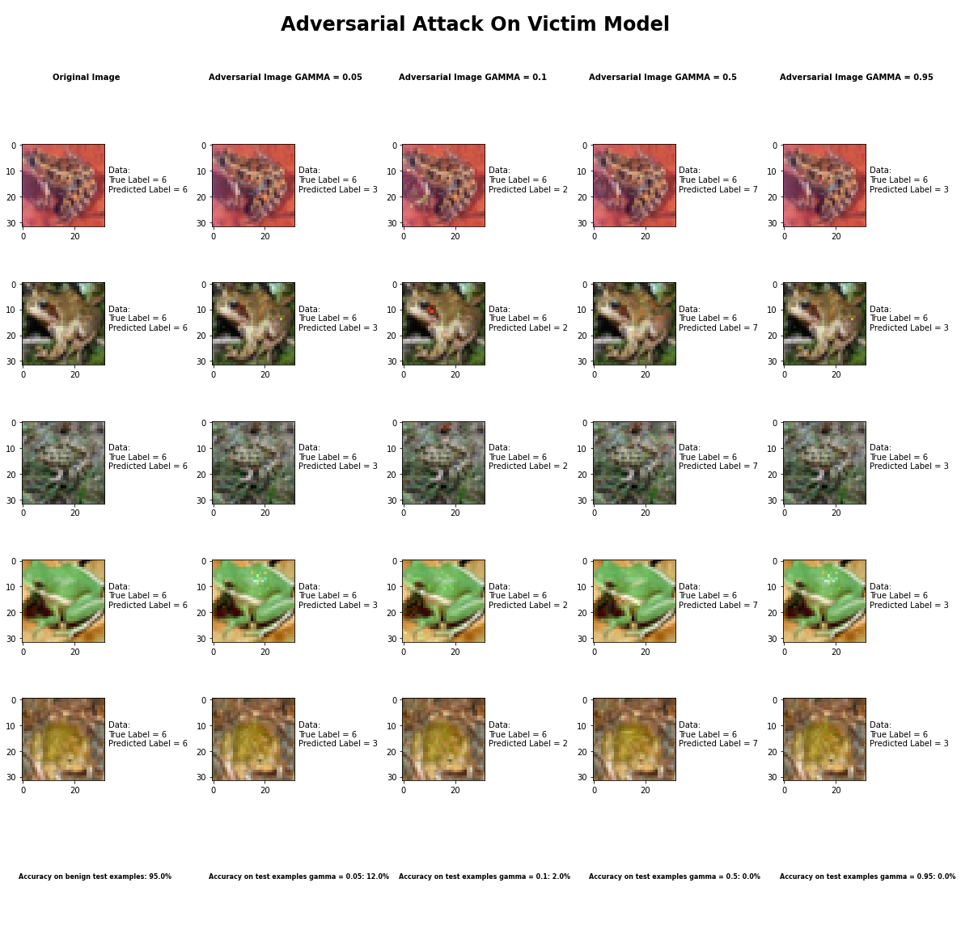

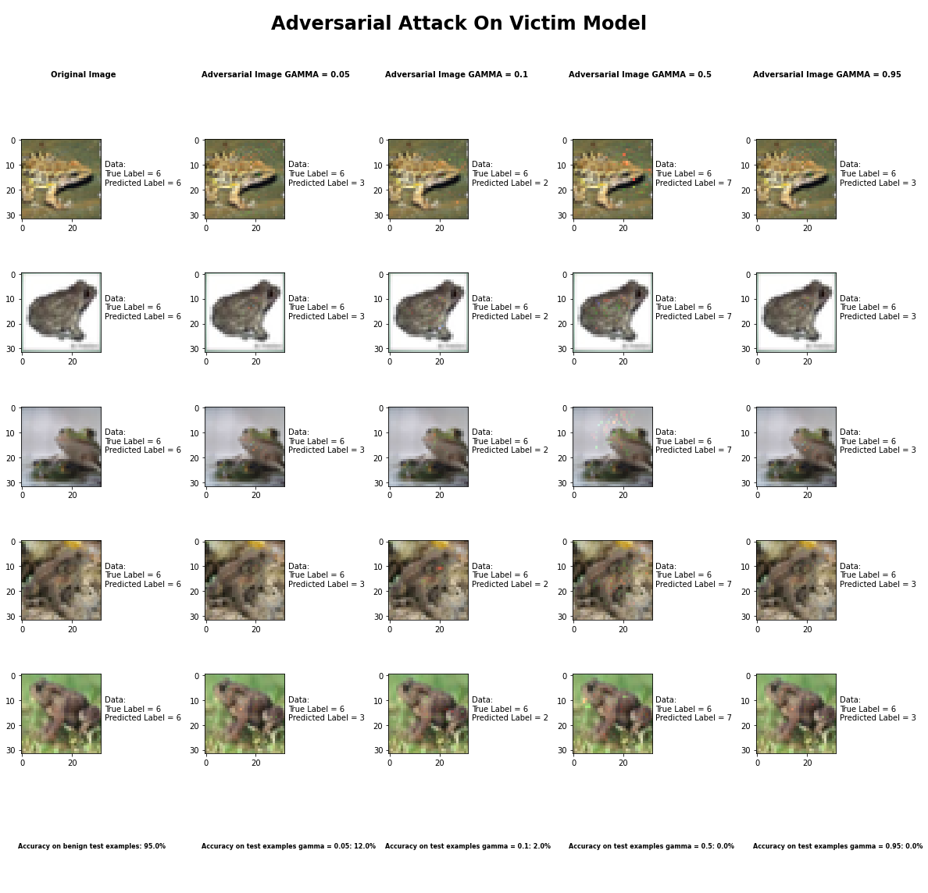

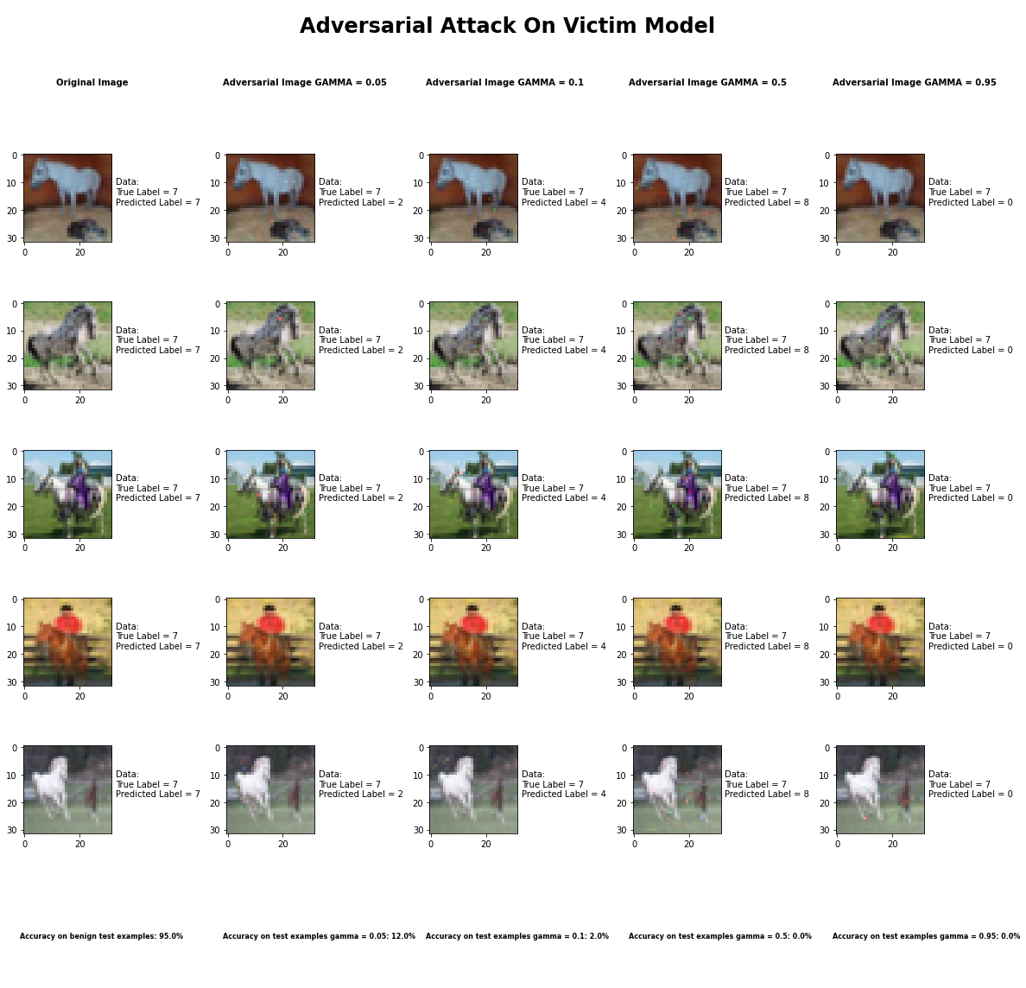

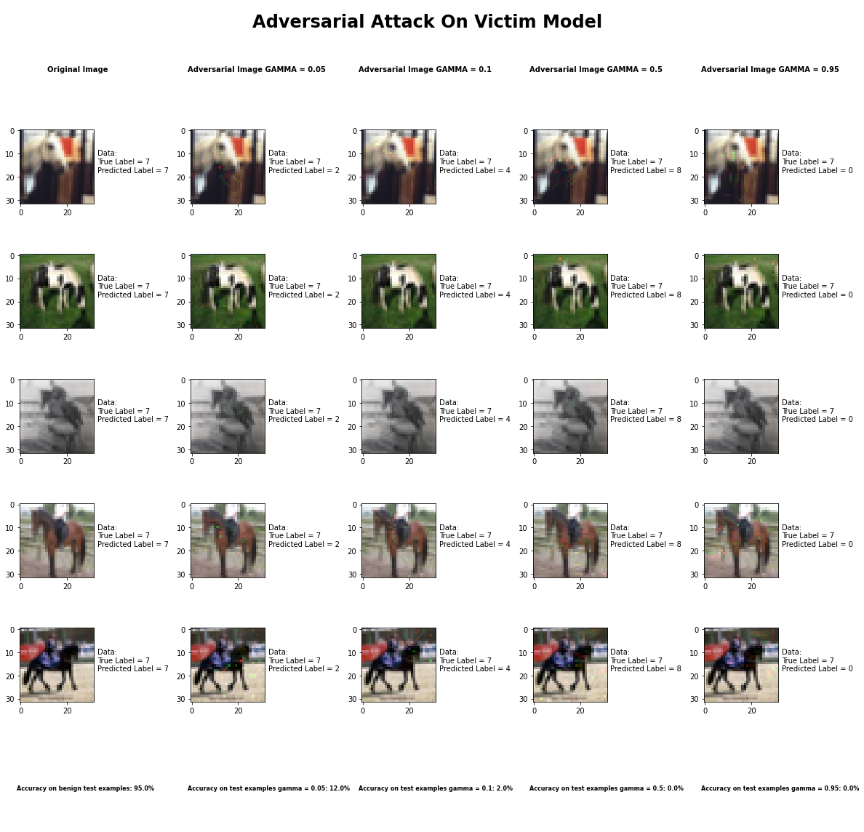

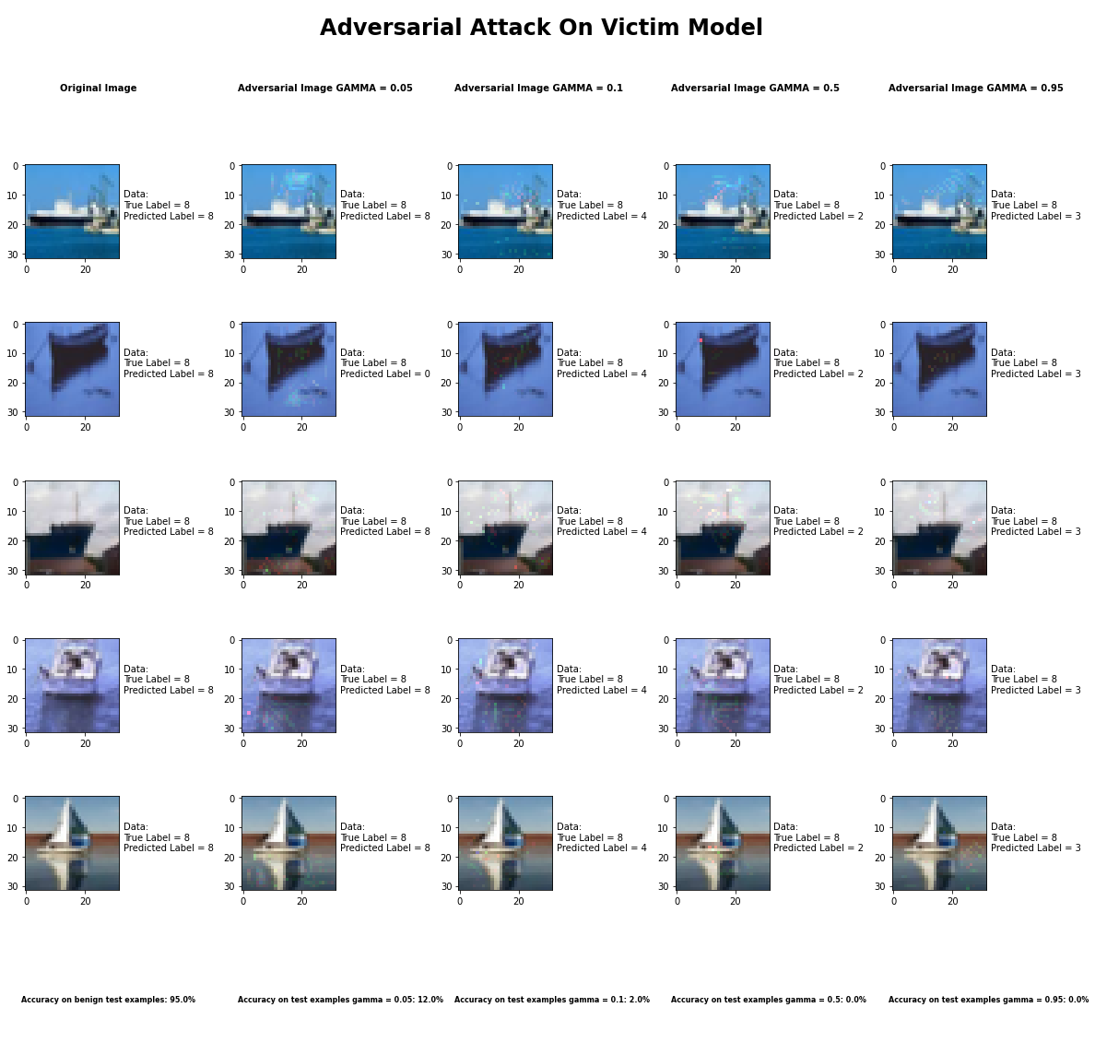

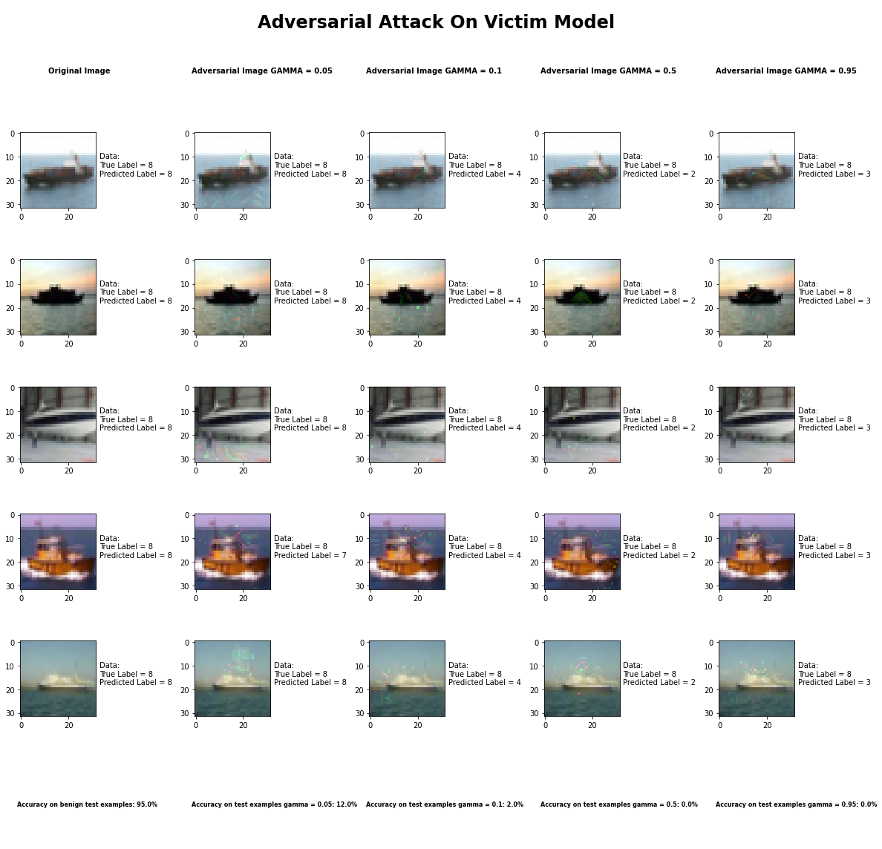

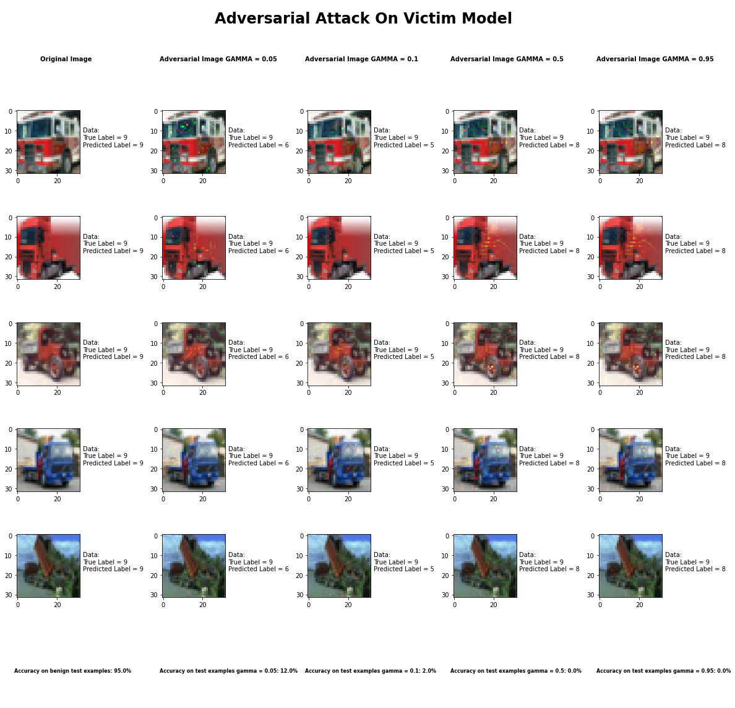

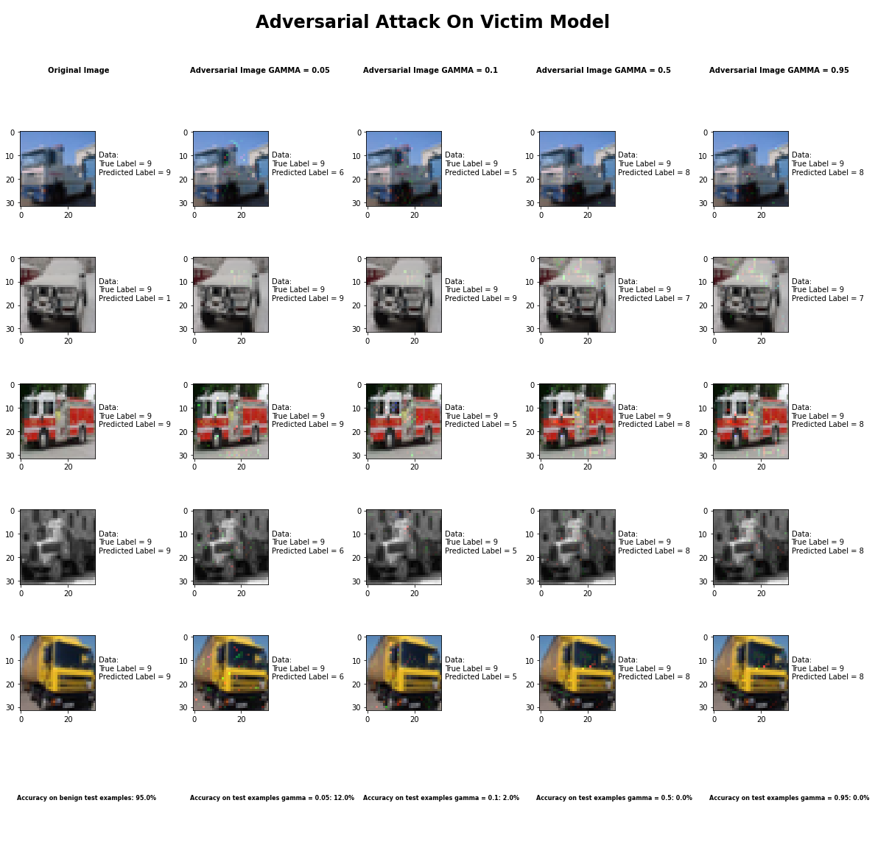

Accuracy on benign test examples: 94.52000000000001%

Average Accuracy on adversarial test examples with gamma = 0.05: 12.5%

Average Accuracy on adversarial test examples with gamma = 0.1: 2.1%

Average Accuracy on adversarial test examples with gamma = 0.5: 0.2%

Average Accuracy on adversarial test examples with gamma = 0.95: 0.1%

Classifier with benign example has Airplane recognition average accuracy of = 97%

Jacobian Saliency Map Method with gamma = 0.05 has Airplane recognition average accuracy of = 19%

Jacobian Saliency Map Method with gamma = 0.1 has Airplane recognition average accuracy of = 2%

Jacobian Saliency Map Method with gamma = 0.5 has Airplane recognition average accuracy of = 0%

Jacobian Saliency Map Method with gamma = 0.95 has Airplane recognition average accuracy of = 0%

Classifier with benign example has Automobile recognition average accuracy of = 99%

Jacobian Saliency Map Method with gamma = 0.05 has Automobile recognition average accuracy of = 34%

Jacobian Saliency Map Method with gamma = 0.1 has Automobile recognition average accuracy of = 6%

Jacobian Saliency Map Method with gamma = 0.5 has Automobile recognition average accuracy of = 0%

Jacobian Saliency Map Method with gamma = 0.95 has Automobile recognition average accuracy of = 0%

Classifier with benign example has Bird recognition average accuracy of = 92%

Jacobian Saliency Map Method with gamma = 0.05 has Bird recognition average accuracy of = 7%

Jacobian Saliency Map Method with gamma = 0.1 has Bird recognition average accuracy of = 1%

Jacobian Saliency Map Method with gamma = 0.5 has Bird recognition average accuracy of = 0%

Jacobian Saliency Map Method with gamma = 0.95 has Bird recognition average accuracy of = 0%

Classifier with benign example has Cat recognition average accuracy of = 87%

Jacobian Saliency Map Method with gamma = 0.05 has Cat recognition average accuracy of = 4%

Jacobian Saliency Map Method with gamma = 0.1 has Cat recognition average accuracy of = 4%

Jacobian Saliency Map Method with gamma = 0.5 has Cat recognition average accuracy of = 1%

Jacobian Saliency Map Method with gamma = 0.95 has Cat recognition average accuracy of = 1%

Classifier with benign example has Deer recognition average accuracy of = 94%

Jacobian Saliency Map Method with gamma = 0.05 has Deer recognition average accuracy of = 2%

Jacobian Saliency Map Method with gamma = 0.1 has Deer recognition average accuracy of = 0%

Jacobian Saliency Map Method with gamma = 0.5 has Deer recognition average accuracy of = 1%

Jacobian Saliency Map Method with gamma = 0.95 has Deer recognition average accuracy of = 0%

Classifier with benign example has Dog recognition average accuracy of = 84%

Jacobian Saliency Map Method with gamma = 0.05 has Dog recognition average accuracy of = 5%

Jacobian Saliency Map Method with gamma = 0.1 has Dog recognition average accuracy of = 3%

Jacobian Saliency Map Method with gamma = 0.5 has Dog recognition average accuracy of = 0%

Jacobian Saliency Map Method with gamma = 0.95 has Dog recognition average accuracy of = 0%

Classifier with benign example has Frog recognition average accuracy of = 98%

Jacobian Saliency Map Method with gamma = 0.05 has Frog recognition average accuracy of = 7%

Jacobian Saliency Map Method with gamma = 0.1 has Frog recognition average accuracy of = 0%

Jacobian Saliency Map Method with gamma = 0.5 has Frog recognition average accuracy of = 0%

Jacobian Saliency Map Method with gamma = 0.95 has Frog recognition average accuracy of = 0%

Classifier with benign example has Horse recognition average accuracy of = 97%

Jacobian Saliency Map Method with gamma = 0.05 has Horse recognition average accuracy of = 10%

Jacobian Saliency Map Method with gamma = 0.1 has Horse recognition average accuracy of = 1%

Jacobian Saliency Map Method with gamma = 0.5 has Horse recognition average accuracy of = 0%

Jacobian Saliency Map Method with gamma = 0.95 has Horse recognition average accuracy of = 0%

Classifier with benign example has Ship recognition average accuracy of = 99%

Jacobian Saliency Map Method with gamma = 0.05 has Ship recognition average accuracy of = 20%

Jacobian Saliency Map Method with gamma = 0.1 has Ship recognition average accuracy of = 1%

Jacobian Saliency Map Method with gamma = 0.5 has Ship recognition average accuracy of = 0%

Jacobian Saliency Map Method with gamma = 0.95 has Ship recognition average accuracy of = 0%

Classifier with benign example has Truck recognition average accuracy of = 96%

Jacobian Saliency Map Method with gamma = 0.05 has Truck recognition average accuracy of = 17%

Jacobian Saliency Map Method with gamma = 0.1 has Truck recognition average accuracy of = 3%

Jacobian Saliency Map Method with gamma = 0.5 has Truck recognition average accuracy of = 0%

Jacobian Saliency Map Method with gamma = 0.95 has Truck recognition average accuracy of = 0%

## DeepFool Method



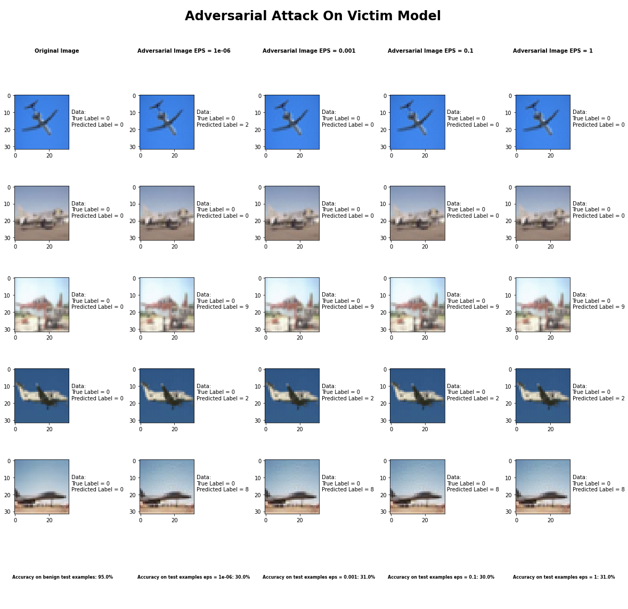

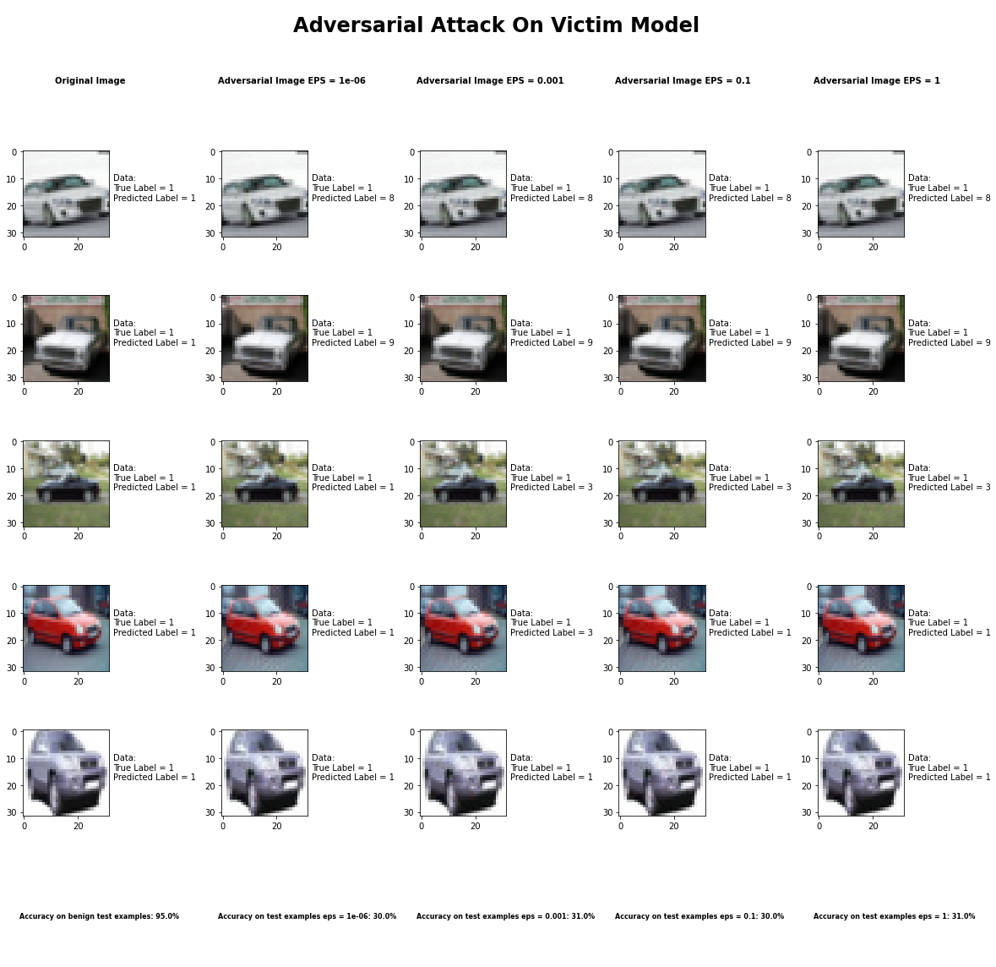

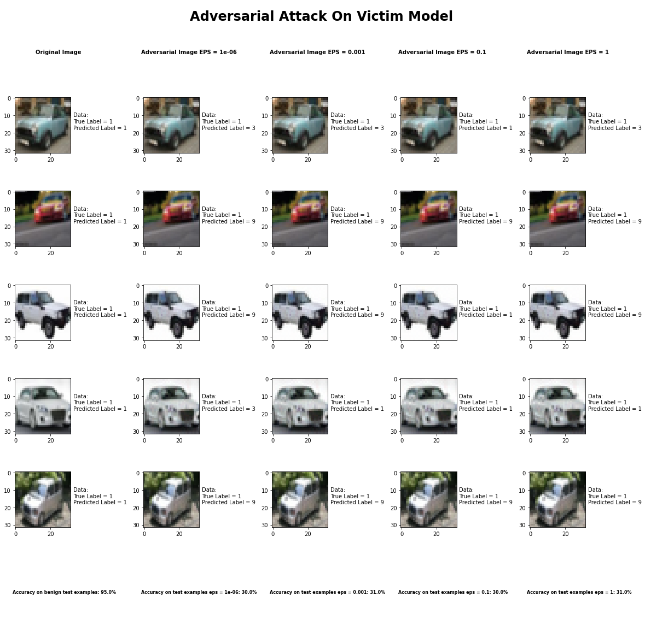

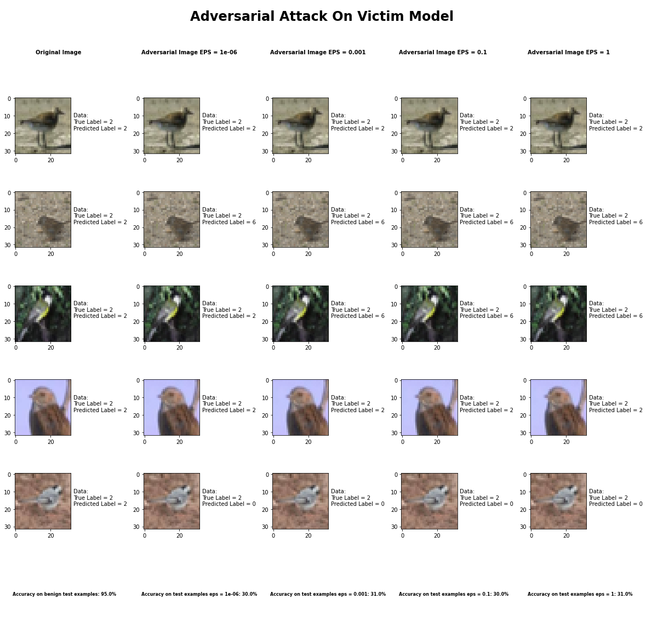

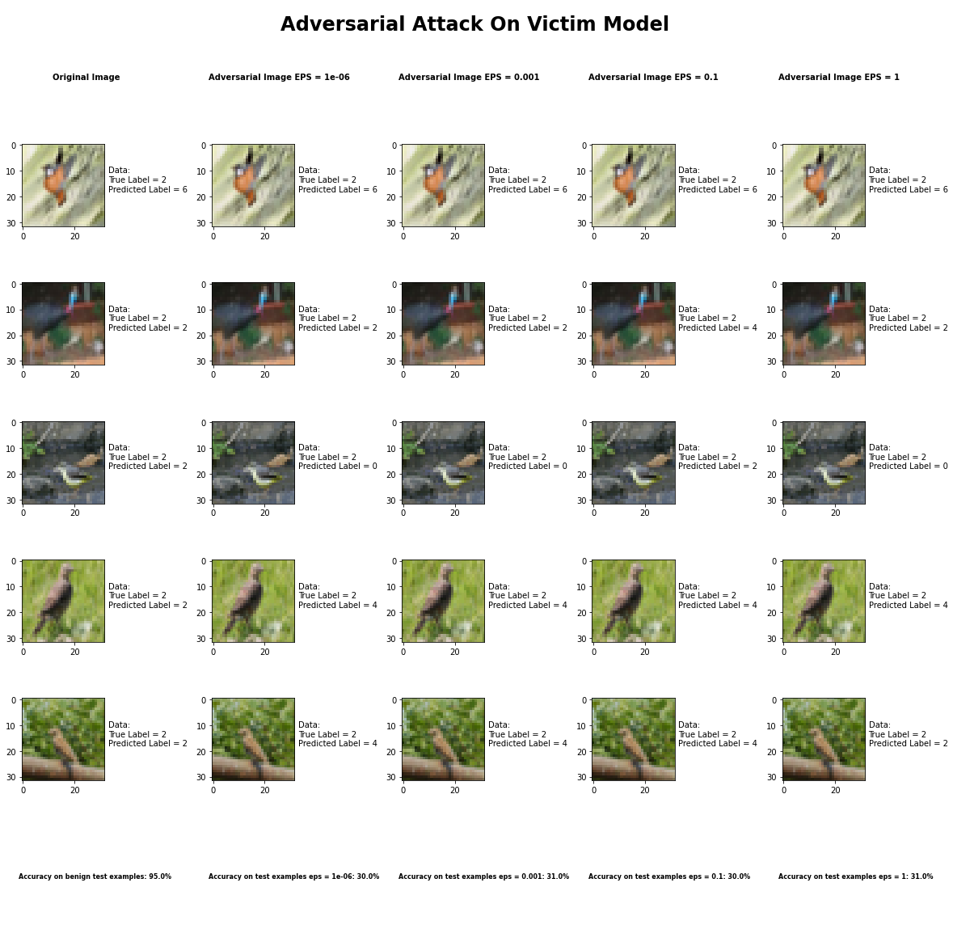

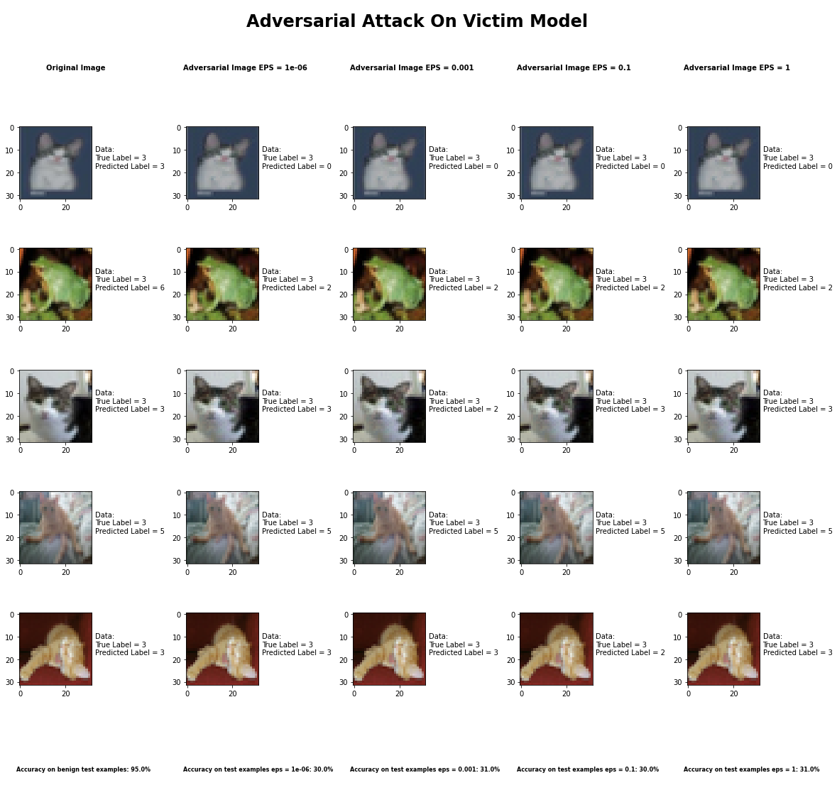

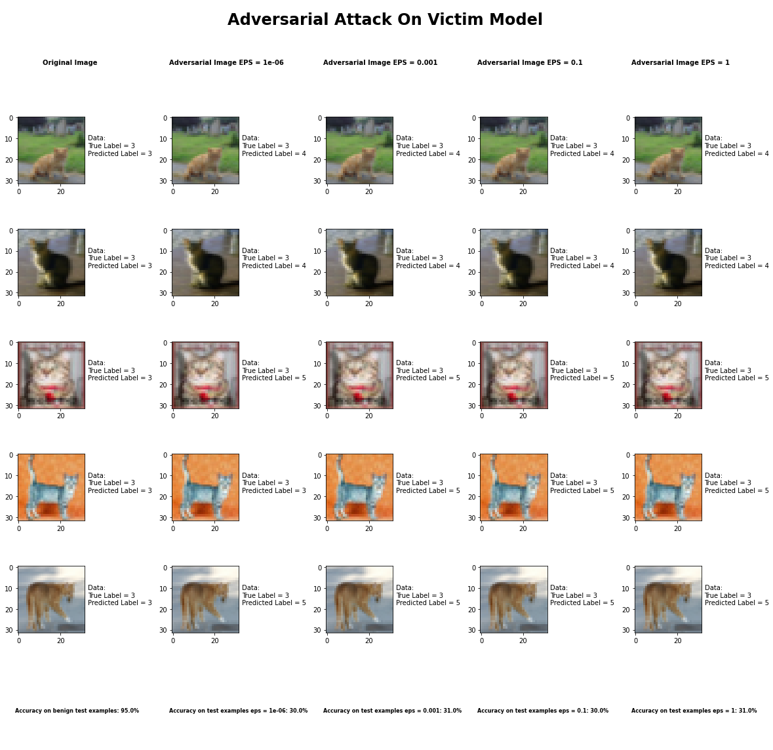

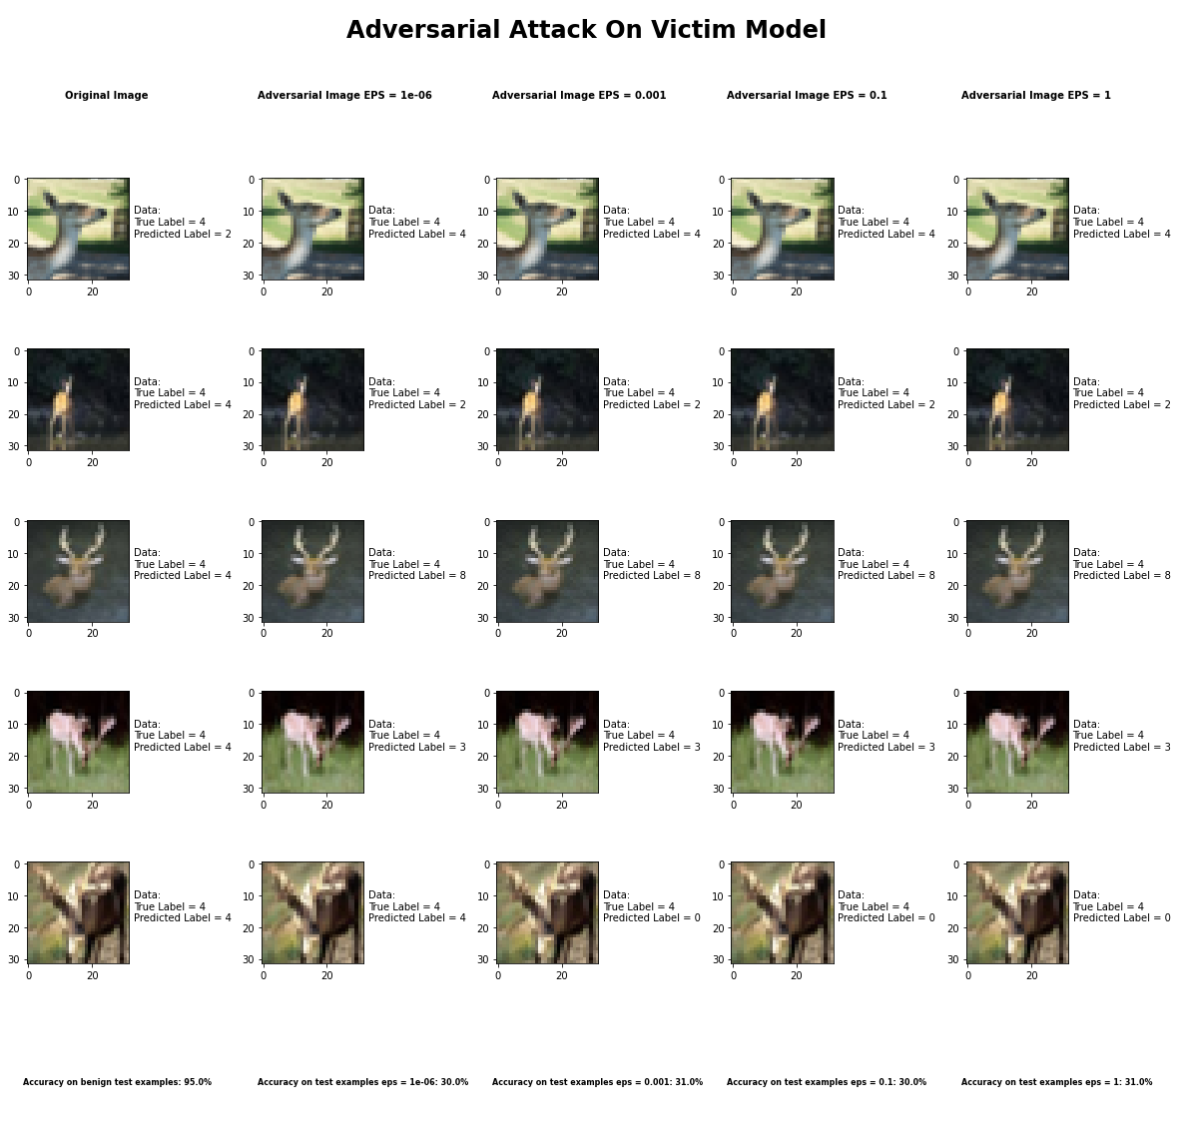

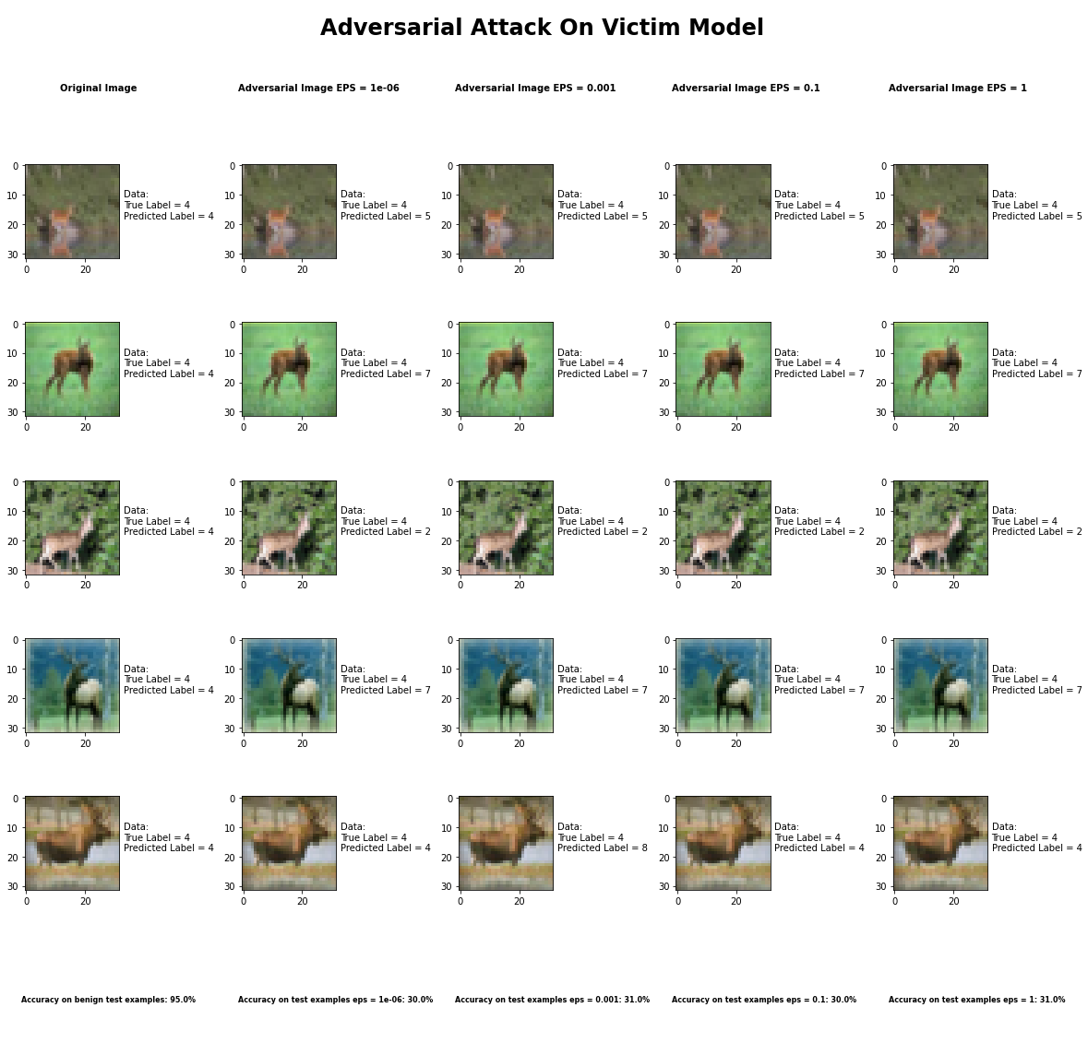

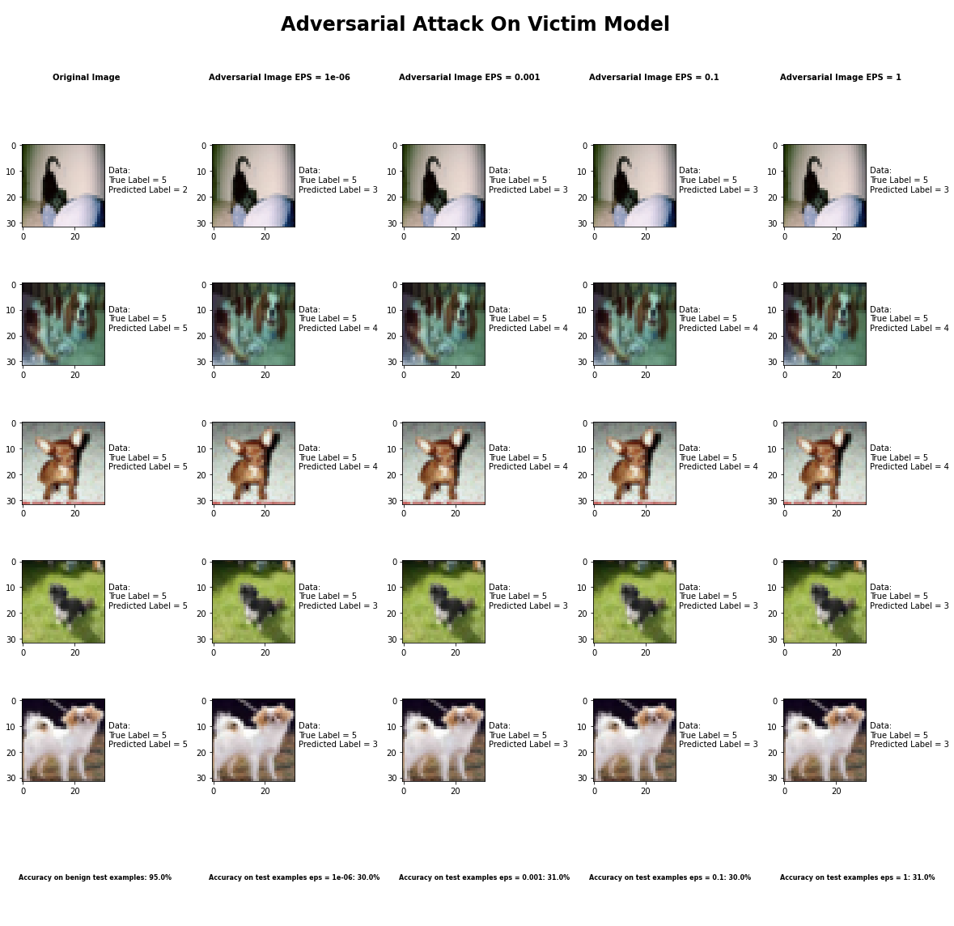

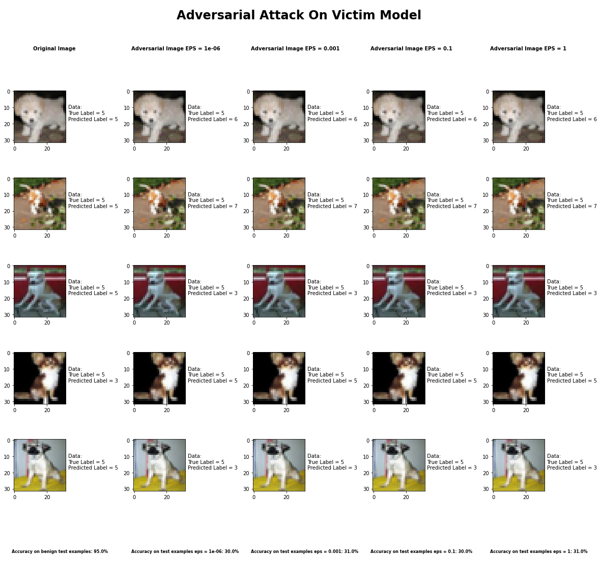

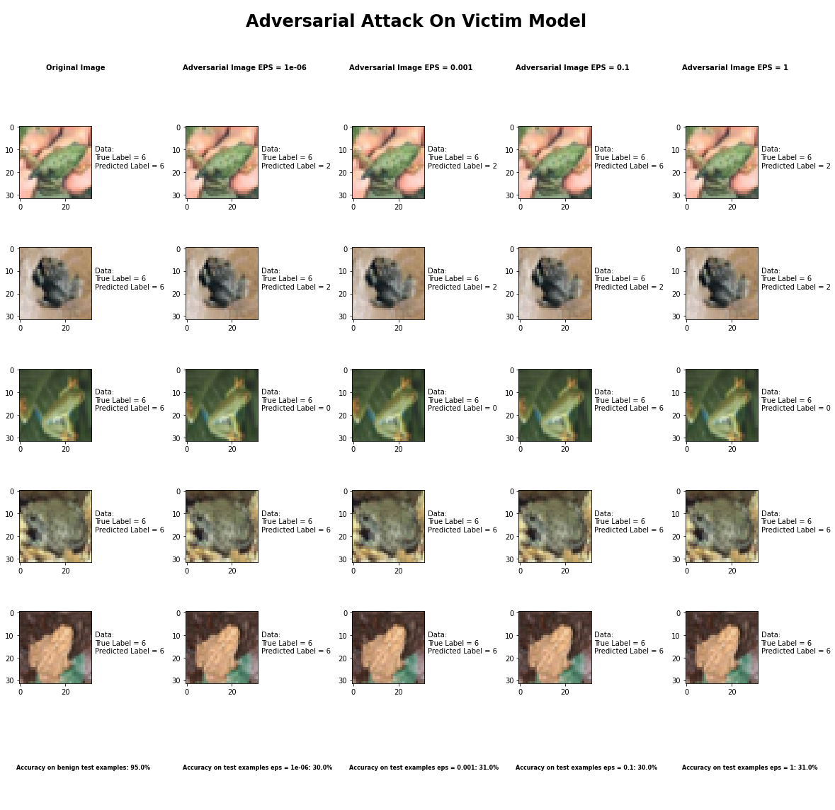

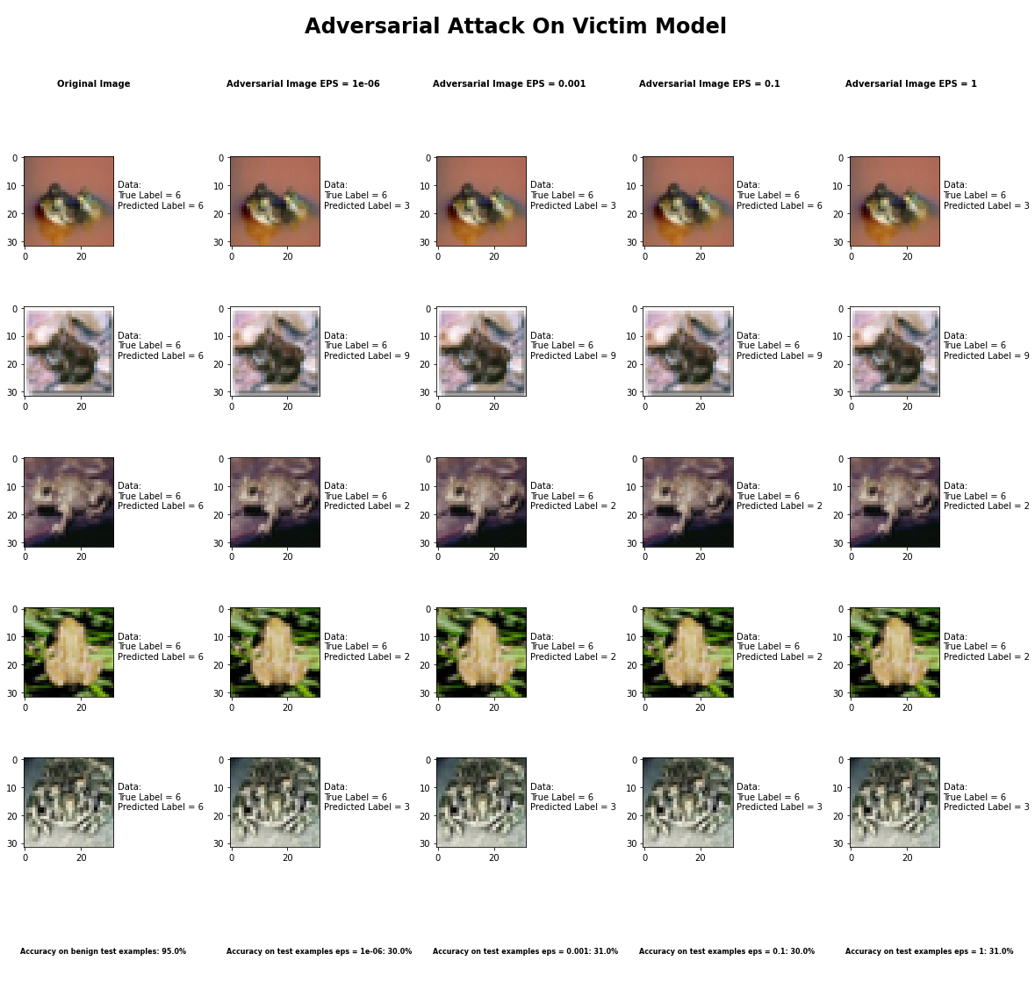

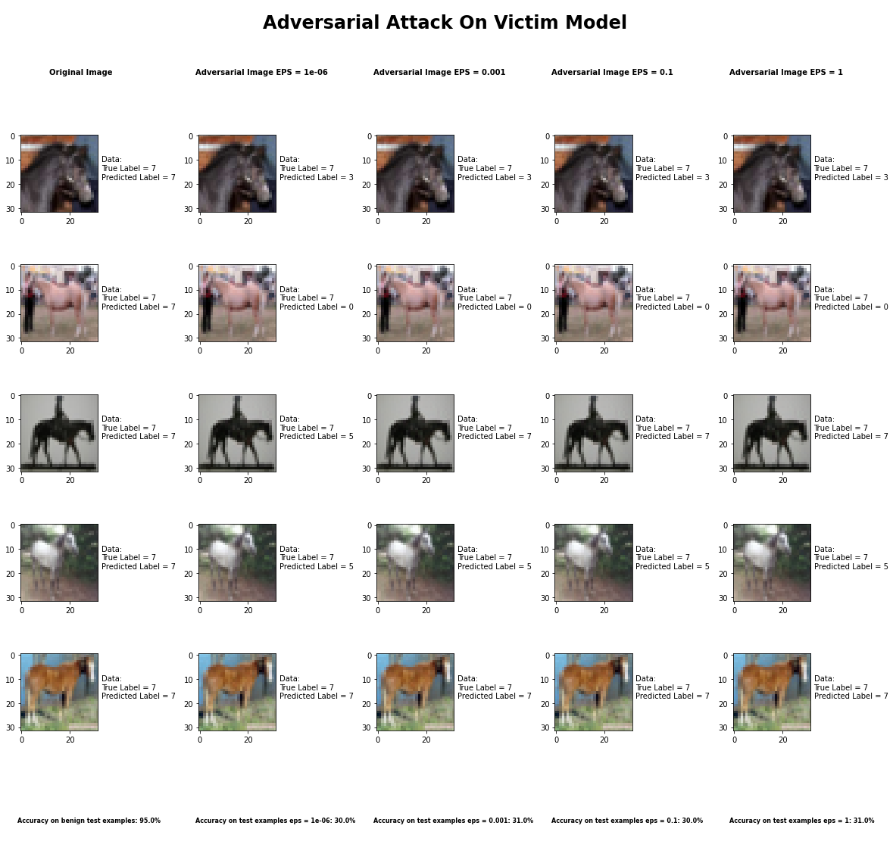

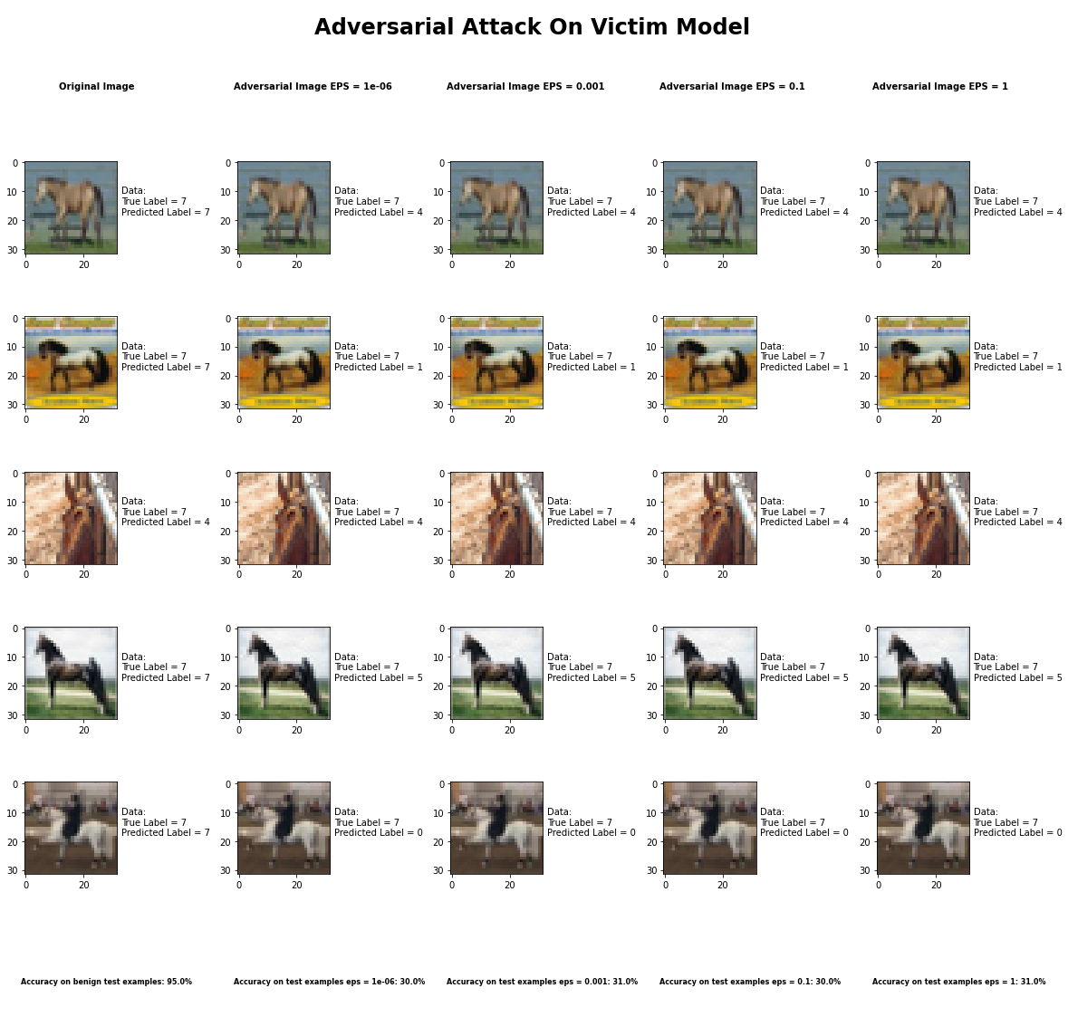

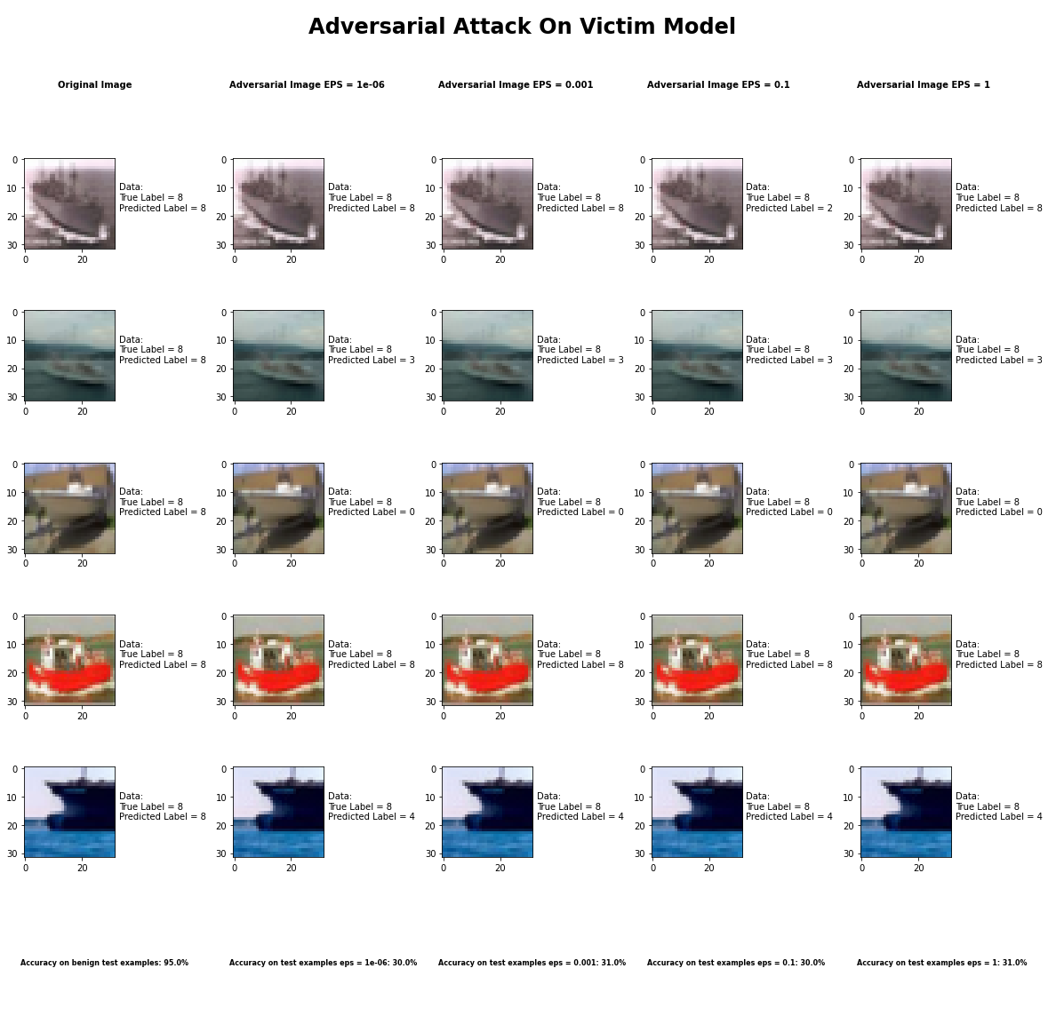

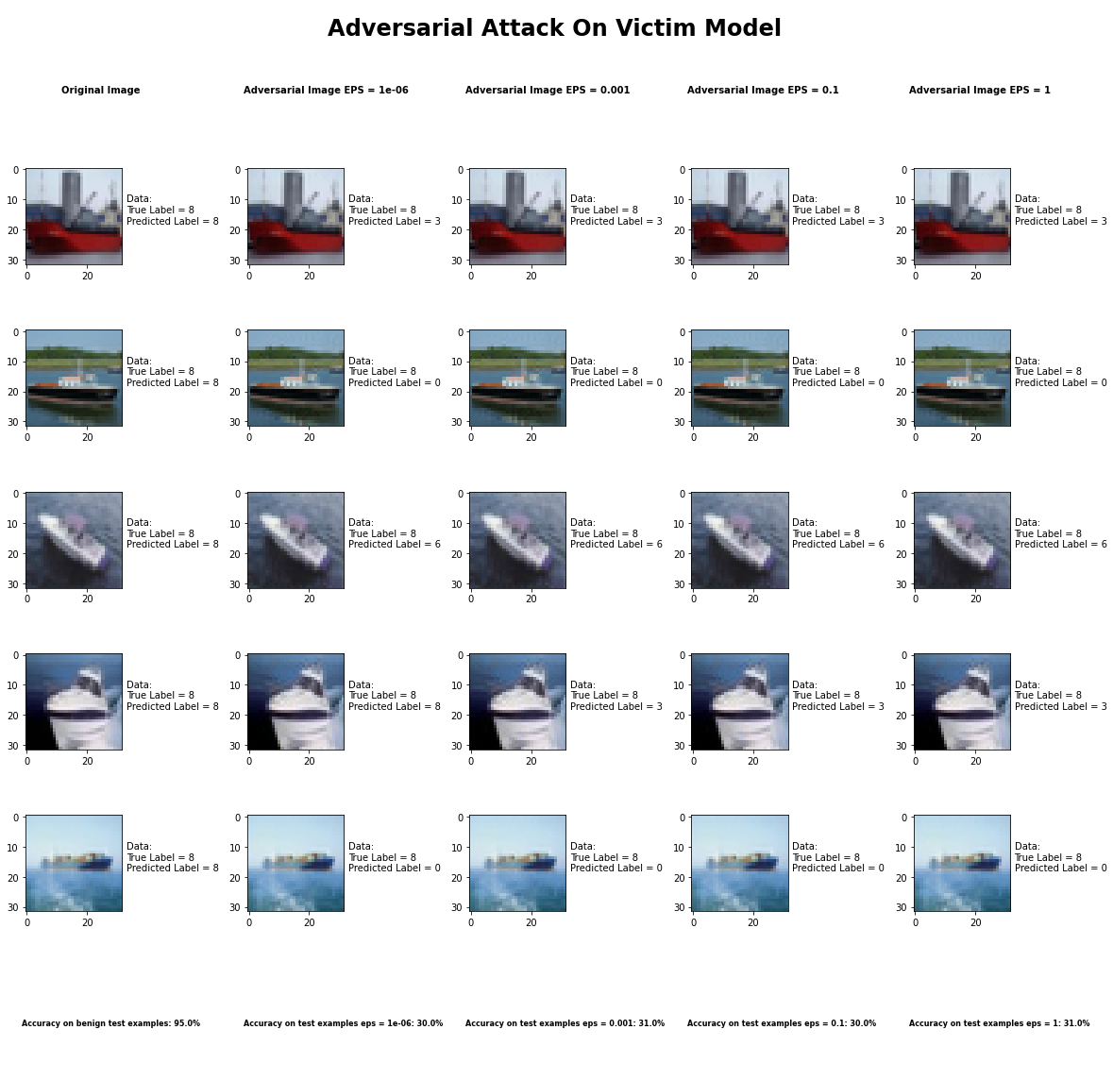

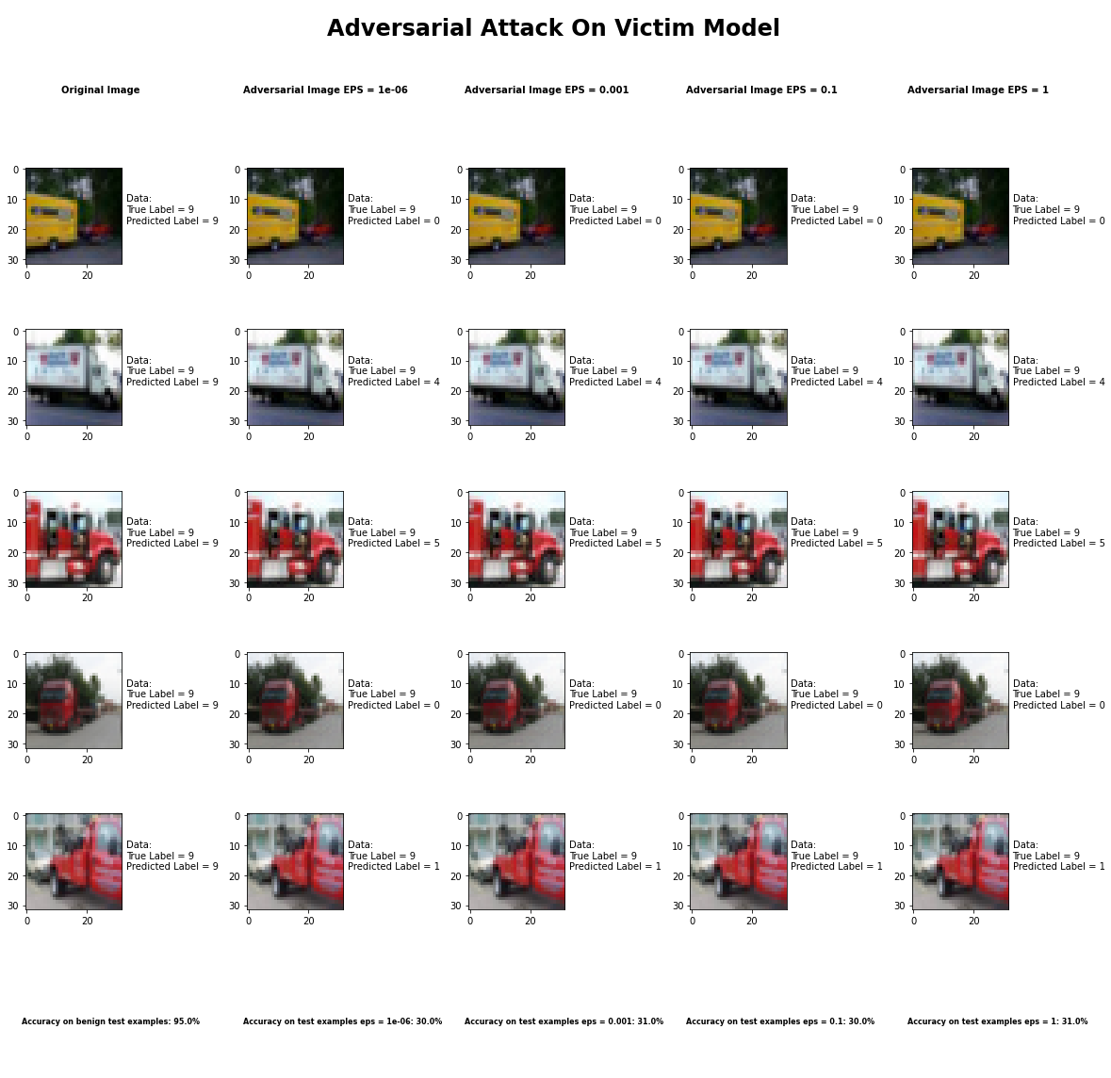

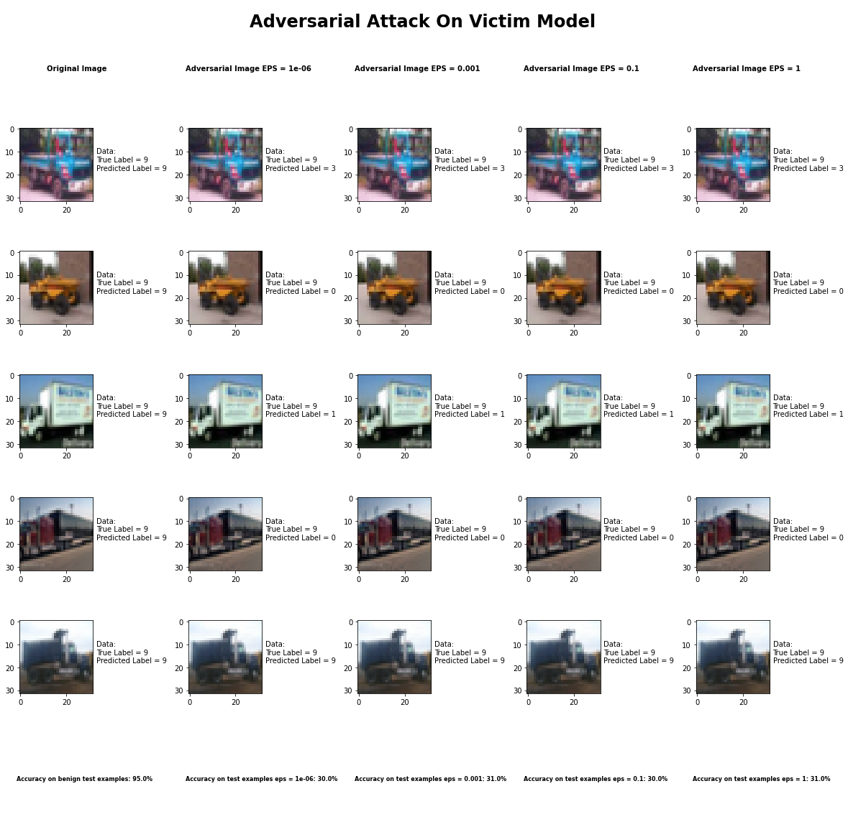

Accuracy on benign test examples: 94.52000000000001%

Average Accuracy on adversarial test examples with eps = 0.05: 30.2%

Average Accuracy on adversarial test examples with eps = 0.1: 31.3%

Average Accuracy on adversarial test examples with eps = 0.5: 30.1%

Average Accuracy on adversarial test examples with eps = 0.95: 31.0%

Classifier with benign example has Airplane recognition average accuracy of = 95%

DeepFool Method with eps = 1e-6 has Airplane recognition average accuracy of = 42%

DeepFool Method with eps = 1e-3 has Airplane recognition average accuracy of = 46%

DeepFool Method with eps = 1e-1 has Airplane recognition average accuracy of = 46%

DeepFool Method with eps = 1 has Airplane recognition average accuracy of = 46%

Classifier with benign example has Automobile recognition average accuracy of = 92%

DeepFool Method with eps = 1e-6 has Automobile recognition average accuracy of = 45%

DeepFool Method with eps = 1e-3 has Automobile recognition average accuracy of = 51%

DeepFool Method with eps = 1e-1 has Automobile recognition average accuracy of = 48%

DeepFool Method with eps = 1 has Automobile recognition average accuracy of = 41%

Classifier with benign example has Bird recognition average accuracy of = 96%

DeepFool Method with eps = 1e-6 has Bird recognition average accuracy of = 27%

DeepFool Method with eps = 1e-3 has Bird recognition average accuracy of = 31%

DeepFool Method with eps = 1e-1 has Bird recognition average accuracy of = 24%

DeepFool Method with eps = 1 has Bird recognition average accuracy of = 28%

Classifier with benign example has Cat recognition average accuracy of = 86%

DeepFool Method with eps = 1e-6 has Cat recognition average accuracy of = 29%

DeepFool Method with eps = 1e-3 has Cat recognition average accuracy of = 26%

DeepFool Method with eps = 1e-1 has Cat recognition average accuracy of = 22%

DeepFool Method with eps = 1 has Cat recognition average accuracy of = 24%

Classifier with benign example has Deer recognition average accuracy of = 95%

DeepFool Method with eps = 1e-6 has Deer recognition average accuracy of = 37%

DeepFool Method with eps = 1e-3 has Deer recognition average accuracy of = 33%

DeepFool Method with eps = 1e-1 has Deer recognition average accuracy of = 38%

DeepFool Method with eps = 1 has Deer recognition average accuracy of = 35%

Classifier with benign example has Dog recognition average accuracy of = 88%

DeepFool Method with eps = 1e-6 has Dog recognition average accuracy of = 20%

DeepFool Method with eps = 1e-3 has Dog recognition average accuracy of = 22%

DeepFool Method with eps = 1e-1 has Dog recognition average accuracy of = 23%

DeepFool Method with eps = 1 has Dog recognition average accuracy of = 22%

Classifier with benign example has Frog recognition average accuracy of = 99%

DeepFool Method with eps = 1e-6 has Frog recognition average accuracy of = 26%

DeepFool Method with eps = 1e-3 has Frog recognition average accuracy of = 24%

DeepFool Method with eps = 1e-1 has Frog recognition average accuracy of = 29%

DeepFool Method with eps = 1 has Frog recognition average accuracy of = 25%

Classifier with benign example has Horse recognition average accuracy of = 93%

DeepFool Method with eps = 1e-6 has Horse recognition average accuracy of = 21%

DeepFool Method with eps = 1e-3 has Horse recognition average accuracy of = 25%

DeepFool Method with eps = 1e-1 has Horse recognition average accuracy of = 24%

DeepFool Method with eps = 1 has Horse recognition average accuracy of = 26%

Classifier with benign example has Ship recognition average accuracy of = 94%

DeepFool Method with eps = 1e-6 has Ship recognition average accuracy of = 32%

DeepFool Method with eps = 1e-3 has Ship recognition average accuracy of = 30%

DeepFool Method with eps = 1e-1 has Ship recognition average accuracy of = 28%

DeepFool Method with eps = 1 has Ship recognition average accuracy of = 32%

Classifier with benign example has Truck recognition average accuracy of = 98%

DeepFool Method with eps = 1e-6 has Truck recognition average accuracy of = 26%

DeepFool Method with eps = 1e-3 has Truck recognition average accuracy of = 24%

DeepFool Method with eps = 1e-1 has Truck recognition average accuracy of = 21%

DeepFool Method with eps = 1 has Truck recognition average accuracy of = 18%

## Fast Gradient Sign Method



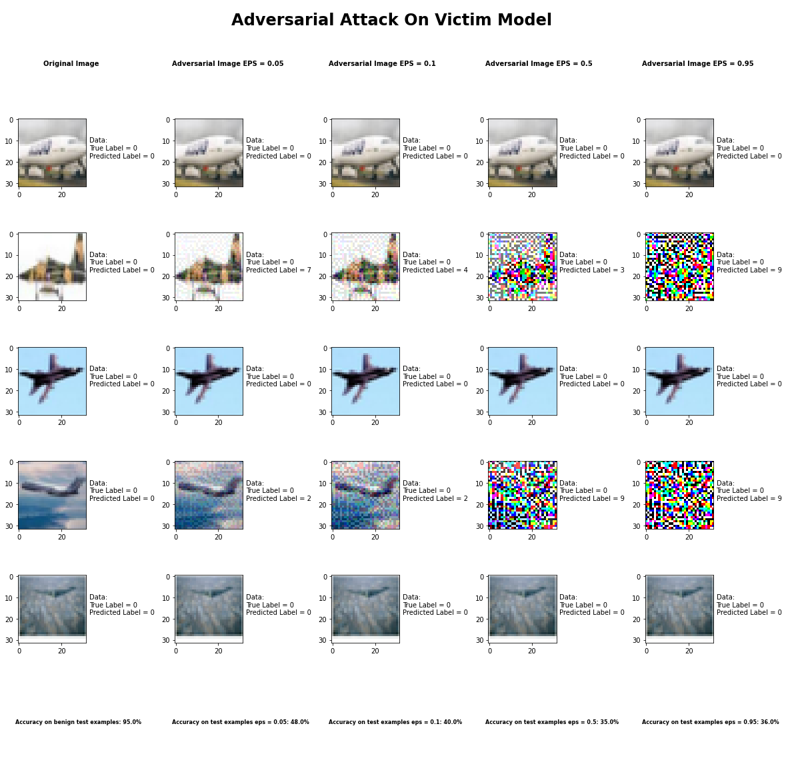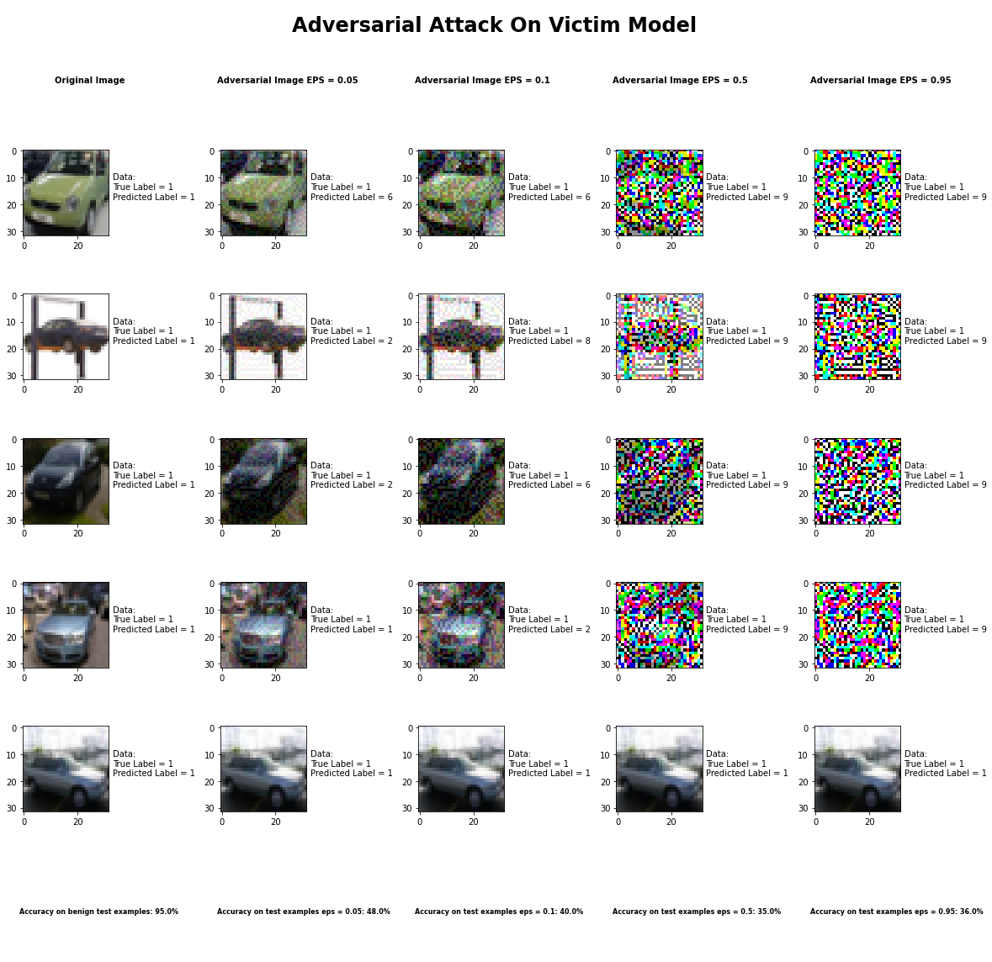

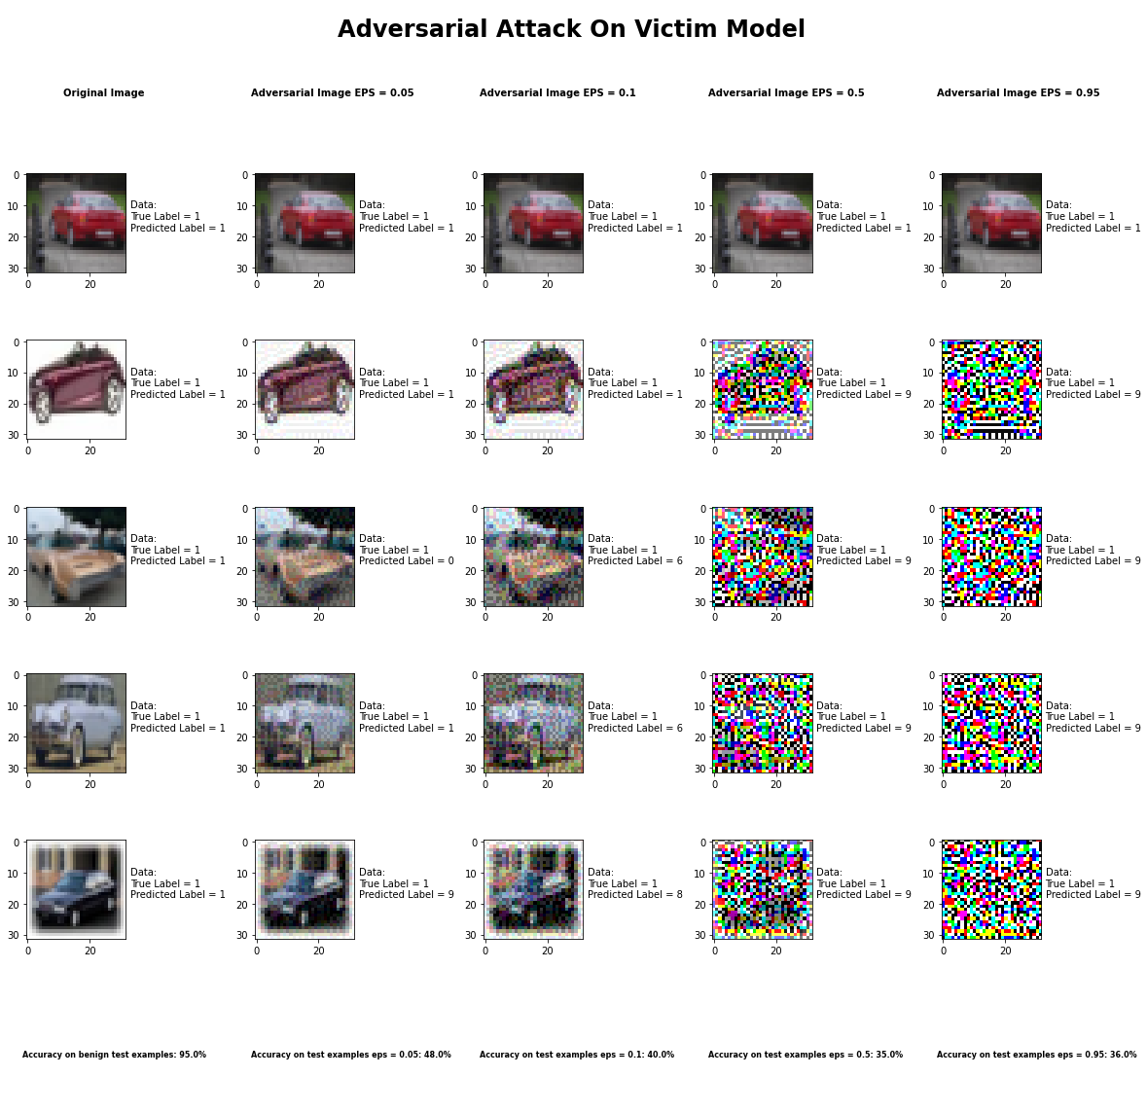

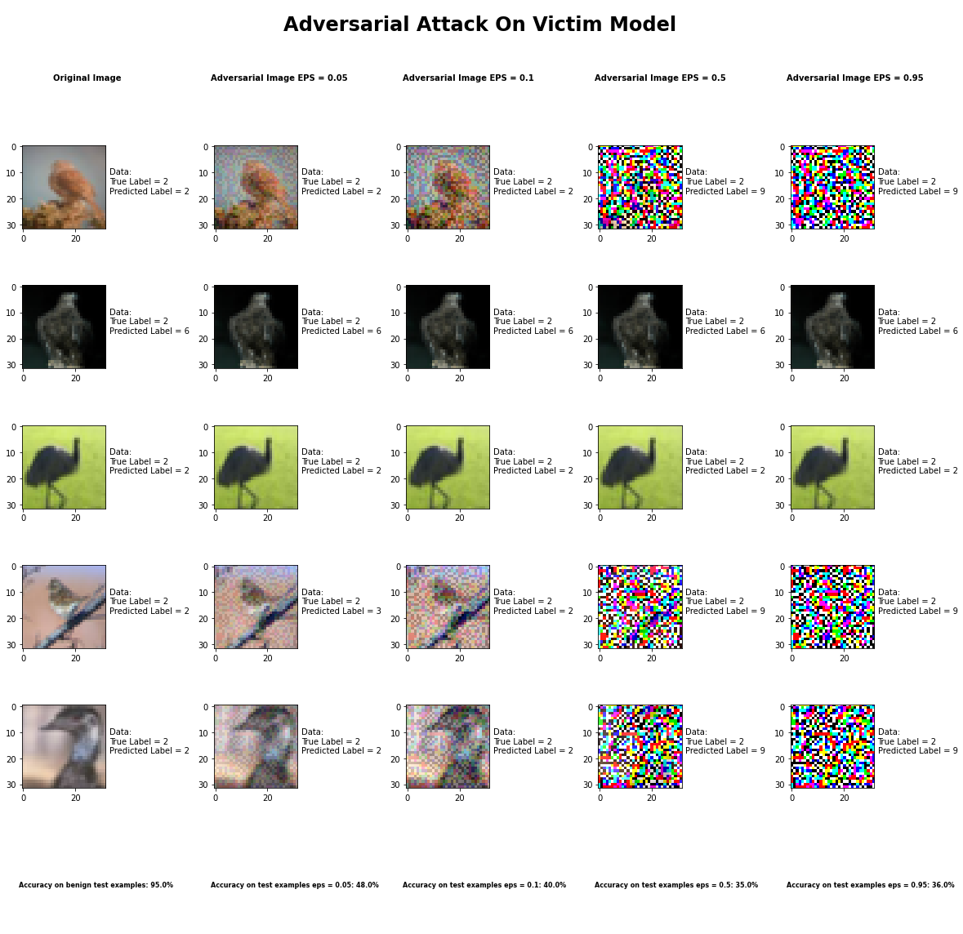

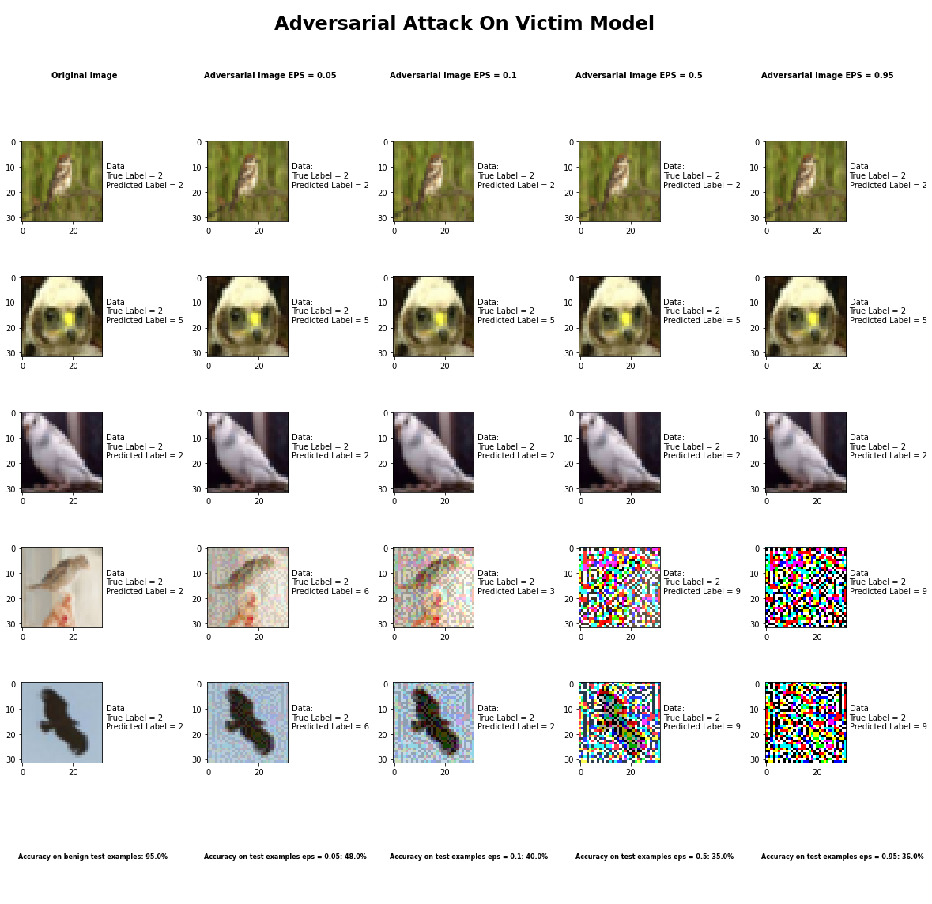

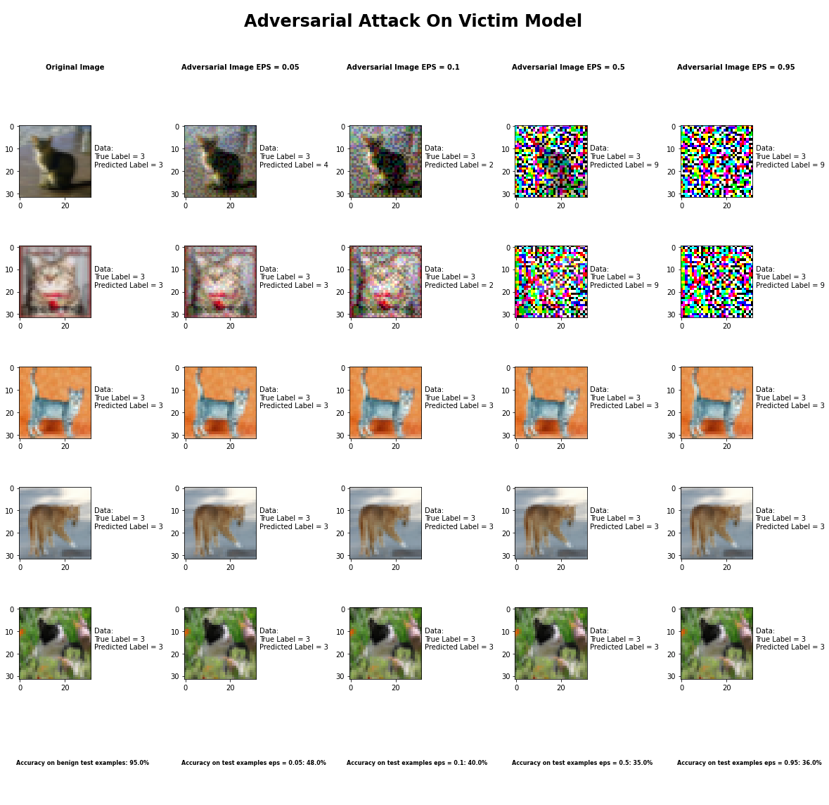

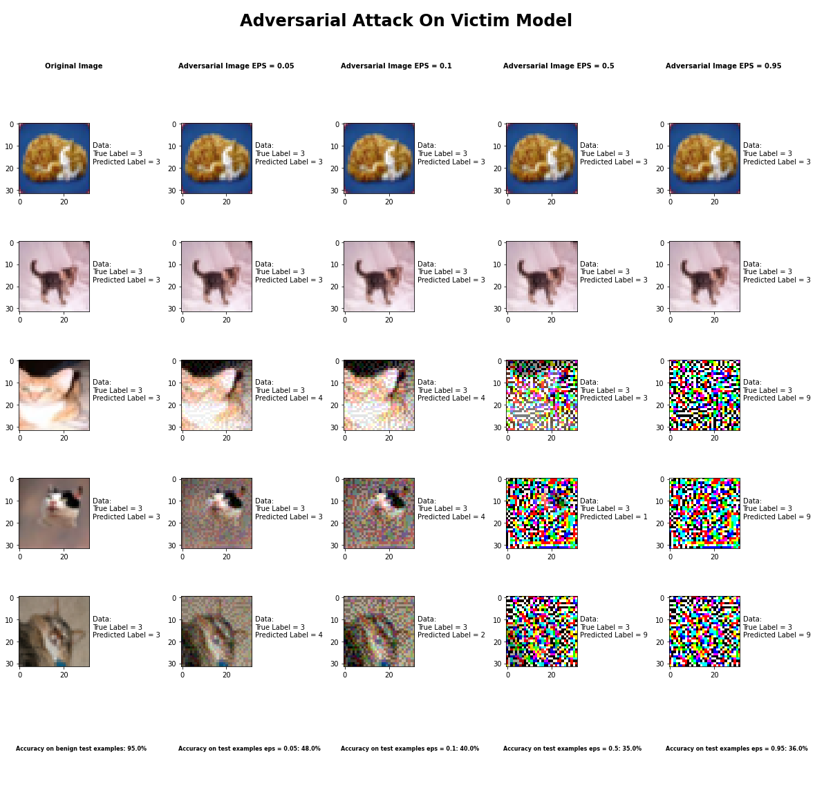

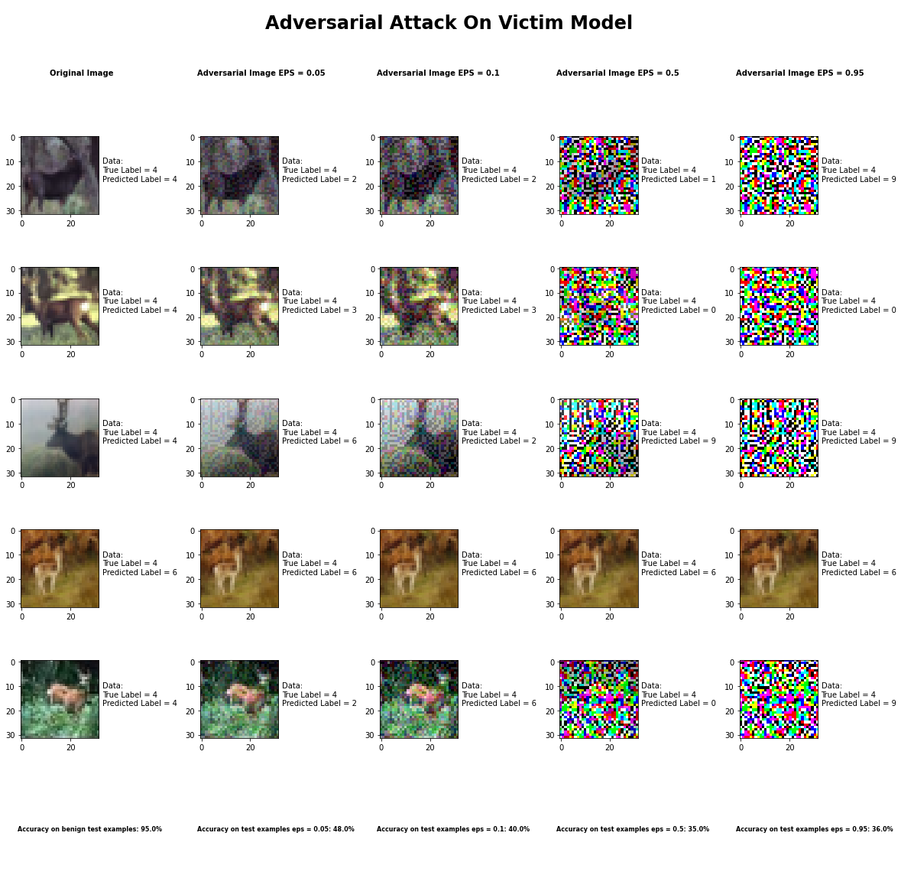

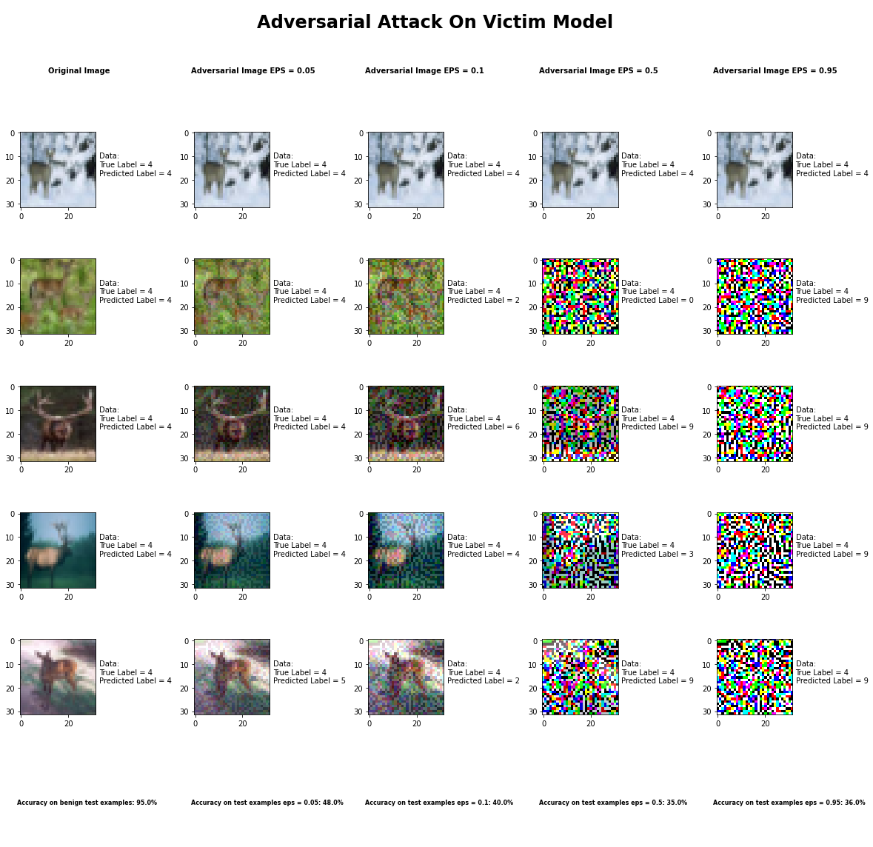

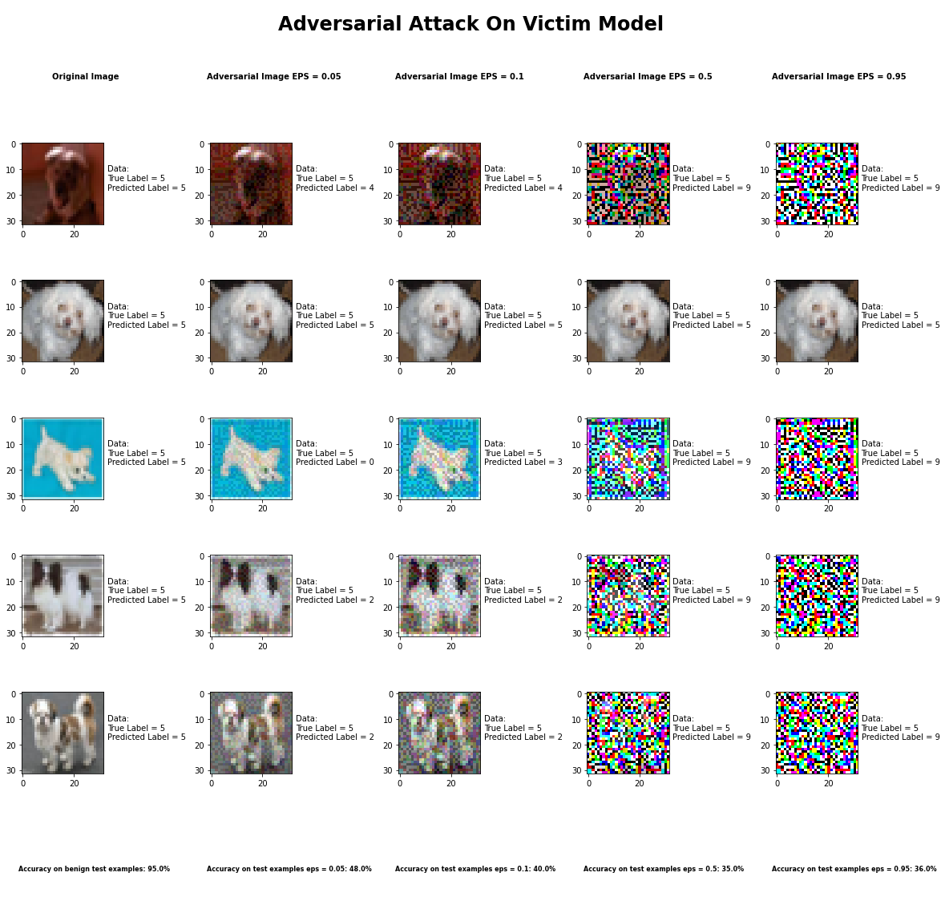

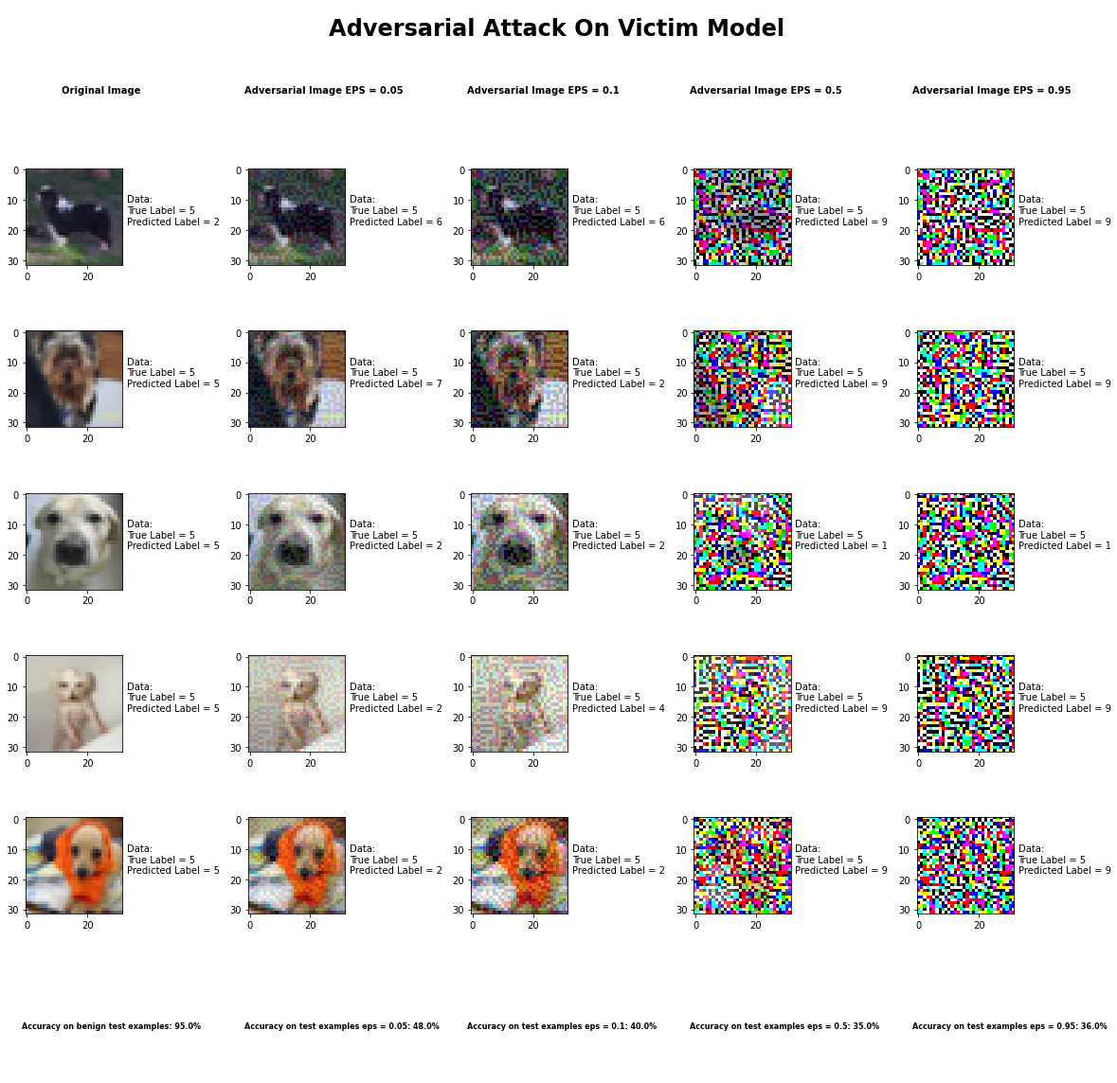

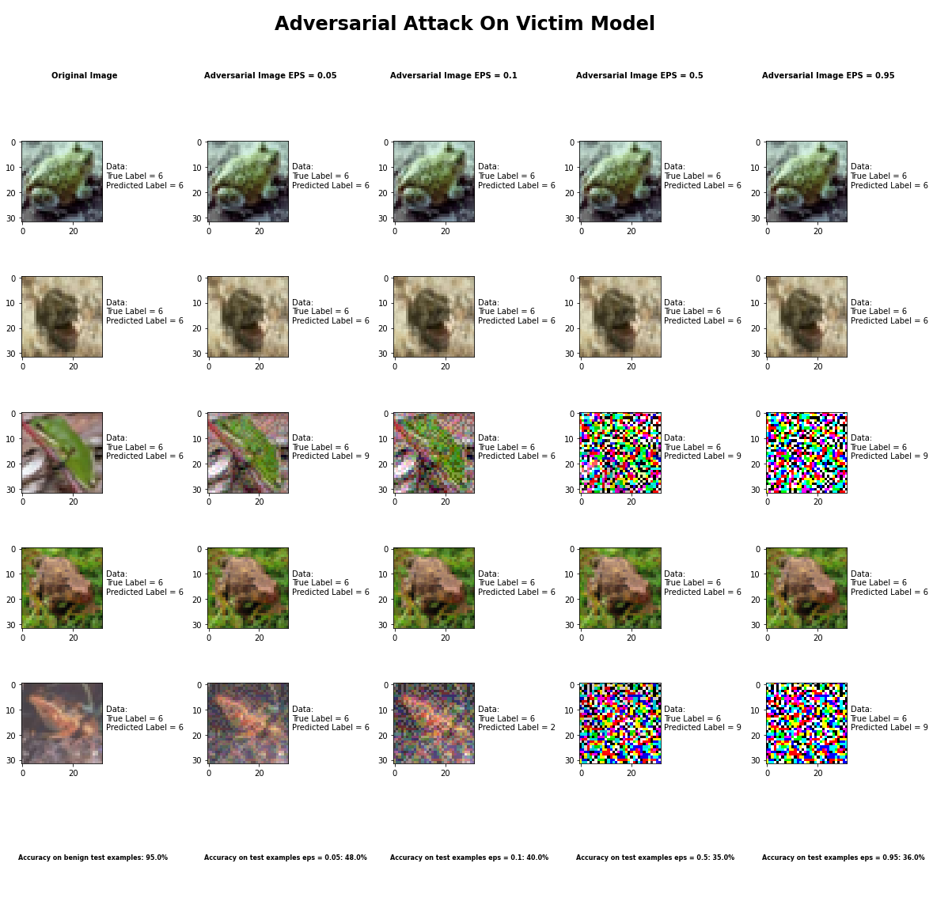

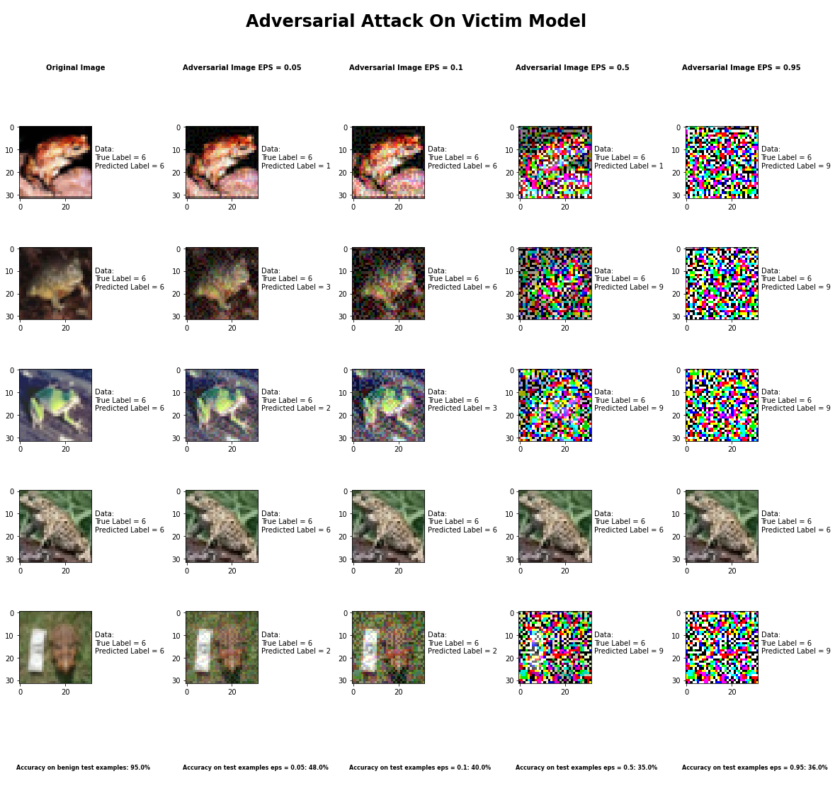

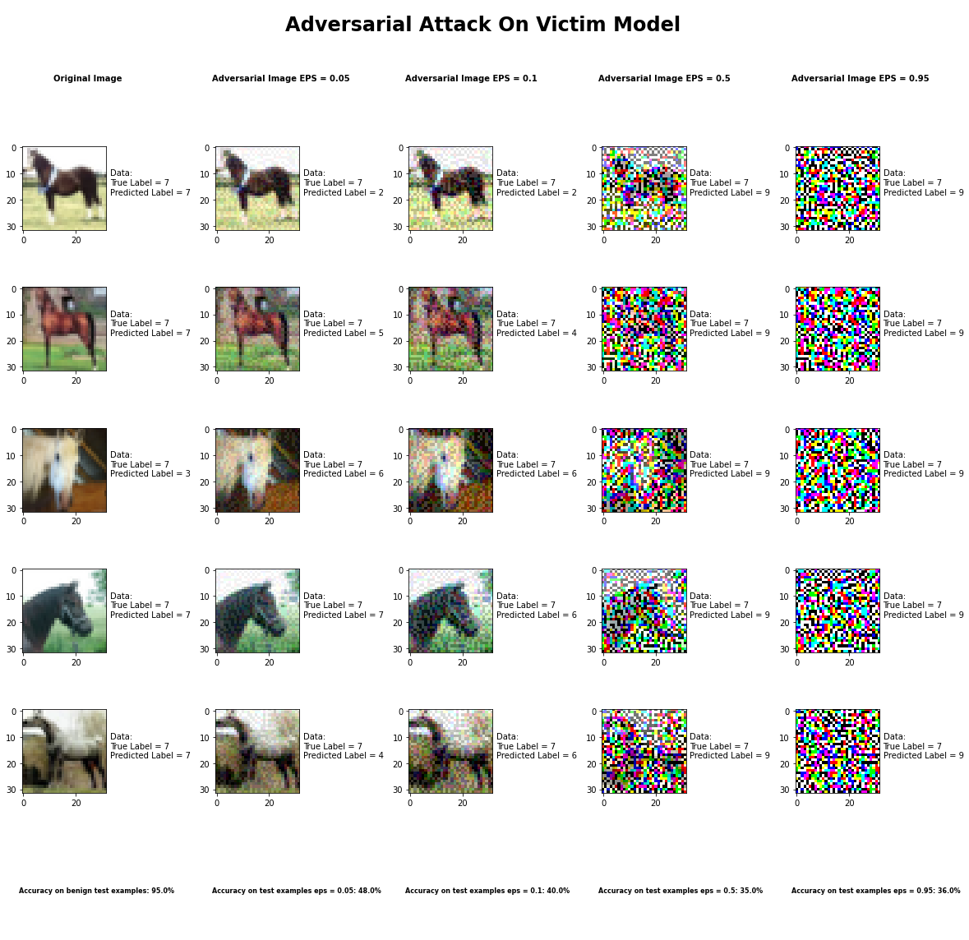

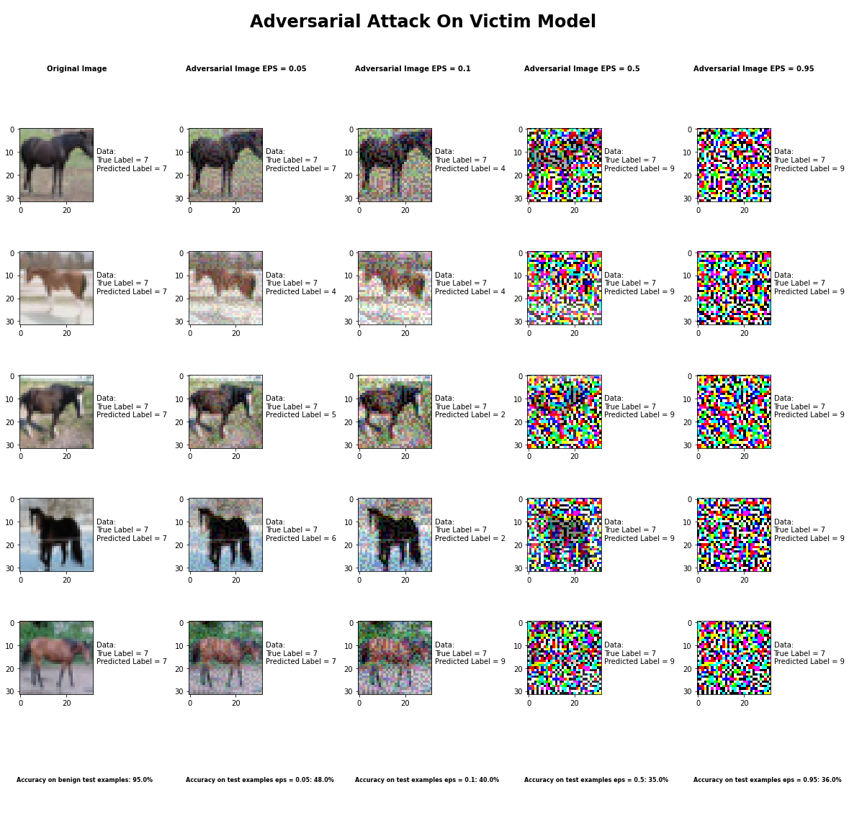



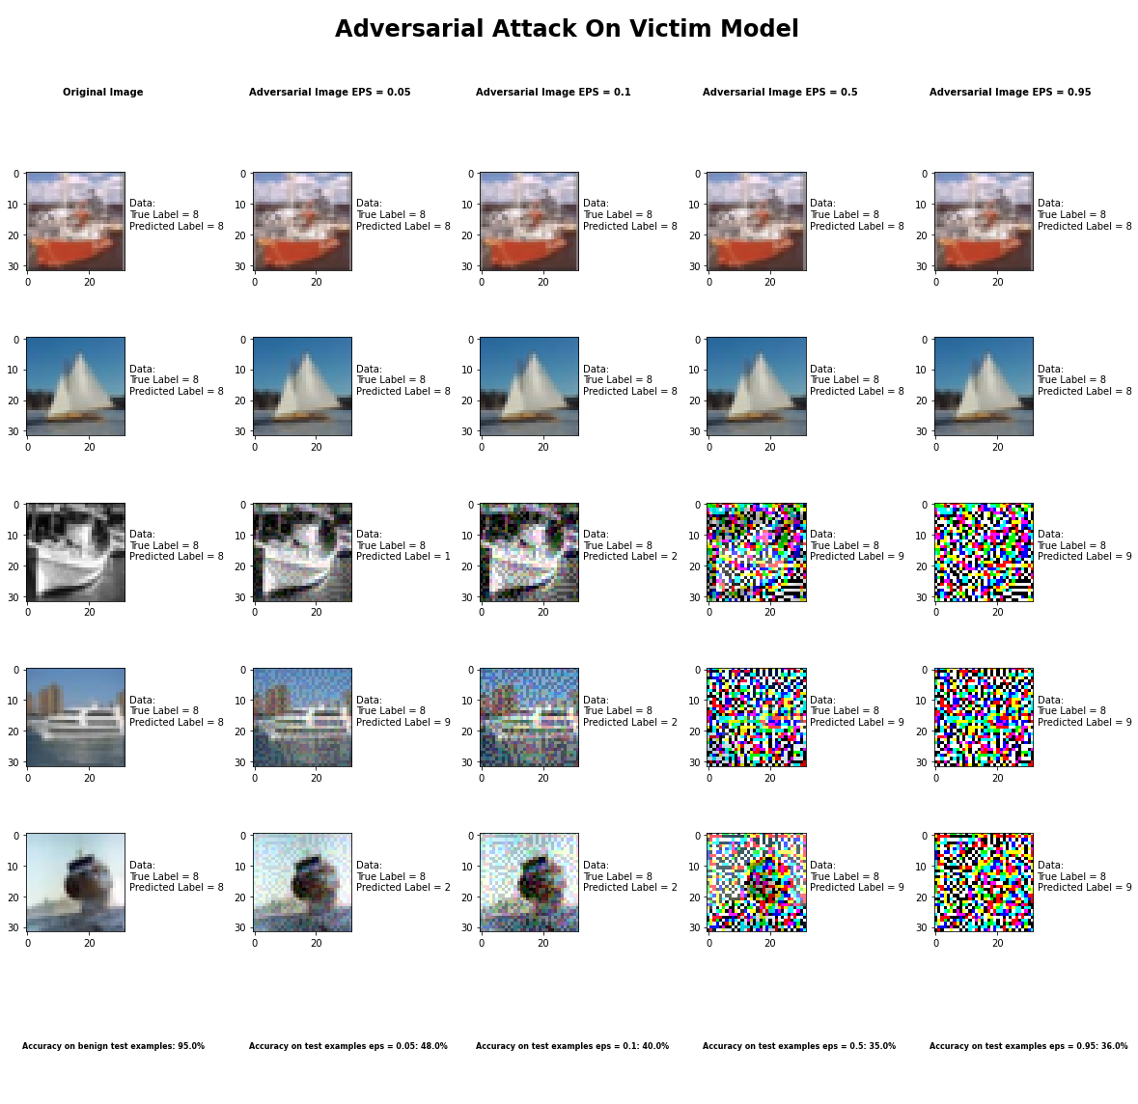

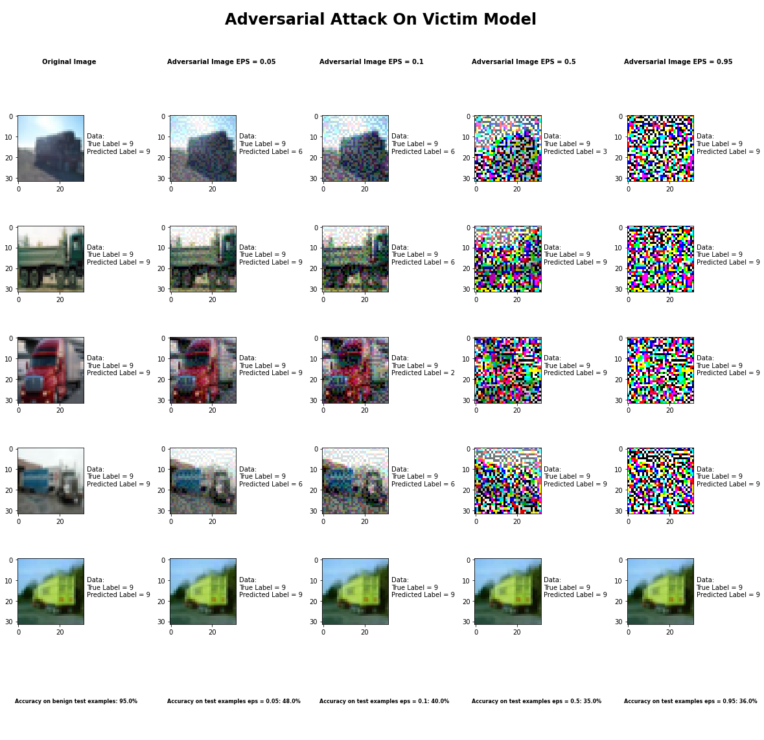

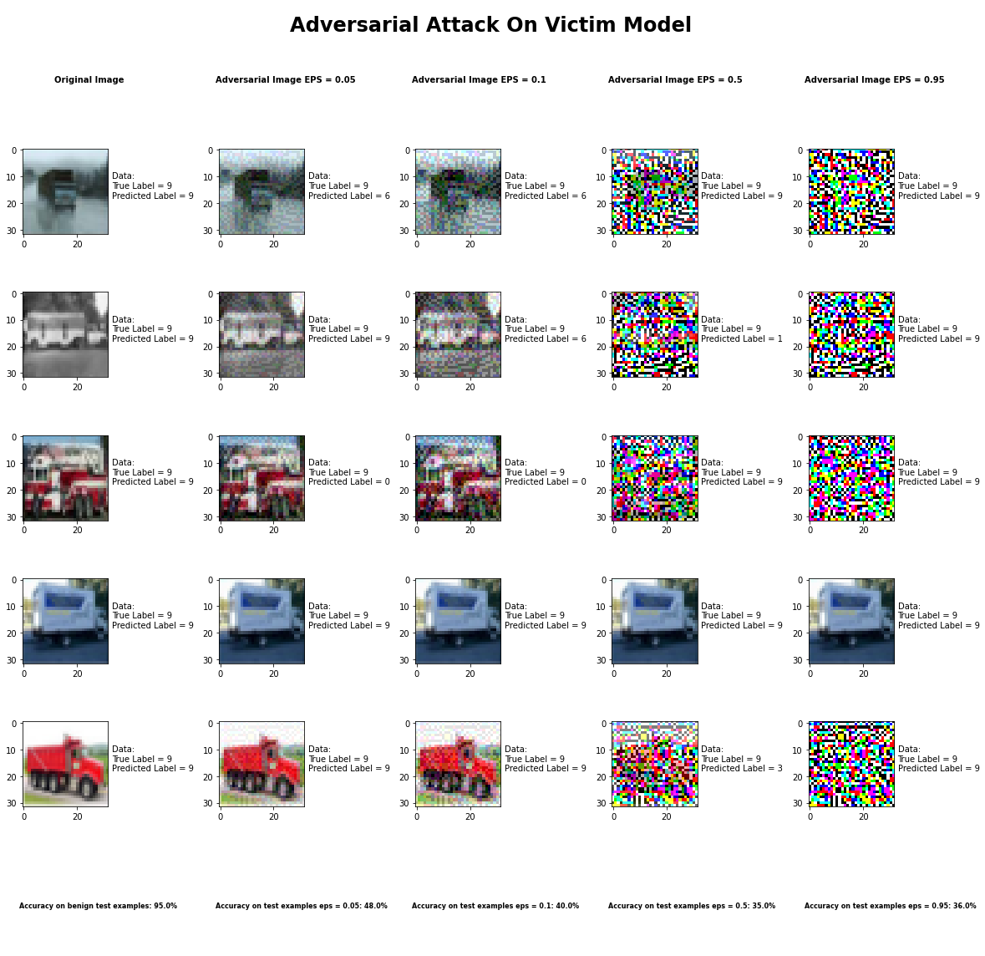

Accuracy on benign test examples: 94.52000000000001%

Average Accuracy on adversarial test examples with eps = 0.05: 48.4%

Average Accuracy on adversarial test examples with eps = 0.1: 39.9%

Average Accuracy on adversarial test examples with eps = 0.5: 35.3%

Average Accuracy on adversarial test examples with eps = 0.95: 35.5%

Classifier with benign example has Airplane recognition average accuracy of = 98%

Fast Gradient Method with eps = 0.05 has Airplane recognition average accuracy of = 32%

Fast Gradient Method with eps = 0.10 has Airplane recognition average accuracy of = 30%

Fast Gradient Method with eps = 0.50 has Airplane recognition average accuracy of = 33%

Fast Gradient Method with eps = 0.95 has Airplane recognition average accuracy of = 30%

Classifier with benign example has Automobile recognition average accuracy of = 96%

Fast Gradient Method with eps = 0.05 has Automobile recognition average accuracy of = 60%

Fast Gradient Method with eps = 0.10 has Automobile recognition average accuracy of = 40%

Fast Gradient Method with eps = 0.50 has Automobile recognition average accuracy of = 40%

Fast Gradient Method with eps = 0.95 has Automobile recognition average accuracy of = 35%

Classifier with benign example has Bird recognition average accuracy of = 95%

Fast Gradient Method with eps = 0.05 has Bird recognition average accuracy of = 68%

Fast Gradient Method with eps = 0.10 has Bird recognition average accuracy of = 70%

Fast Gradient Method with eps = 0.50 has Bird recognition average accuracy of = 34%

Fast Gradient Method with eps = 0.95 has Bird recognition average accuracy of = 34%

Classifier with benign example has Cat recognition average accuracy of = 86%

Fast Gradient Method with eps = 0.05 has Cat recognition average accuracy of = 42%

Fast Gradient Method with eps = 0.10 has Cat recognition average accuracy of = 34%

Fast Gradient Method with eps = 0.50 has Cat recognition average accuracy of = 37%

Fast Gradient Method with eps = 0.95 has Cat recognition average accuracy of = 32%

Classifier with benign example has Deer recognition average accuracy of = 96%

Fast Gradient Method with eps = 0.05 has Deer recognition average accuracy of = 43%

Fast Gradient Method with eps = 0.10 has Deer recognition average accuracy of = 28%

Fast Gradient Method with eps = 0.50 has Deer recognition average accuracy of = 20%

Fast Gradient Method with eps = 0.95 has Deer recognition average accuracy of = 20%

Classifier with benign example has Dog recognition average accuracy of = 84%

Fast Gradient Method with eps = 0.05 has Dog recognition average accuracy of = 31%

Fast Gradient Method with eps = 0.10 has Dog recognition average accuracy of = 23%

Fast Gradient Method with eps = 0.50 has Dog recognition average accuracy of = 23%

Fast Gradient Method with eps = 0.95 has Dog recognition average accuracy of = 23%

Classifier with benign example has Frog recognition average accuracy of = 96%

Fast Gradient Method with eps = 0.05 has Frog recognition average accuracy of = 60%

Fast Gradient Method with eps = 0.10 has Frog recognition average accuracy of = 68%

Fast Gradient Method with eps = 0.50 has Frog recognition average accuracy of = 26%

Fast Gradient Method with eps = 0.95 has Frog recognition average accuracy of = 26%

Classifier with benign example has Horse recognition average accuracy of = 93%

Fast Gradient Method with eps = 0.05 has Horse recognition average accuracy of = 33%

Fast Gradient Method with eps = 0.10 has Horse recognition average accuracy of = 24%

Fast Gradient Method with eps = 0.50 has Horse recognition average accuracy of = 24%

Fast Gradient Method with eps = 0.95 has Horse recognition average accuracy of = 23%

Classifier with benign example has Ship recognition average accuracy of = 99%

Fast Gradient Method with eps = 0.05 has Ship recognition average accuracy of = 58%

Fast Gradient Method with eps = 0.10 has Ship recognition average accuracy of = 45%

Fast Gradient Method with eps = 0.50 has Ship recognition average accuracy of = 45%

Fast Gradient Method with eps = 0.95 has Ship recognition average accuracy of = 45%

Classifier with benign example has Truck recognition average accuracy of = 97%

Fast Gradient Method with eps = 0.05 has Truck recognition average accuracy of = 57%

Fast Gradient Method with eps = 0.10 has Truck recognition average accuracy of = 37%

Fast Gradient Method with eps = 0.50 has Truck recognition average accuracy of = 71%

Fast Gradient Method with eps = 0.95 has Truck recognition average accuracy of = 87%